**National University of Ho Chi Minh City**

**UNIVERSITY OF INFORMATION TECHNOLOGY**

**DEPARTMENT OF INFORMATION SYSTEMS**

IEM5723.O12.CTTT

**DATA, PROCESS AND OBJECT MODELING**

**PROJECT: COSMETIC SALES MANAGEMENT**

**Instructors:** Dr. Cao Thi Nhan

MSc. Duong Phi Long

Group 2:

Nguyễn Minh Thành - 20521920

Nguyễn Văn Tân - 20521880

Quách Vinh Quang - 20521811

Lê Văn Sỹ - 20521854

**TABLE OF CONTENTS**

Contents

Chapter 1: INTRODUCTION 5

1.1. Introduction 5

1.2. Research problems / Problems of the project 6

1.3. Research Objectives / Objectives of the project 6

1.4. Scope of project / Limitations of the study 7

Chapter 2: REQUIREMENT SPECIFICATION 7

2.1. Situation survey/ Survey of the current situation 7

2.1.1. Interview 8

2.1.2. Survey of the organization/ Current organizational situation 16

2.1.3. Survey of business processes, major activities 16

2.1.4. Survey of the existing system 20

2.2. Software requirements 21

2.2.1. Functional requirements 21

2.2.1.1. Storage function 21

2.2.1.2. Feature function 21

2.2.2. Non-functional requirements 22

Chapter 3: ANALYSIS AND DESIGN 23

3.1. Use-case Diagram 23

3.1.1. Administrator 23

3.1.2. Customer 25

3.1.3. List of actors 26

3.1.4. List of Use-case 26

3.2. Use-case specification and activity diagram (Activity Diagram) 27

3.2.1. Sign in 27

3.2.1.1 Sign in with external account 31

3.2.1.1.1. Sign in with Facebook 31

3.2.1.1.2. Sign in with gmail 32

3.2.1.2. Sign in with web account 33

3.2.2. Sign up 33

3.2.3. Add to cart 35

3.2.4. Proceed to checkout 37

3.2.5. Update password 40

3.2.6. Search product (Customer) 42

3.2.7. Search order (Customer) 44

3.2.8. Generate sales report 46

3.2.9. Manage product 48

3.2.10. Manage account 53

3.2.11. Manage order 58

3.3. Sequence Diagram and Class Diagram 62

3.3.1. Sign in 62

3.3.1.1. Sequence Diagram 62

3.3.1.2. Class Diagram 65

3.3.2. Sign up 68

3.3.2.1. Sequence Diagram 68

3.3.2.2. Class Diagram 69

3.3.3. Add to Cart 69

3.3.3.1. Sequence Diagram 69

3.3.3.2. Class Diagram 71

3.3.4. Proceed to checkout 71

3.3.4.1. Sequence Diagram 71

3.3.4.2. Class Diagram 73

3.3.5. Update password 74

3.3.5.1. Sequence Diagram 74

3.3.5.2. Class Diagram 76

3.3.6. Search product (Customer) 77

3.3.6.1. Sequence diagram 77

3.3.6.2. Class diagram 79

3.3.7. Search order (Customer) 80

3.3.7.1. Sequence Diagram 80

3.3.7.2. Class Diagram 81

3.3.8. Generate sales report 82

3.3.8.1. Sequence Diagram 82

3.3.8.2. Class Diagram 83

3.3.9. Manage products 84

3.3.9.1. Sequence Diagram 84

3.3.9.2. Class Diagram 88

3.3.10. Manage account 89

3.3.10.1. Sequence Diagram 89

3.3.10.2. Class Diagram 93

3.3.11. Manage Order 94

3.3.11.1. Sequence Diagram 94

3.3.11.2. Class Diagram 98

3.4. Class Diagram and Entity class diagram 99

3.4.1. Customer class diagram overview 99

3.4.2. Administrator class diagram overview 100

3.4.3. Entity class diagram 100

3.4.4. Class Diagram Specification 101

3.4.4..1 Account 101

3.4.4.2 Product 102

3.4.4.3 Order 103

3.5. State Diagram 105

3.5.1. Account 105

3.5.2. Product 106

3.5.3. Order 107

3.6. Mapping to Relational Model from Entity class diagram 107

Chapter 4: IMPLEMENTATION AND TESTING 108

4.1. Introduction to the implementation environment 108

4.1.1 Development environment 108

4.2. User Interface 109

4.2.1. Product page 109

4.2.2. Cart page 112

4.2.3. Checkout page 113

4.2.4. Order 114

4.2.5. Login Modal 116

4.2.6. Sign Up Modal 117

4.2.7. Dashboard admin 118

4.2.8. Users management 119

4.2.9. Delete Users Modal 120

4.2.10. Products management 121

4.2.11. Add Products Modal 122

4.2.12. Edit Products Modal 123

4.2.13. Delete Products Modal 124

4.2.14. Orders management 125

4.2.15. View Orders Details Modal 126

4.2.16. Edit Orders Modal 127

4.2.17. Delete Orders Modal 128

Chapter 5: CONCLUSION 129

5.1 Project achievement 129

5.2 Limitations 129

5.3 Development direction 130

Chapter 6: SELF ASSESSMENT 130

# 

# Chapter 1: INTRODUCTION

## Introduction

In the age of technology, having a website has played a crucial part in managing business. Not only does it help to establish an online presence throughout the week, but also creates an opportunity for the enterprise to showcase their products internationally. When it comes to industries whose external appearance or beauty standard is important such as the music industry, model industry, cosmetic is the product that needs consideration the most. Following the rise of e-commerce, building a website for cosmetic management has contributed to the success of the cosmetic business. In this topic, we are going to discuss a lot of key aspects of building a cosmetic sales management website like gathering user requirements, designing an inventory management system,... and ensuring that the website is visually attractive, functional, and profitable.

## Research problems / Problems of the project

Due to the geographical issue between the store and the customer, the proposed solution is an application (web-based, mobile-based, desktop-based) that aims to deliver information to customers as soonest. Customers are not only convenient in retrieving information about the products they intend to buy, but also easily perform operations such as booking or selecting the type of the product, etc. Nowadays, almost all stores have been applying technology to management and information delivery systems, but there are still problems.

Online Sales: With the rise of e-commerce, shoe stores need to have a strong online presence to remain competitive. Research could explore how to optimize online sales channels, including website design, search engine optimization, and social media marketing. This could involve developing user-friendly interfaces, using data analytics to track customer behavior, and implementing targeted online advertising.

Add-to-cart function: Due to being the online sales website, the add-to-cart function is the most important and also the main function of the system. This function allows the customer to select products, add them to the cart, and proceed with the payment.

## Research Objectives / Objectives of the project

Because of limitations about time and human resources, a lot of functions are not added to the website. These functions are:

* Manage products inventory levels and product information to ensure the availability of stock and accurate product details.
* Manage user accounts and login information to ensure secure and personalized access to the website.
* Manage order information to efficiently deliver goods to customers and keep tracking the payment.
* Manage the latest information updates to keep customers informed about new arrivals and trends.
* Manage a backup system to ensure the safety and security of all data, including inventory, user information, and transactions.

## Scope of project / Limitations of the study

Because of limitations about time, human, our teams focus to some main features such as:

* Login to Admin/Customer Page
* Add to cart and Proceed to checkout.
* Account management.
* Product management.
* Order management.

# Chapter 2: REQUIREMENT SPECIFICATION

## 2.1. Situation survey/ Survey of the current situation

A situation survey is one of the important parts of the software engineering process. Conducting a situation survey, not only gives our team a better understanding of the organization's needs and expectations about the system but also helps in ensuring that the software system is designed and developed to meet the specific requirements of the organization and align with its goals. The situation survey of the Cosmetic Sales Management System is split into four smaller parts: Interview, Survey of the organization, Survey of business processes, and Survey of the existing system.

### 2.1.1. Interview

Establish an interview plan from preliminary to detailed, with content and results with some notes about the interview with the partner of the project Building a cosmetic sales management web application:

|  |  |  |  |  |
| --- | --- | --- | --- | --- |
| **Preliminary Interview Plan**  Project Name: Cosmetic sales management web application  Creator: Nguyễn Minh Thành  Created Date: October 11th, 2023 | | | | |
| **No.** | **Topic** | **Achieved Goals** | **Start date** | **End date** |
| 1 | Sales Management | Understand the process of buying & selling products. | October 11th, 2023 | October 11th, 2023 |
| 2 | Product Management | Understand how to manage product inventory. | October 11th, 2023 | October 11th, 2023 |
| 3 | Customer Management | Understand how to manage customer. | October 11th, 2023 | October 11th, 2023 |
| 4 | Requirements about information technology: interface, hardware, software support | Learn more about the store's existing machinery resources to make the design plan, understand the customer's requirements for the system, and suggest to the customer the resource systems that need to be prepared. | October 11th, 2023 | October 11th, 2023 |

*Table 1 Preliminary interview plan*

|  |  |
| --- | --- |
| **Detailed Interview Plan**  Project Name: Cosmetic sales management web application  Creator: Nguyễn Minh Thành  Created Date: October 12th, 2023 | |
| **Start date & End date** | * Start: 9h00, October 12th, 2023 * End: 11h15, October 12th, 2023 |
| **Interview Location** | Directly at Dormitory A of the National University |
| **Interviewer team** | Consist of 2 members:   * Nguyễn Minh Thành: Lead Interviewer * Quách Vinh Quang |
| **Interviewee team** | Consist of 2 members:   * Nguyễn Văn Tân: Lead Project Partner * Lê Văn Sỹ |
| **Goals** | Capture and collect enough information about the items outlined in the preliminary interview plan made on October 11th, 2023. |
| **Detailed Interview** | The interview took place with the following schedule of sections:   * Project Introduction and Validation. * Overview of the system to be built for the store. * In-depth system analysis: * Topic 1: Sales Management. * Topic 2: Product Management. * Topic 3: Customer Management. * Topic 4: Requirements about information technology: interface, hardware, software support. |
| **Expected Time** | Expected time for each section of the interview:   * Project Introduction and Validation: **15 minutes** * Overview of the system to be built for the store: **30 minutes** * In-depth system analysis: **2 hours** |
| **General result** | * At the end of the interview, the interviewer team collected the necessary information to analyze the design of a project of building an application to manage shoe sales. * The partners are very open to contributing to the project and accepting the team's suggestions on how to build the application. |
| **Unexpected occurrence** | * No unexpected occurrences happened. |
| **Conclusion & Notes** | * If there are any additional requirements in the execution process, you can contact us, we are free to discuss improving the software in the best way possible. * Contact information: * Phone number: 0902 659 897 * Contact email: 20521920@gm.uit.edu.vn * Thank you for the information you have provided today, see you in the nearest day. |

*Table 2 Detailed interview plan*

|  |  |  |  |
| --- | --- | --- | --- |
| **Detailed Interview Content Table**  Project Name: Cosmetic sales management web application  Creator: Nguyễn Minh Thành  Created Date: October 12th, 2023 | | | |
| **Question** | | **Record** | **Answer attitude** |
| ***Topic 1***: Sales Management | *Question 1*: How many payment methods does the system need? | The system should support customer with various payment methods, such as: credit card, Momo, bank card, on-cash,… | Open-minded, enthusiastic |
| *Question 2:* Do the system need to display how many times customer has not received delivered products? | Yes, the system needs to keep track on the number of times customer refused to take the products when they are delivered. | Open-minded, enthusiastic |
| ***Topic 2:*** Product Management | *Question 1*: How are the regulations on storing goods in the warehouse? | Goods will be stored in the physical warehouse, the physical warehouse location can be at the store if the quantity of goods is small, in addition, only warehouse staff can go to the warehouse. | Open-minded, enthusiastic |
| *Question 2:* How is the price of product determined? Does the product price affect the product quantity? | Product prices are set at a fixed market price, which will change depending on the sales of that product. The product quantity may vary depending on the price of the product. | Open-minded, enthusiastic |
| *Question 3:* How is product information stored? | Store on specialized software: product name, quantity and price of product. | Open-minded, enthusiastic |
| ***Topic 3:*** Customer management | *Question 1:* What outstanding features of the product to attract customers? | * Difference in design: different design compared to other stores but still has unique features, variety of colors and designs… * Material: The product is cool, absorbs sweat well, washes without stretching. * Price: moderate, not too expensive, suitable for all budgets. | Open-minded, enthusiastic |
| *Question 3:* How is customer information stored? | Store on specialized software: full name, contact information and address. | Open-minded, enthusiastic |
| ***Topic 4:*** Requirements about information technology: interface, hardware, software support | *Question 1*: How is your computer system configured? | We currently have 2 facilities and all of them are equipped with electrical equipment that are considered high today. | Open-minded, enthusiastic |
| *Question 2*: What are your wishes about the software interface eg colors, images, layout? | We want green as the main color and black white can be customized via light/dark mode. Lists and reports must be displayed in tabular format. The store logo should appear in the top left corner of every page. | Open-minded, enthusiastic |

*Table 2 Detailed Interview Content Table*

### 2.1.2. Survey of the organization/ Current organizational situation

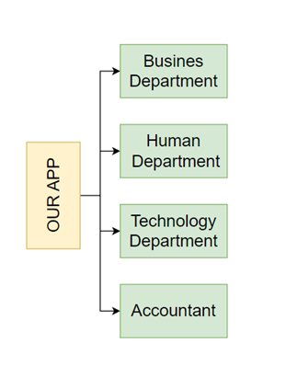

*Figure 1. Current organizational situation OurApp*

### 2.1.3. Survey of business processes, major activities

After looking through the given documents, we splitted the business process into smaller parts, which can be described as: Customer management, Product management, Inventory management, Product booking process and Order management. Additionally, we thoroughly analyzed processes and wrote down each of them in a detailed way. Below are a comprehensive business process that have been broken down into sub processes:

**Business Department:**

**Cosmetic product management business**: establish connections with cosmetic suppliers and partner systems to input details about cosmetic inventory, pricing, and product specifications. This integration facilitates smooth data exchange and collaboration with suppliers. The process involves entering information and pricing.

**Importing information process:**

* Set up integration with cosmetic suppliers to receive product data.
* Preprocess the received data and store it in our cosmetic product management database for future transactions.
* The imported information includes cosmetic details such as name, category, gender and other relevant attributes.

**Pricing process:**

* Determine cosmetic pricing based on various factors, including the original price from suppliers or customized pricing.
* Use specific pricing formulas or algorithms to calculate the final price.
* Store the information in our cosmetic product management database.
* Cosmetic marketing business: suggest innovative methods to enhance product visibility, attract customers, and optimize search engine rankings.

**Promotion process:**

* Develop creative promotional strategies to attract customers and boost sales.
* Identify target customer segments and customize promotions to their preferences.
* Collaborate with the technical department to implement effective promotional campaigns.

**Customer services process:**

* Establish a customer relationship management system to handle customer information and interactions.
* Ensure prompt responses to customer inquiries and provide timely support.
* Implement customer service strategies in harmony with other departments to deliver a seamless customer experience.
* Search engine optimization process:
* Implement strategies to optimize the visibility of cosmetic products on popular search engines like Google, Bing, etc.
* Improve site content, meta tags, and keywords to enhance organic search rankings.

**Human Resource Department**

**Human resource management:** Supervising the activities of all employees in the shoe shop, including the employee information management process, employee activity management process and other related processes.

**Employee information management process:**

* Recruitment: Handle the recruitment process, including job posting, candidate selection and referral process.
* Add employee information: Collect and enter new employee information such as personal information, contact details, employment history and related documents.
* Update employee information: Regularly update employee records to reflect changes in personal information, job positions or any other relevant updates.
* Delete employee information: Delete employee information who have not been working with the company or have their contract expired and not renewed.

**Employee management process:**

* Employee working hours and activity tracking
* Employee activity history
* Periodic reports on employee performance

**Technology Department**

System management & development business: Oversee the performance of the cosmetic product management system and be prepared to address any irregularities while assessing customer requirements for system enhancement, new features, and release documentation.

**System management processes:**

* Monitoring system information: Monitor and track traffic, requests, and database performance to ensure optimal functionality of the system.
* Interface readiness: Be ready to interface with the system in the event of anomalies or issues, promptly minimizing and resolving disruptions.
* Quality control: Conduct thorough quality control measures before updating the system to ensure stability, functionality, and reliability.
* Database scaling and caching: Implement strategies for scaling the database and utilizing caching techniques to enhance system performance and responsiveness.

**System development process:**

* Collect customer needs: Collaborate with the marketing department to gather customer needs and feedback, comprehending their requirements and expectations.
* Upgrade the cosmetic product management system to meet customer needs by incorporating new features and functionalities.
* Source code management to ensure version control.
* Development and operations integration: Facilitate a seamless integration between development and operations teams to streamline system development, deployment, and maintenance.
* Continuous development and continuous delivery.

**Accountant**

**Analysis business:** Introduce data-driven reports to facilitate the monitoring of the cosmetic product management system's performance. This encompasses tasks related to financial computations, employee compensation, and report generation.

**Compensation process:**

* Gather data from the Human Resources department, including details on employee work hours and other pertinent factors.
* Compute salaries and bonuses for each employee at the conclusion of the specified period.
* Securely store compensation data in the database for documentation and future reference.

**Reporting process**:

* Retrieve essential data from the cosmetic product management system's database.
* Generate comprehensive reports, concentrating on key metrics such as total cosmetic product sales, revenue, customer engagement, and promotional activities.
* Analyze the reports to extract insights into the overall performance of the cosmetic product management system.
* Present the reports to the management team for analysis and decision-making purposes.

### 2.1.4. Survey of the existing system

Based on the result of survey, the existing system requires:

* Operating System: Windows 7 or above.
* Processor: Intel core i3.
* Memory: 4Gb.
* Storage: 4Gb available space.

## 2.2. Software requirements

### 2.2.1. Functional requirements

### 2.2.1.1. Storage function

The storage functionality stands out as a crucial element within the system, serving as the foundation for the implementation of its various features. To ensure efficient administration, the system must store the specified information:

Product information: name, price, description, quantity, type of product, status.

Order information: first name, last name, email, country, city, address, phone number, postal code, and status.

User information: username, password, email, phone number, role, status.

Invoice information: payment method, tax amount, discount amount, shipping cost, grand total, status.

### 2.2.1.2. Feature function

In addition, the website has an ability to do functions listed below:

* The website needs to be able to respond to query requests from customers/managers such as:
* Product information based on ID, name, category.
* Account information based on ID, name, email,...
* Order information based in ID, address,...
* Calculate function: In addition, the website is also capable at calculating the total cost customer need to pay in the order.

### 2.2.2. Non-functional requirements

GUI requirement: The user interface is friendly, easy-to-use and multi-language support.

Security: The system needs to ensure data’s privacy and safety from cyberattacks.

Performance: The system needs to progress at an acceptable speed (not consuming a lot of time to load a page).

Compatibility: The system can run on different web browsers (Safari, Chrome, Firefox, …).

# Chapter 3: ANALYSIS AND DESIGN

## Use-case Diagram

### 3.1.1. Administrator

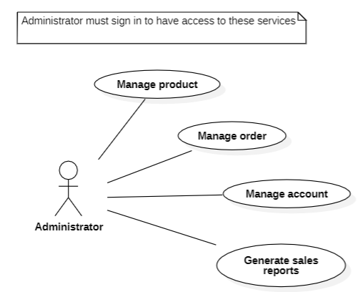

Diagram 1: General Use Case Diagram of Administrator

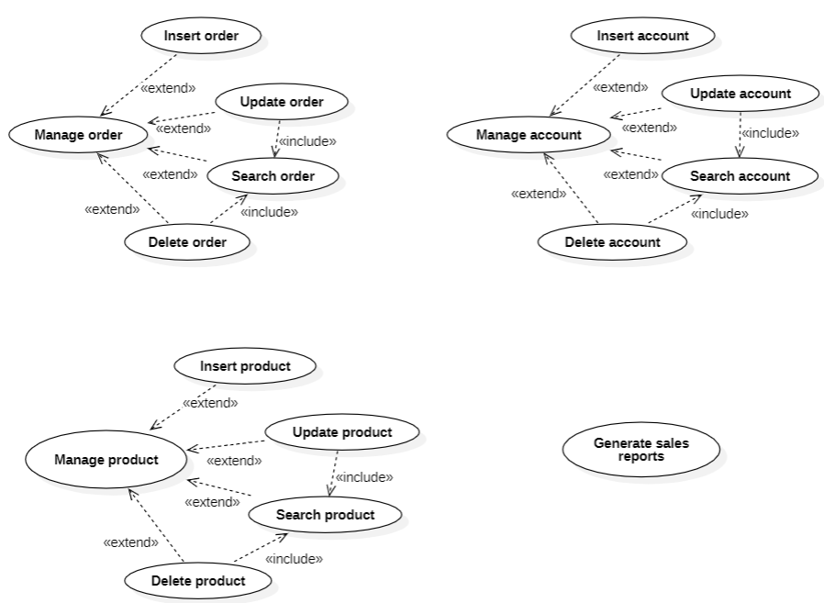

Diagram 2: Detailed Use Case Diagram of Administrator

### 3.1.2. Customer

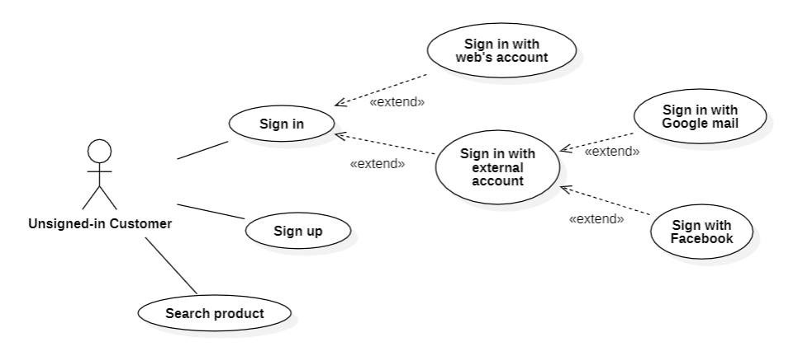

Diagram 3: Use Case Diagram of Unsigned-in Customer

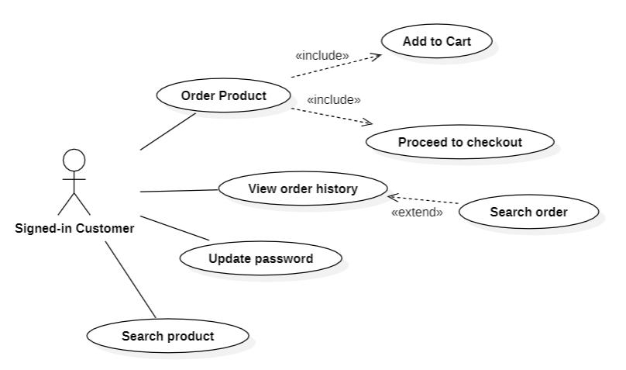

Diagram 4: Use Case Diagram of Signed-in Customer

### 3.1.3. List of actors

|  |  |  |
| --- | --- | --- |
| **Index** | **Actors** | **Meaning** |
| 1 | Administrator | People manage the system. |
| 2 | Customer | People use partial system’s services |
| 3 | Unsigned-in customer | People can sign in / sign up to use all the system’s  services |
| 4 | Signed-in customer | People is signed-in to system |

### 3.1.4. List of Use-case

|  |  |  |
| --- | --- | --- |
| **Role** | **Use Case** | **Meaning** |
| Customer’s Role | Sign up | Sign up for membership |
| Sign in | Sign in for using services |
| Search Product | Search information such as product name ,type... |
| Proceed to checkout | Create order and payment |
| Add to cart | A customer add item into their cart |
| Admin’s Role | Sign In | Sign in for using services |
| Manage Order | Insert/Update/Delete Order |
| Manage Product | Insert/Update/Delete Product |
| Manage Account | Insert/Update/Delete Account |
| Generates Sale Report | An administrator generates a sales report. |

## Use-case specification and activity diagram (Activity Diagram)

### Sign in

|  |  |
| --- | --- |
| Use case name | Sign in |
| Description | This use case describes how a customer logs in using their account. |
| Trigger | The customer clicks “Sign in” or “Log in” button. |
| Pre-conditions | User devices must have access to the Internet.  A customer account exists. |
| Post-conditions | The customer is redirected to the home page.  Customer account information is stored in the database if they log in with their external account first time.  Customer account login status is stored. |
| Normal flows | 1. The system displays the sign-up page. 2. The customer enters and chooses one of the following functions:  * If they choose to sign in with a web account, the sub-flow A. Sign in with a web account is performed. * If they choose to sign in with Facebook, the sub-flow B. Sign in with Facebook is performed. * If they choose to sign in with Facebook, the sub-flow B. Sign in with gmail is performed. |
| Sub flows | 1. **Sign in with a web account.** 2. The system displays the sign-up page. 3. The customer enters account information. 4. The system validates the format of the information entered by the customer. 5. The system checks the triggers and constraints in the database. 6. The system stores login status. 7. The system sends a success message and redirects to the home page 8. **Sign in with Facebook** 9. The system displays a sign-in page. 10. The customer clicks the "Sign in with Facebook" button. 11. The system checks if a customer account logged in with Facebook exists. 12. The system displays the Facebook page. 13. The system displays a message to ask customer permission to access their account. 14. The customer clicks "continue" or "cancel". 15. The system stores data. 16. The system stores login status. 17. The system displays a success message and redirects to the home page. 18. **Sign in with Facebook** 19. The system displays a sign-in page. 20. The customer clicks the "Sign in with Facebook" button. 21. The system checks if a customer account logged in with Facebook exists. 22. The system displays the Facebook page. 23. The system displays a message to ask customer permission to access their account. 24. The customer clicks "continue" or "cancel". 25. The system stores data. 26. The system stores login status. 27. The system displays a success message and redirects to the home page. |
| Alternative flows | 1. **Sign in with web account:**   3a. The system displays an error message due to incorrect format. This use case continues with step 3.  4a. The system displays an error message due to violating constraints. This use case continues with step 3.   1. **Sign in with Facebook:**   3a. If the customer account logged in with Facebook exists, the system displays a success message and redirects to the home page. This use case ends here.  7a. If the customer clicks cancel, the system redirects to the sign-in page and displays an error message. This use case ends here.   1. **Sign in with Gmail:**   3a. If the customer account logged in with Gmail exists, the system displays a success message and redirects to the home page. This use case ends here.  7a. If the customer clicks cancel, the system redirects to the sign-in page and displays error message. This use case ends here. |

# 

### 3.2.1.1 Sign in with external account

### 3.2.1.1.1. Sign in with Facebook

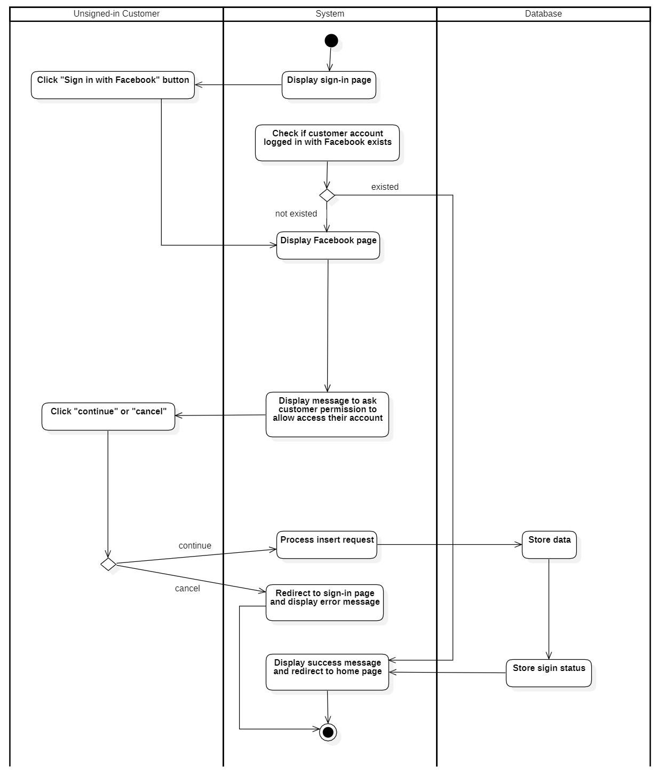

Diagram 5: Activity Diagram of Sign in with Facebook

### 3.2.1.1.2. Sign in with gmail

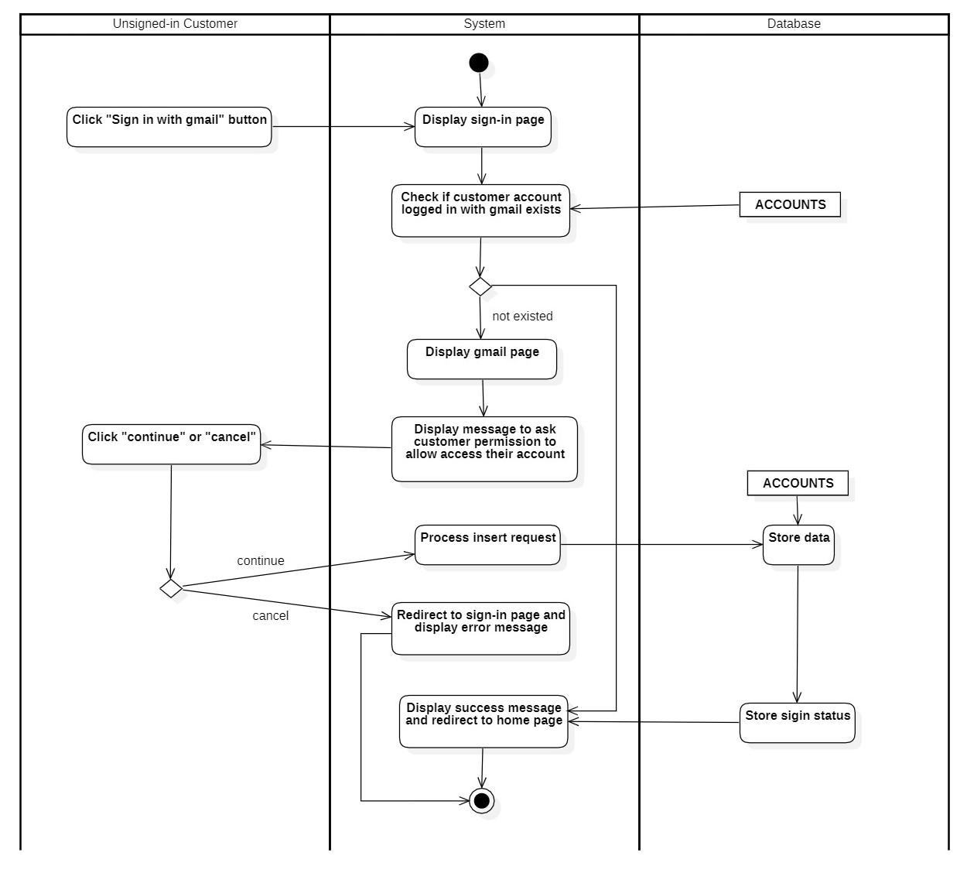

Diagram 6: Activity Diagram of Sign in with gmail

### 3.2.1.2. Sign in with web account

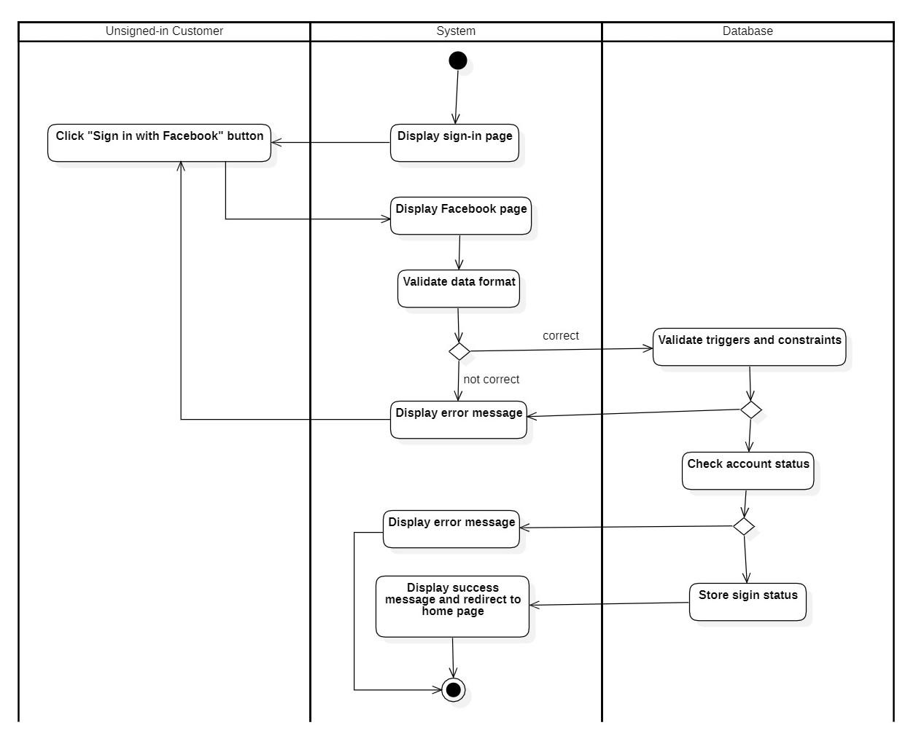

Diagram 7: Activity Diagram of Sign in with web account

### Sign up

|  |  |
| --- | --- |
| Use case name | Sign up |
| Description | This use case describes how a customer creates an account. |
| Trigger | The customer clicks “Sign up” or “Create an account” button. |
| Pre-conditions | User devices must have access to the Internet. |
| Post-conditions | Customer account information is stored in the database. |
| Normal flows | 1. The customer clicks “Sign up” or “Create an account” button. 2. The system displays the sign-up page. 3. The customer enters account information. 4. The system validates the format of the information entered by the customer. 5. The system checks the triggers and constraints in the database. 6. The system stores the account information in the database. 7. The system sends verification mail to the customer email provided in the database. 8. The system displays success message. |
| Sub flows |  |
| Alternative flows | 4a. The system displays an error message due to incorrect format. This use case continues with step 3.  5a. The system displays an error message due to violating constraints. This use case continues with step 3. |

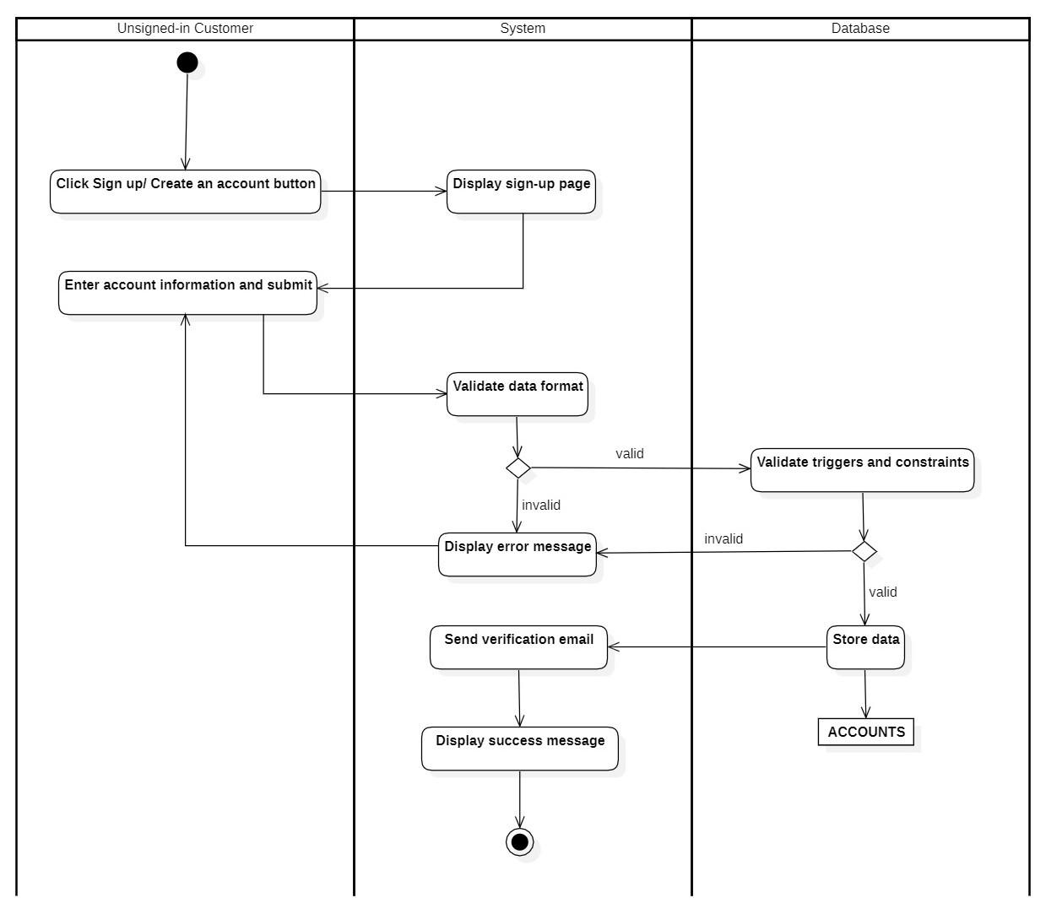

Diagram 8: Activity Diagram of Sign up

### Add to cart

|  |  |
| --- | --- |
| **Use case name** | **Add to cart** |
| Description | This use case describes how a customer adds products to a cart. |
| Trigger | The customer needs to choose the add-to-cart function. |
| Pre-conditions | User devices must have access to the Internet.  The user logs into the system with the customer role. |
| Post-conditions | Cart information is updated with product information in the database. |
| Normal flows | 1. The system displays a product information page.  2. The customer enters the information about the products needed to buy.  3. The system processes search requests.  4. The system executes the product information query.  5. The system displays the list of found products.  6. The customer chooses one of the displayed products.  7. The customer clicks the “Add to Cart” or increase/decrease quantity button.  8. The system checks whether the product quantity is zero or not.  9. The system updates the cart with selected product information.  10. The system displays a success message. |
| Sub flows |  |
| Alternative flows | 4a. The system displays a message no products are found. This use case continues with step 2.  9a. If the product quantity is equal to zero, the system displays the product is out of stock message. This use case ends here. |

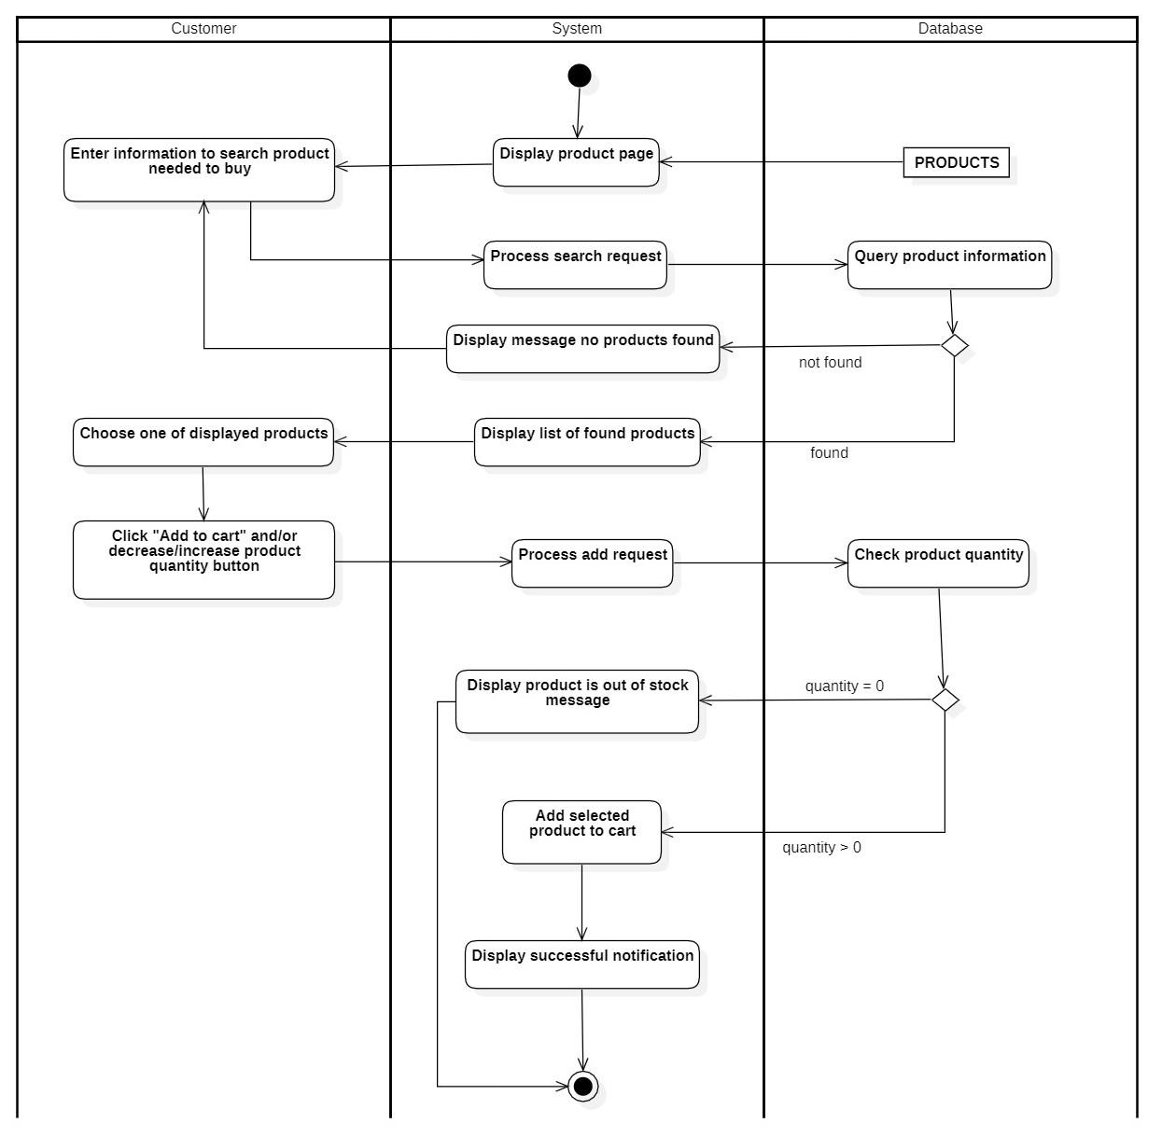

Diagram 9: Activity Diagram of Add to cart

### Proceed to checkout

|  |  |
| --- | --- |
| Use case name | Proceed to checkout |
| Description | This use case describes how a customer confirms their order. |
| Trigger | The customer needs to click the “proceed to checkout” button. |
| Pre-conditions | User devices must have access to the Internet.  The user logs into the system with the customer role. |
| Post-conditions | Product quantity is updated in the database.  Purchase order information is stored in the database. |
| Normal flows | 1. The system displays the product page.  2. The user clicks the Cart button/icon.  3. The system displays a Cart page.  4. The customer clicks “proceed to checkout” or “continue shopping”.  5. The system displays the checkout page.  6. The customer enters billing details information and submits.  7. The system validates the data format entered by the user.  8. The system validates the triggers and constraints in the database.  9. The system stores billing details data and updates product quantity.  10. The system displays successful notifications. |
| Sub flows |  |
| Alternative flows | 4a. If the customer clicks “continue shopping”, the system will redirect to the product page. This use case ends here.  7a. The system displays an error message due to incorrect format This use case continues with step 6.  7b. The system displays an error message due to violating constraints. This use case continues with step 6. |

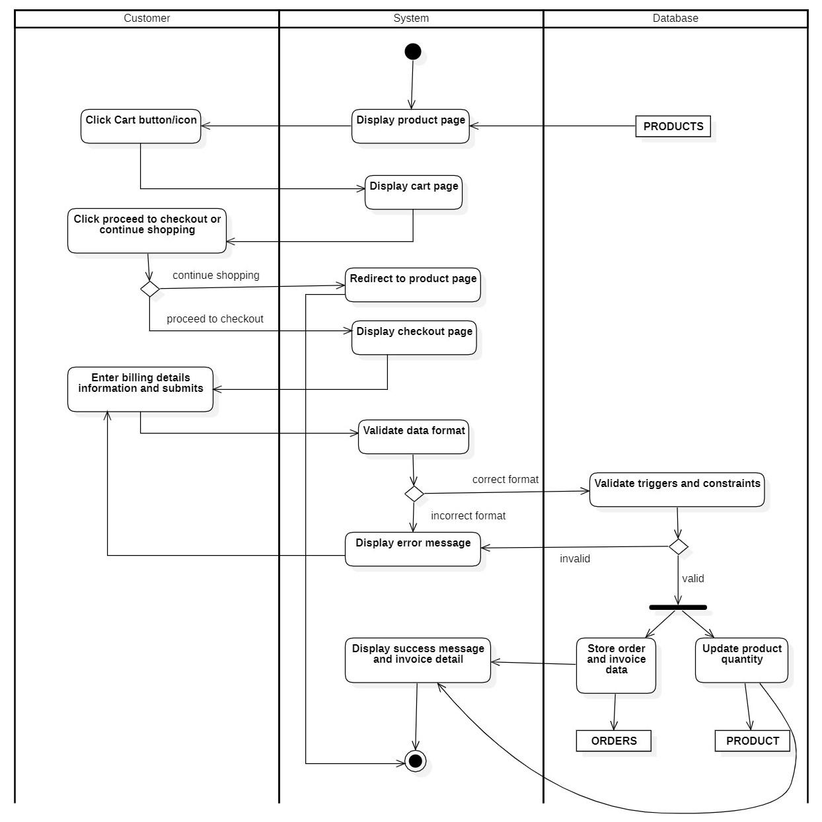

Diagram 10: Activity Diagram of Proceed to checkout

### Update password

|  |  |
| --- | --- |
| Use case name | Update password |
| Description | This use case is used for describing how customer updates passwords. |
| Trigger | The customer needs to choose the update password function. |
| Pre-conditions | User devices must have access to the Internet.  The user logs into the system with the customer role. |
| Post-conditions | A new password is stored in the database. |
| Normal flows | 1. The user clicks the "Forgot password/Change password" button. 2. The system displays the change password page. 3. The user enters their email and submits it to the system. 4. The system checks if the submitted email matches with email in the database. 5. The system sends a verification email with a URL to the customer's mailbox. 6. The user clicks the URL within the mail sent by the system. 7. The system redirects to the change password page. 8. The user Enter a new password and submit it to the system. 9. The system validates the format of the information entered by the user. 10. The system checks the triggers and constraints in the database. 11. The system stores the account information in the database. 12. The system notifies a successful editing of the product. 13. The system displays the account management page with new product data from the database. |
| Sub flows |  |
| Alternative flows | 4a. The system displays an error message due to email doesn’t match with the email in the database. This use case continues with step 3.  9a. The system displays an error message due to incorrect format. This use case continues with step 8.  10a. The system displays an error message due to violating constraints. This use case continues with step 8. |

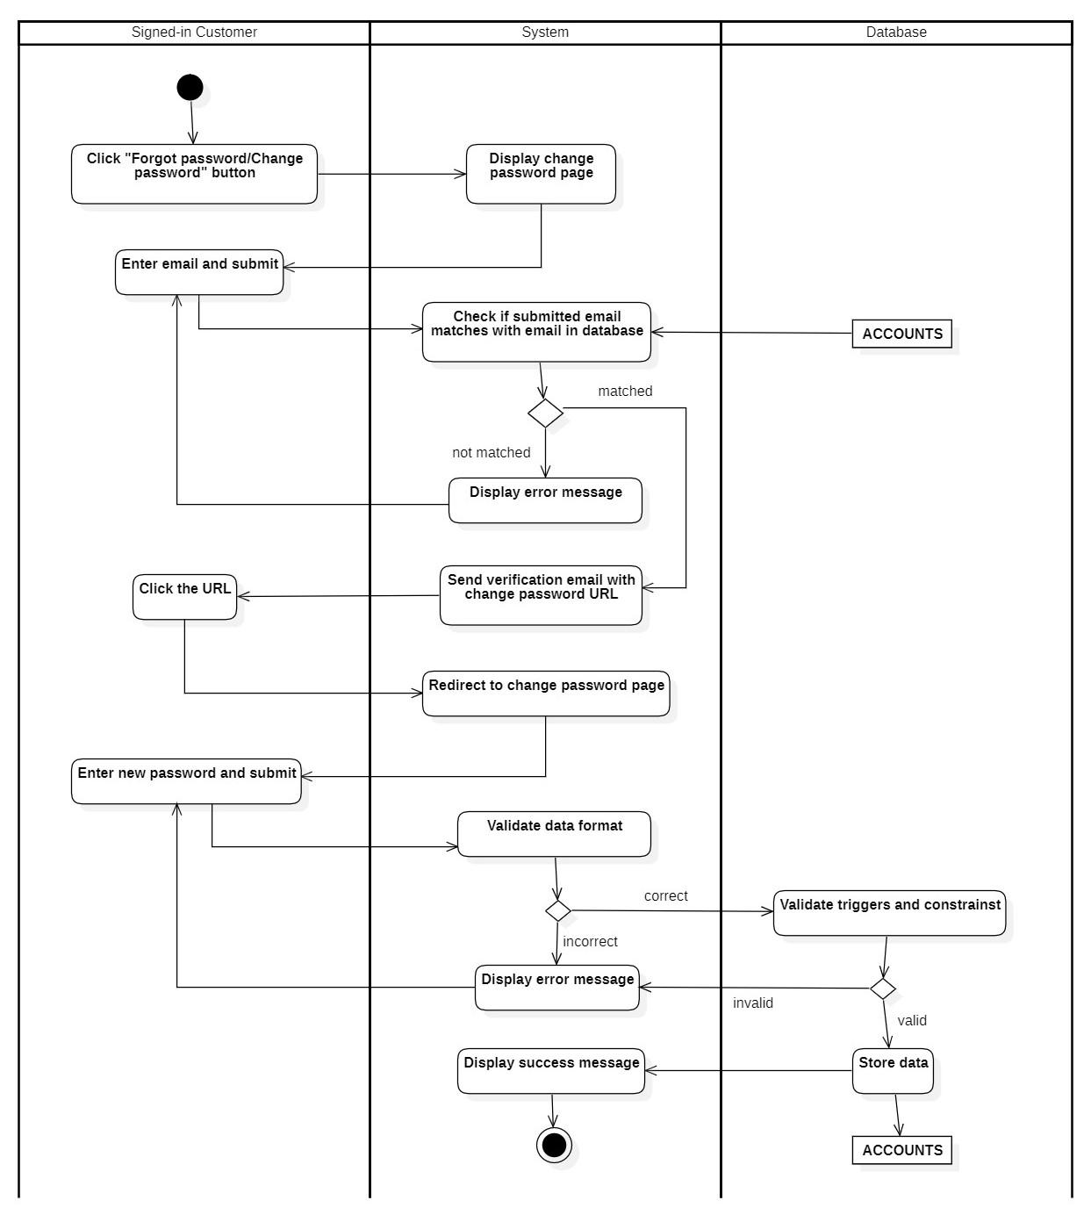

Diagram 11: Activity Diagram of Update password

### Search product (Customer)

|  |  |
| --- | --- |
| Use case name | Search product (customer) |
| Description | This use case is used for describing how a customer (both Signed-in and Unsigned-in) searches for products. |
| Trigger | The customer needs to choose the search products function. |
| Pre-conditions | User devices must have access to the Internet.  The user logs into the system with the customer role. |
| Post-conditions | The page displays search results. |
| Normal flows | 1. The system displays product page. 2. The customer enters the keywords of the product information. 3. The system processes the search request from the customer. 4. The system checks the product information in the database that matches the search request. 5. The system displays product information in the database that matches the search request. |
| Sub flows |  |
| Alternative flows | 3. The system displays a no information found message due to no data in the database that matches the search request. This use case ends the search process. |

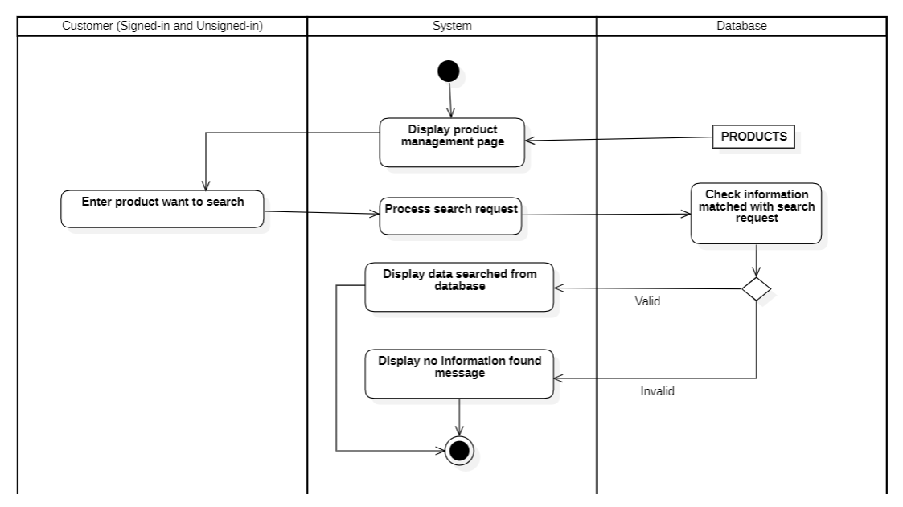

Diagram 12: Activity Diagram of Search product (customer)

### Search order (Customer)

|  |  |
| --- | --- |
| Use case name | Search order (customer) |
| Description | This use case is used for describing how a customer (Signed-in) searches for products. |
| Trigger | The customer needs to choose the search order function. |
| Pre-conditions | User devices must have access to the Internet.  The user logs into the system with the customer role. |
| Post-conditions | The page displays search results. |
| Normal flows | 1. The system displays the order history page. 2. The customer enters the keywords of the order information. 3. The system processes the search request from the customer. 4. The system checks the product information in the database that matches the search request. 5. The system displays product information in the database that matches the search request. |
| Sub flows |  |
| Alternative flows | 3. The system displays a no information found message due to no data in the database that matches the search request. This use case ends the search process. |

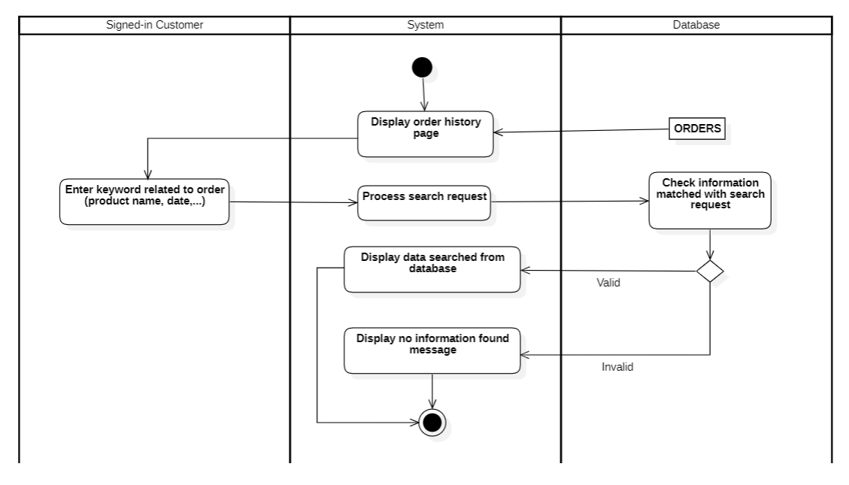

Diagram 13: Activity Diagram of Search order (customer)

### Generate sales report

|  |  |
| --- | --- |
| Use case name | Generate sales report |
| Description | This use case describes how an administrator generates a sales report. |
| Trigger | The administrator needs to select the Generate a Sales Report function |
| Pre-conditions | User devices must have access to the Internet. |
| Post-conditions | A report is generated and downloaded to the administrator’s PC. |
| Normal flows | 1. The system displays a report generator page with product and order information. 2. The administrator chooses the report criteria they want (product type, period,...) 3. The system displays the report with the selected report criteria. 4. The administrator chooses a default report format on the website or a redefined format from their PC. 5. The system displays the report in the selected format. 6. The administrator clicks the "generate report" button. 7. The system displays a confirm dialog. 8. The administrator confirms generating the report. 9. The system generates the report.   10. The system displays a success message and downloads the report pdf file to user's PC |
| Sub flows |  |
| Alternative flows | 4a. The system displays an error message due to incorrect format. This use case continues with step 3.  5a. The system displays an error message due to violating constraints. This use case continues with step 3. |

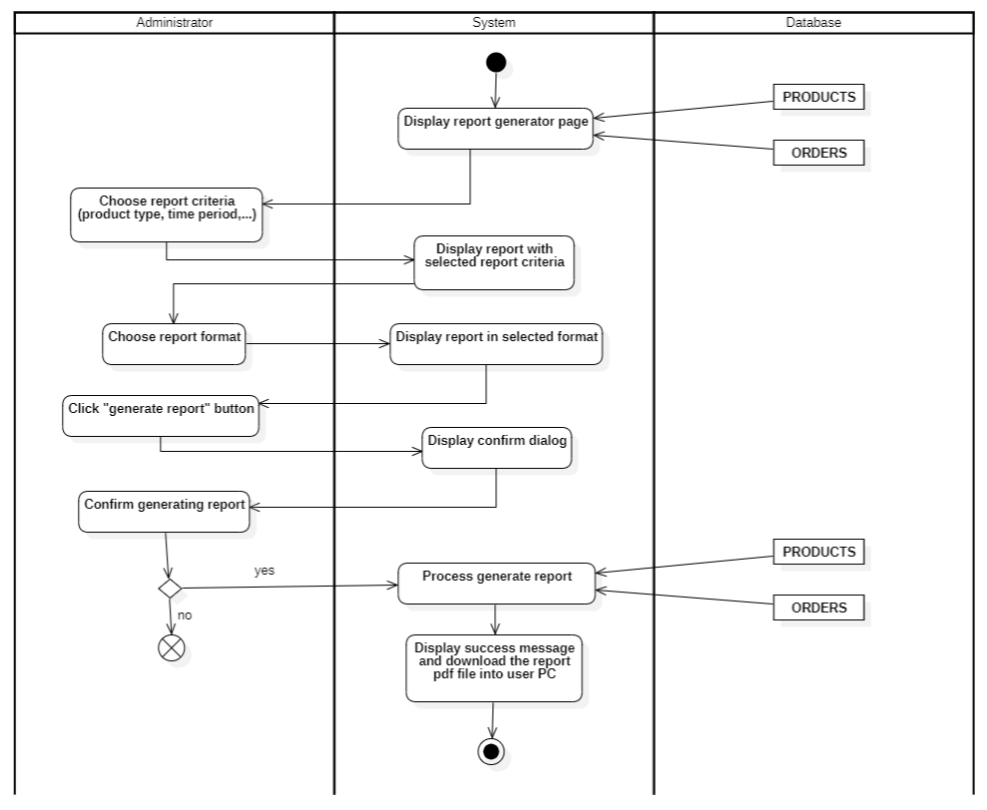

Diagram 14: Activity Diagram of Search order (customer)

### Manage product

|  |  |
| --- | --- |
| Use case name | Manage product |
| Description | This use case is used for describing how Administrators add, update, delete, and search products. |
| Trigger | The Administrator needs to choose the management function to add, update, delete, and search products. |
| Pre-conditions | User devices must have access to the Internet.  The user logs into the system with the Administrator role. |
| Post-conditions | The product is stored in the database.  The data on the product management page is reloaded with new data from the database. |
| Normal flows | 1. The system displays the product management user interface with data queried from the database.  2. The administrator chooses one of the following functions:  a. If they choose a function to add a new product: the S1-add product sub-flow is performed.  b. If they choose a function to update a product: the S2-update product sub-flow is performed.  c. If they choose a function to delete a product: the S3-delete product sub-flow is performed.  d. If they choose a function to search a product: the S4-search product sub-flow is performed. |
| Sub flows | - **S1 – Add product:**  S1.1. The system displays the product information with the product ID queried from the database.  S1.2. The administrator enters the product information and confirms for creation of a new product.  S1.3. The system validates the format of the information entered by the user.  S1.4. The system checks the triggers and constraints in the database.  S1.5. The system stores the product information in the database.  S1.6. The system displays a successful notification. (The system notifies the successful creation of the new product.)  S1.7. The system displays the product management page with new product data from the database.  - **S2 – Update product:**  S2.1. The Administrator chooses one product to edit information.  S2.2. The system displays the product information with product ID queried from the database.  S2.3. The Administrator modifies the product information and confirms for creation of a new product.  S2.4. The system validates the format of the information entered by the user.  S2.5. The system checks the triggers and constraints in the database.  S2.6. The system stores the product information in the database.  S2.7. The system notifies a successful editing of the product.  S2.8. The system displays the product management page with new product data from the database.  - **S3 – Delete product:**  S3.1.The Administrator chooses one product to delete.  S3.2. The system displays a confirm dialog.  S3.3. The Administrator confirms the deletion.  S3.4. The system processes the deletion request from the Administrator.  S3.5. The system checks the triggers and constraints in the database.  S3.6. The system stores the product information in the database.  S3.7. The system notifies a successful deletion notification.  S3.8. The system displays the product management page with new product data from the database.  - **S4 – Search product:**  S4.1.The Administrator enters keywords of the product information.  S4.2. The system processes the search request from the Administrator.  S4.3. The system checks the product information in the database that matches the search request.  S4.4. The system displays product information in the database that matches the search request. |
| Alternative flows | - **S1 – Add product:**  S1.3a. The system displays an error message due to incorrect format This use case continues with step S1.2.  S1.4a. The system displays an error message due to violating constraints. This use case continues with step S1.2.  - **S2 – Update product:**  S2.4a. The system displays an error message due to incorrect format. This use case continues with step S2.3.  S2.5a. The system displays an error message due to violating constraints. This use case continues with step S2.3.  - **S3 – Delete product:**  S3.5a. The system displays an error message due to violating constraints. This use case ends the deletion process.  - **S4 – Search product:**  S4.3a. The system displays a no information found message due to no data in the database that matches the search request. This use case ends the search process. |

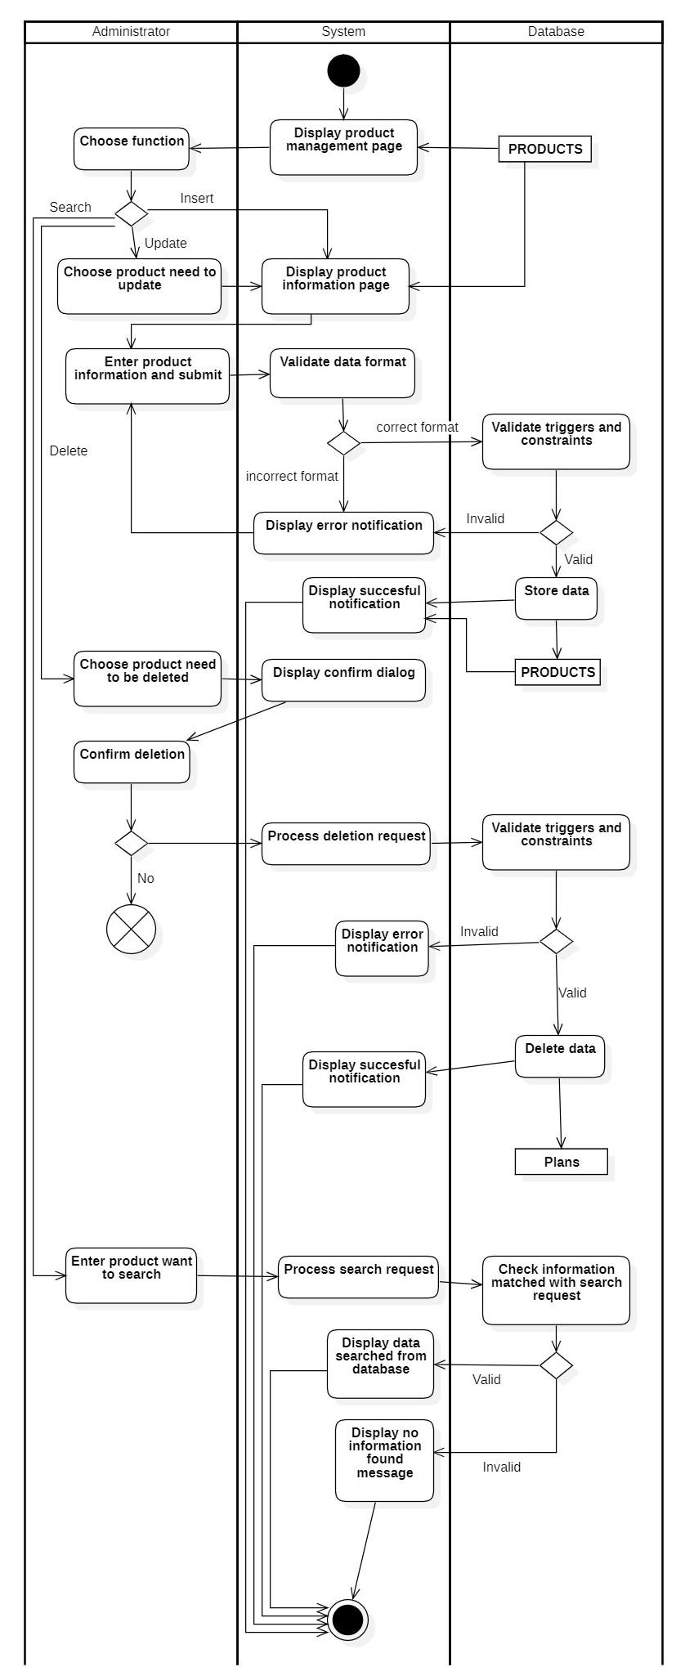

Diagram 15: Activity Diagram of Manage product

### Manage account

|  |  |
| --- | --- |
| **Use case name** | **Manage account** |
| Description | This use case is used for describing how Administrators add, update, delete, and search accounts. |
| Trigger | The administrator needs to choose the management function to add, update, delete, and search accounts. |
| Pre-conditions | User devices must have access to the Internet.  The user logs into the system with the administrator role. |
| Post-conditions | The account is stored in the database.  The data on the account management page is reloaded with new data from the database. |
| Normal flows | 1. The system displays the account management user interface with data queried from the database. 2. The administrator chooses one of the following functions:  * If they choose a function to add a new account: the S1-add account sub-flow is performed. * If they choose a function to update an account: the S2-update account sub-flow is performed. * If they choose a function to delete an account: the S3-delete account sub-flow is performed. * If they choose a function to search an account: the S4-search account sub-flow is performed. |
| Sub flows | * **S1 – Add account:**   S1.1. The system displays the account information with the account ID queried from the database.  S1.2. The administrator enters the account information and confirms for creation of a new account.  S1.3. The system validates the format of the information entered by the user.  S1.4. The system checks the triggers and constraints in the database.  S1.5. The system stores the account information in the database.  S1.6. The system displays a successful notification. (The system notifies the successful creation of the new product.)  S1.7. The system displays the account management page with new product data from the database.   * **S2 – Update account:**   S2.1. The Administrator chooses one account to edit information.  S2.2. The system displays the account information with the account ID queried from the database.  S2.3. The Administrator modifies the account information and confirms for creation of a new account.  S2.4. The system validates the format of the information entered by the user.  S2.5. The system checks the triggers and constraints in the database.  S2.6. The system stores the account information in the database.  S2.7. The system notifies a successful editing of the product.  S2.8. The system displays the account management page with new product data from the database.   * **S3 – Delete product:**   S3.1.The Administrator chooses one account to delete.  S3.2. The system displays a confirm dialog.  S3.3. The Administrator confirms the deletion.  S3.4. The system processes the deletion request from the Administrator.  S3.5. The system checks the triggers and constraints in the database.  S3.6. The system stores the account information in the database.  S3.7. The system notifies a successful deletion notification.  S3.8. The system displays the account management page with new product data from the database.   * **S4 – Search product:**   S4.1.The Administrator enters keywords of the account information.  S4.2. The system processes the search request from the Administrator.  S4.3. The system checks the account information in the database that matches the search request.  S4.4. The system displays account information in the database that matches the search request. |
| Alternative flows | * **S1 – Add product:**   S1.3a. The system displays an error message due to incorrect format This use case continues with step S1.2.  S1.4a. The system displays an error message due to violating constraints. This use case continues with step S1.2.   * **S2 – Update product:**   S2.4a. The system displays an error message due to incorrect format. This use case continues with step S2.3.  S2.5a. The system displays an error message due to violating constraints. This use case continues with step S2.3.   * **S3 – Delete product:**   S3.5a. The system displays an error message due to violating constraints. This use case ends the deletion process.   * **S4 – Search product:**   S4.3a. The system displays a no information found message due to no data in the database that matches the search request. This use case ends the search process. |

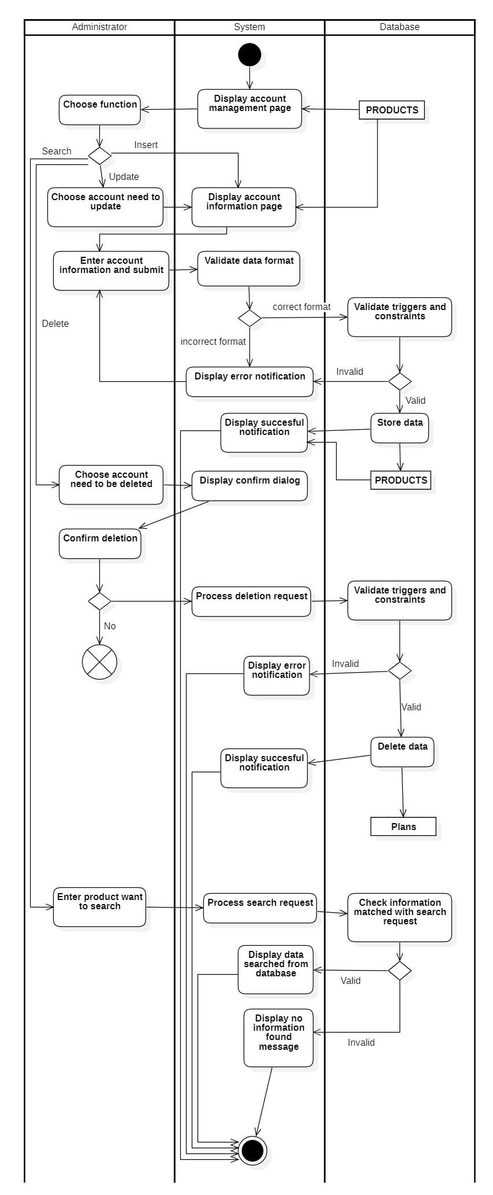

Diagram 16: Activity Diagram of Manage account

### 3.2.11. Manage order

|  |  |
| --- | --- |
| **Use case name** | **Manage Order** |
| Description | This use case is used for describing how Administrators add, update, delete, and search orders. |
| Trigger | The administrator needs to choose the management function to add, update, delete, and search orders. |
| Pre-conditions | User devices must have access to the Internet.  The user logs into the system with the administrator role. |
| Post-conditions | The order is stored in the database.  The data on the ordermanagement page is reloaded with new data from the database. |
| Normal flows | 1. The system displays the order management user interface with data queried from the database. 2. The administrator chooses one of the following functions: 3. If they choose a function to add a new order: the S1-add order sub-flow is performed. 4. If they choose a function to update an order : the S2-update order sub-flow is performed. 5. If they choose a function to delete an order : the S3-delete order duct sub-flow is performed. 6. If they choose a function to search an order : the S4-search order sub-flow is performed. |
| Sub flows | * **S1 – Add order:**   S1.1. The system displays the creation order information form.  S1.2. The administrator enters the order information and confirms the creation of a new order .  S1.3. The system validates the format of the information entered by the administrator .  S1.4. The system checks the triggers and constraints in the database.  S1.5. The system stores the order information in the database.  S1.6. The system displays a successful notification. (The system notifies the successful creation of the new order .)  S1.7. The system displays the order management page with new order data from the database.   * **S2 – Update order :**   S2.1. The Administrator chooses one order to edit information.  S2.2. The system displays the order information with order ID queried from the database.  S2.3. Administrators modify order information and confirm order updates.  S2.4. The system validates the format of the information entered by the user.  S2.5. The system checks the triggers and constraints in the database.  S2.6. The system stores the order information in the database.  S2.7. The system notifies a successful editing of the order .  S2.8. The system displays the order management page with new order data from the database.   * **S3 – Delete order :**   S3.1.The Administrator chooses one order to delete.  S3.2. The system displays a confirm dialog.  S3.3. The Administrator confirms the deletion.  S3.4. The system processes the deletion request from the Administrator.  S3.5. The system checks the triggers and constraints in the database.  S3.6. The system delete the order information in the database.  S3.7. The system notifies a successful deletion notification.  S3.8. The system displays the order management page with new product data from the database.   * **S4 – Search order :**   S4.1.The Administrator enters ID of the order information.  S4.2. The system processes the search request from the Administrator.  S4.3. The system checks the order information in the database that matches the search request.  S4.4. The system displays order information in the database that matches the search request. |
| Alternative flows | * **S1 – Add order :**   S1.3a. The system displays an error message due to incorrect format This use case continues with step S1.2.  S1.4a. The system displays an error message due to violating constraints. This use case continues with step S1.2.   * **S2 – Update order :**   S2.4a. The system displays an error message due to incorrect format. This use case continues with step S2.3.  S2.5a. The system displays an error message due to violating constraints. This use case continues with step S2.3.   * **S3 – Delete order :**   S3.3a. The user decides not to delete the order data . This use case ends the deletion process  S3.5a. The system displays an error message due to violating constraints. This use case ends the deletion process.   * **S4 – Search order :**   S4.3a. The system displays a no information found message due to no data in the database that matches the search request. This use case ends the search process. |

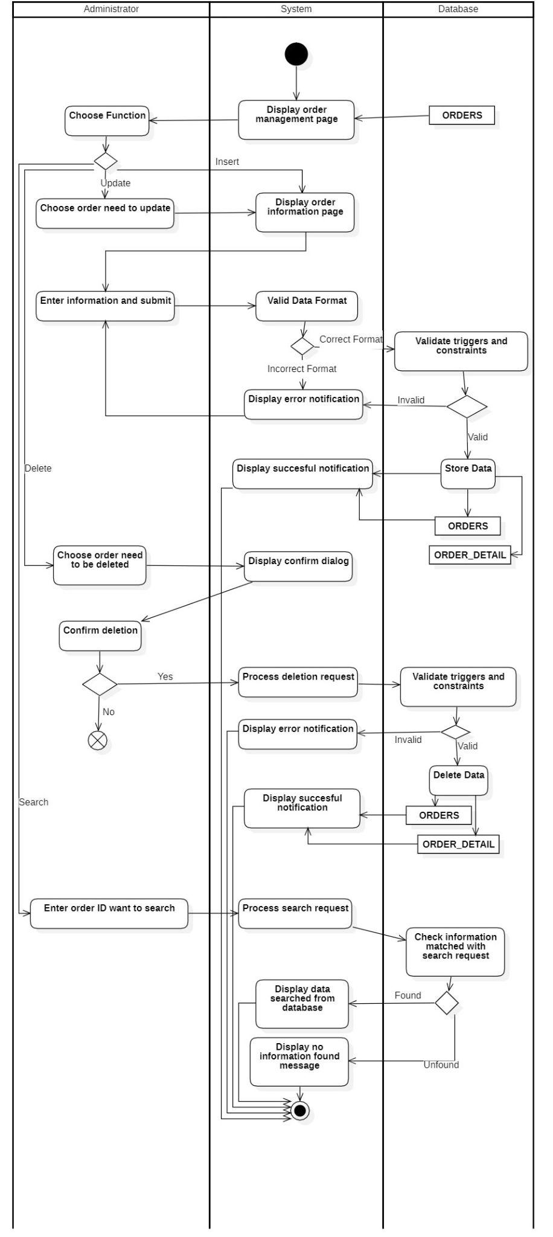

Diagram 17: Activity Diagram of Manage order

## Sequence Diagram and Class Diagram

### Sign in

### Sequence Diagram

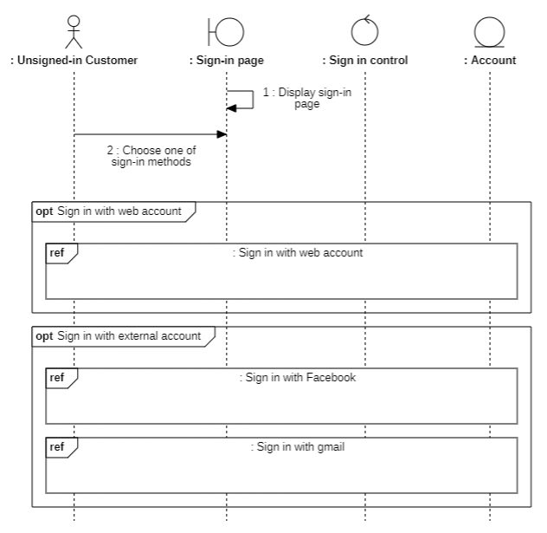

Diagram 18: Sequence Diagram of Sign in

**Sign in with external account**

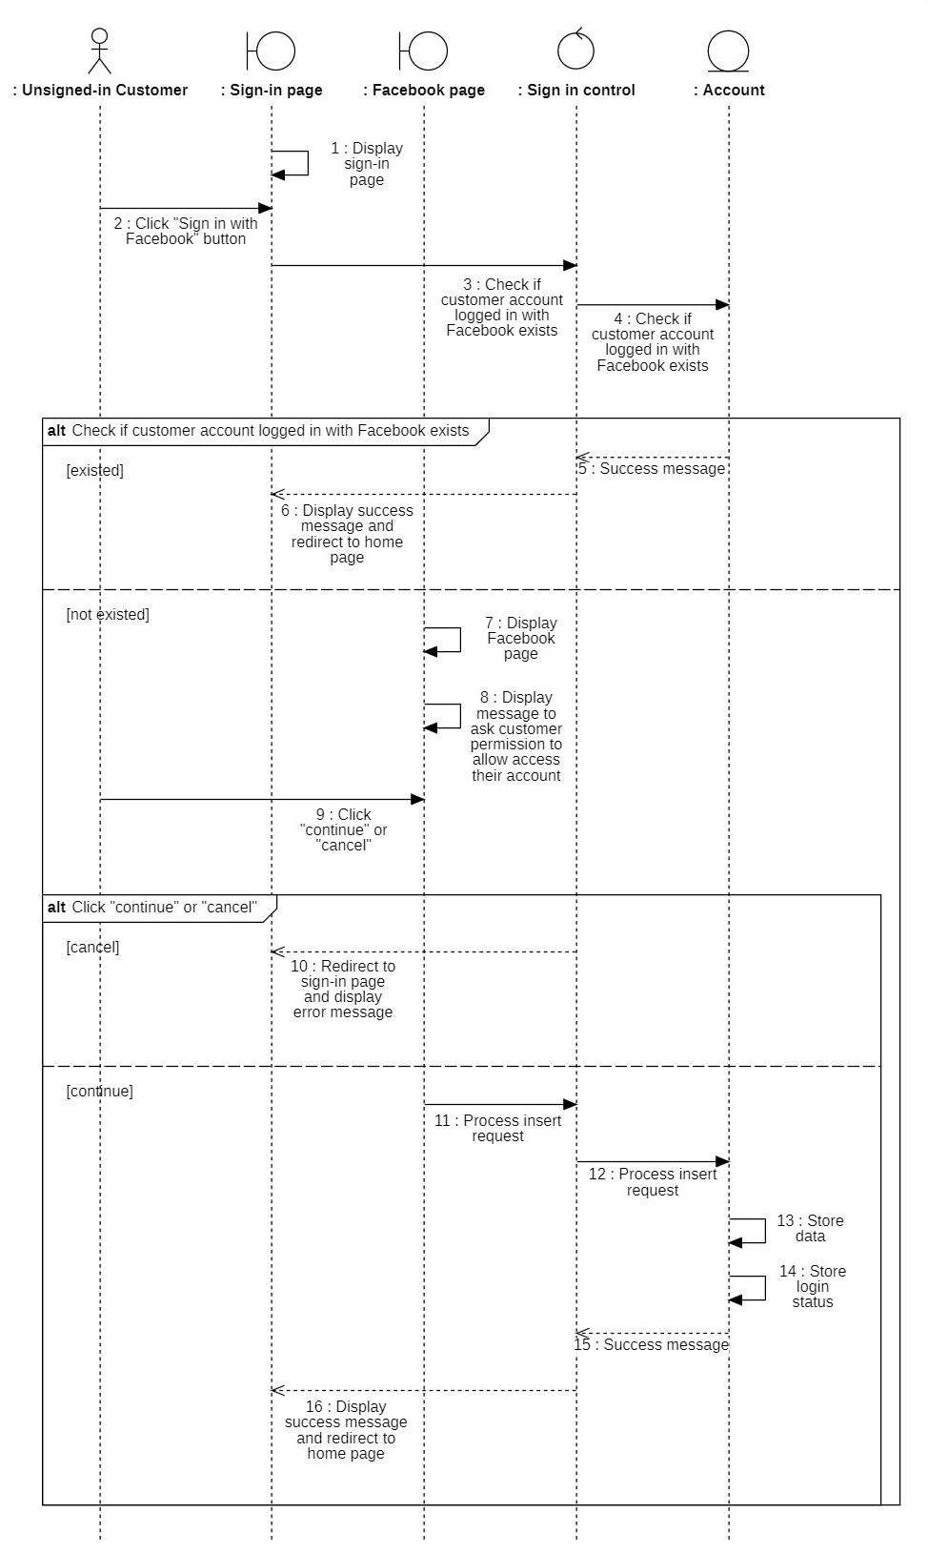

Diagram 19: Sequence Diagram of Sign in with Facebook

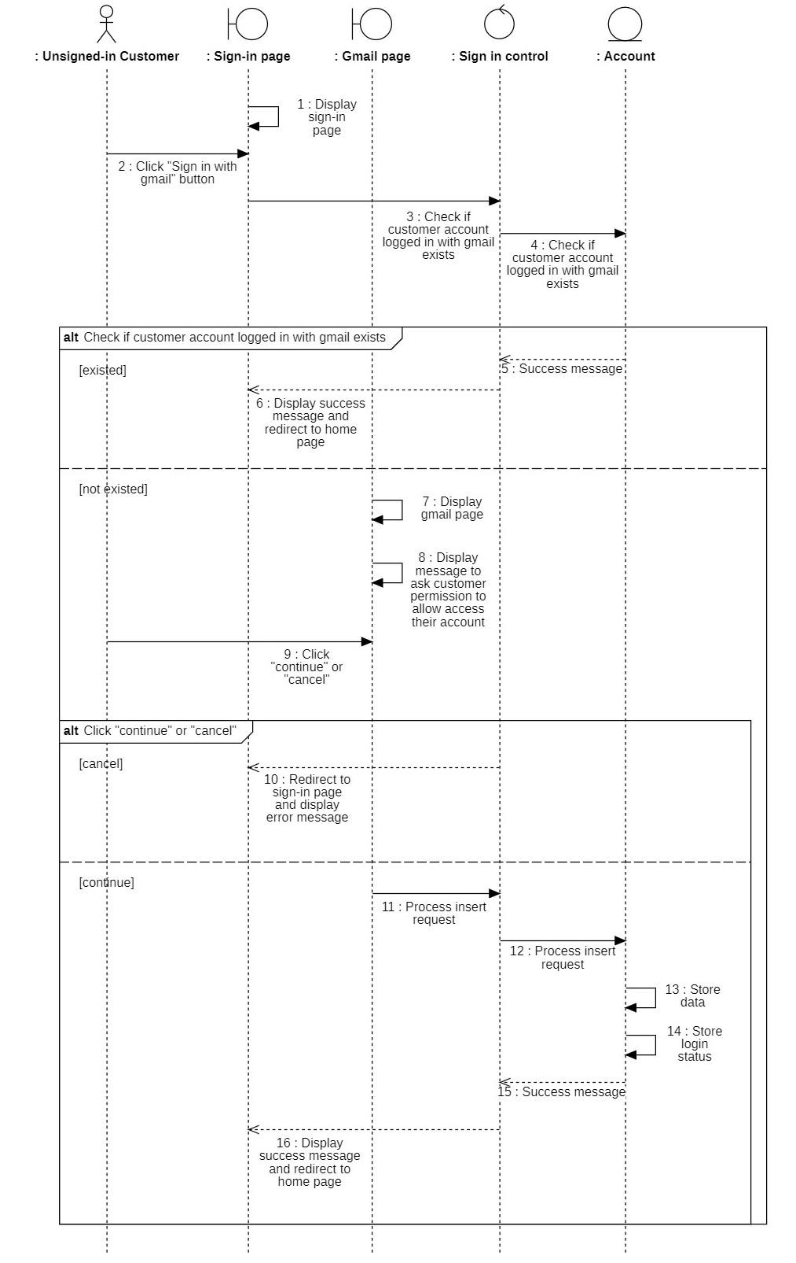

Diagram 20: Sequence Diagram of Sign in with gmail

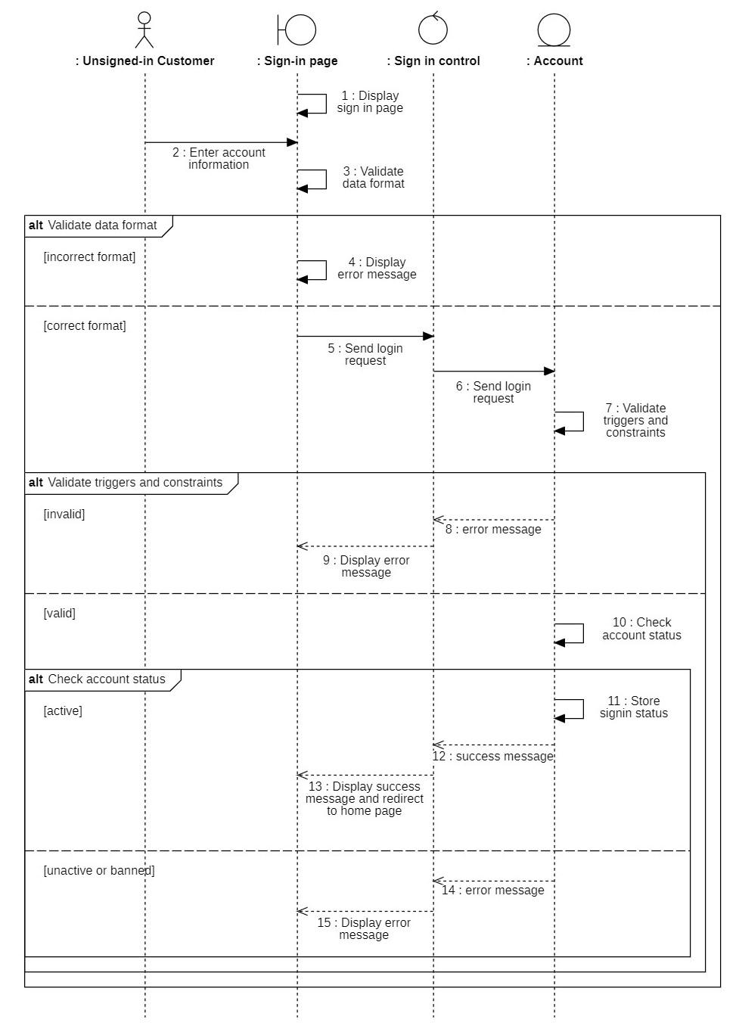

Diagram 21: Sequence Diagram of Sign in with web account

### 3.3.1.2. Class Diagram

**Sign in with external account**

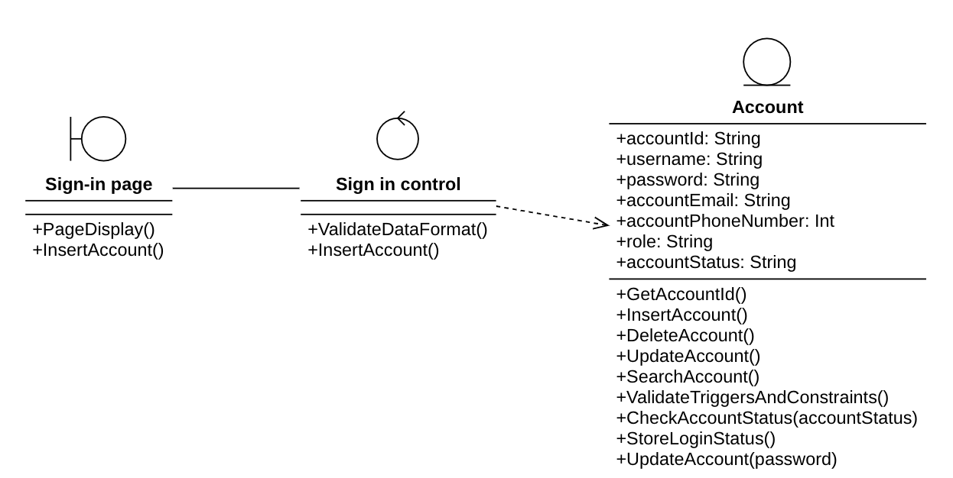

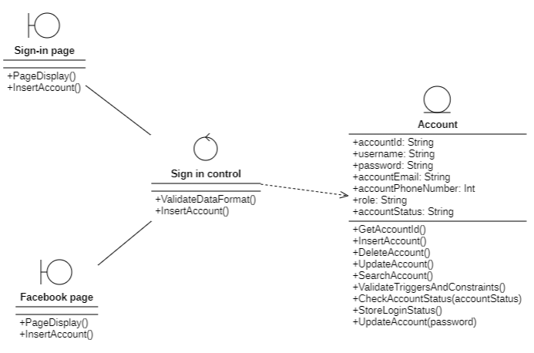

Diagram 22: Class Diagram of Sign in with Facebook

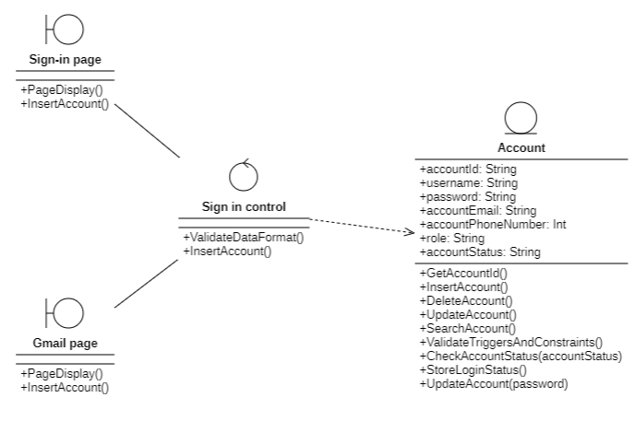

Diagram 23: Class Diagram of Sign in with gmail

**Sign in with web account**

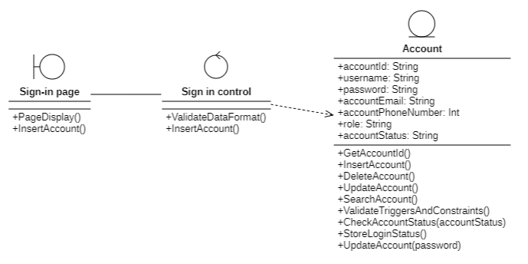

Diagram 24: Class Diagram of Sign in web account

### Sign up

### Sequence Diagram

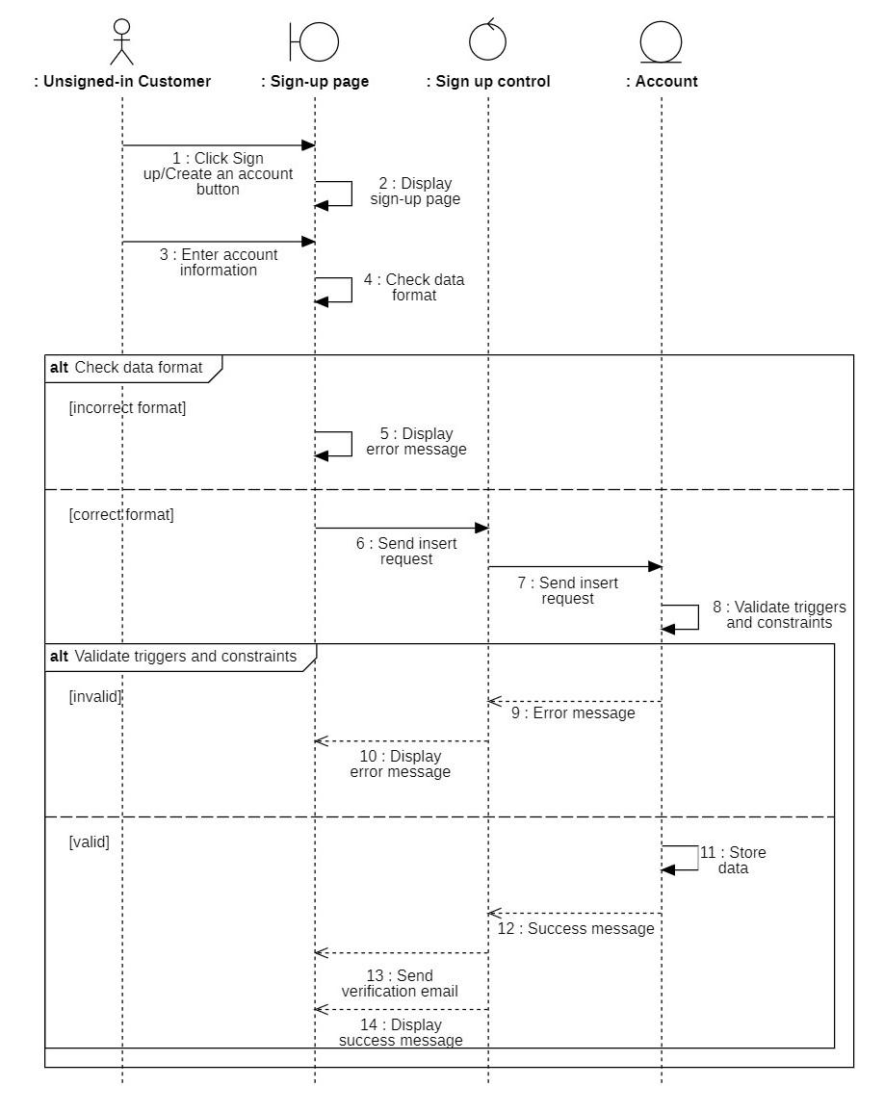

Diagram 25: Sequence Diagram of Sign up

### Class Diagram

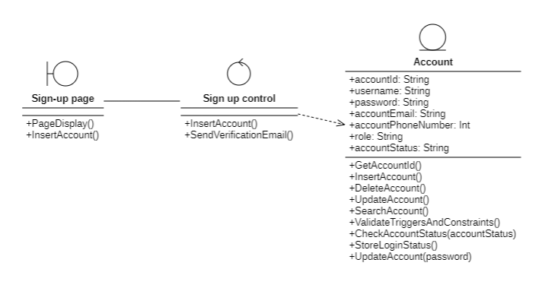

Diagram 26: Class Diagram of Sign up

### Add to Cart

### Sequence Diagram

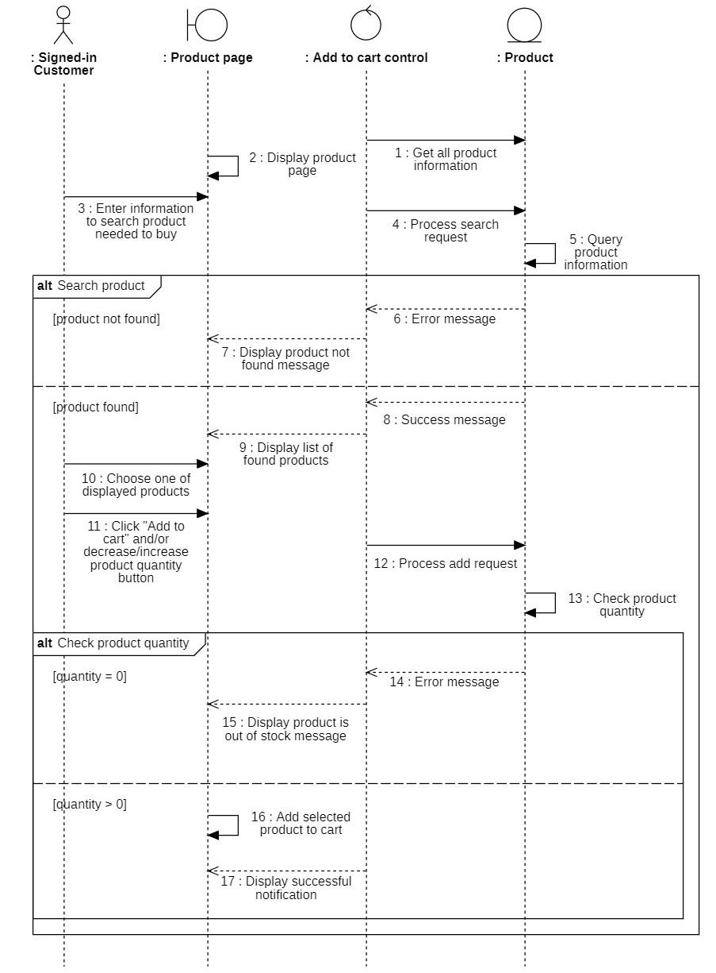

Diagram 27: Sequence Diagram of Add to cart

### Class Diagram

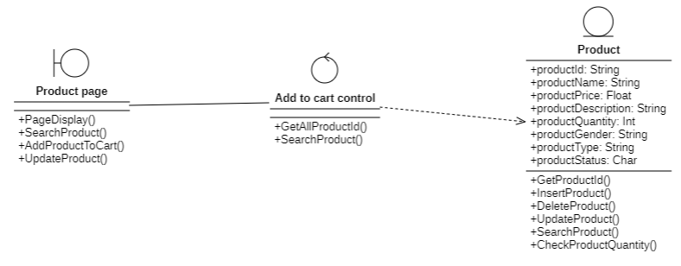

Diagram 28: Class Diagram of Add to cart

### Proceed to checkout

### Sequence Diagram

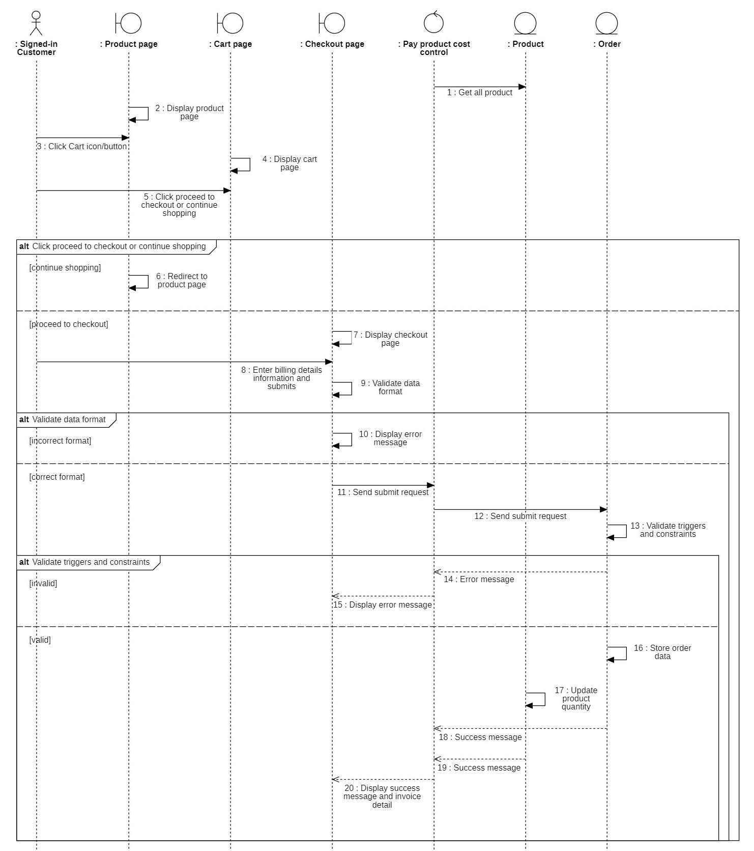

Diagram 29: Sequence Diagram of Proceed to checkout

### Class Diagram

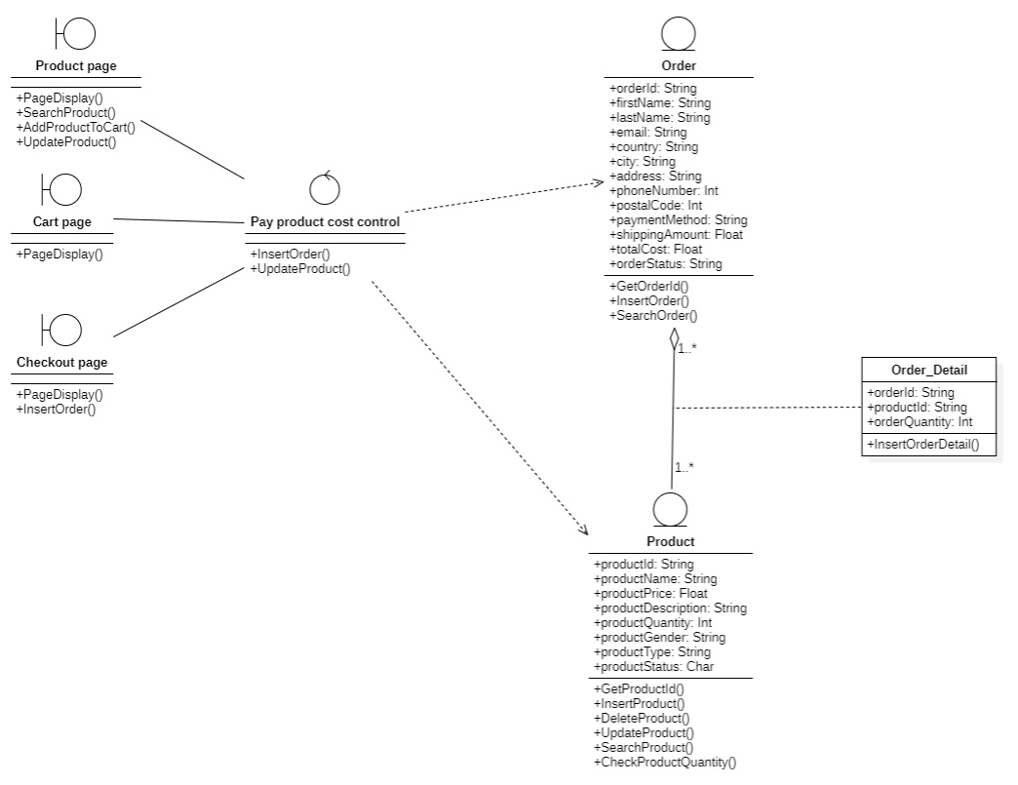

Diagram 30: Class Diagram of Proceed to checkout

### 3.3.5. Update password

### 3.3.5.1. Sequence Diagram

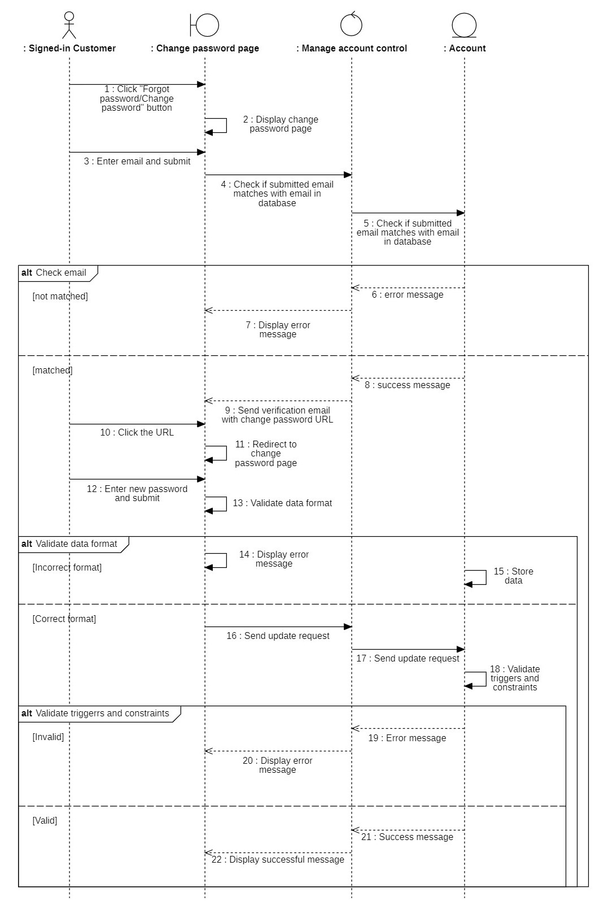

Diagram 31: Sequence Diagram of Update password

### 3.3.5.2. Class Diagram

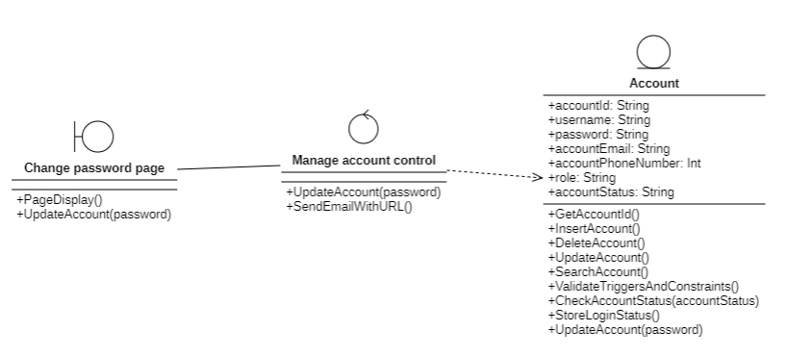

Diagram 32: Class Diagram of Update password

### 3.3.6. Search product (Customer)

### 3.3.6.1. Sequence diagram

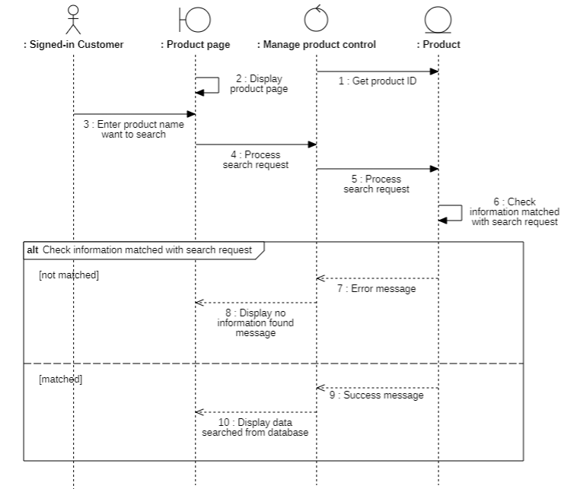

Diagram 33: Sequence Diagram of Search product (Signed-in Customer)

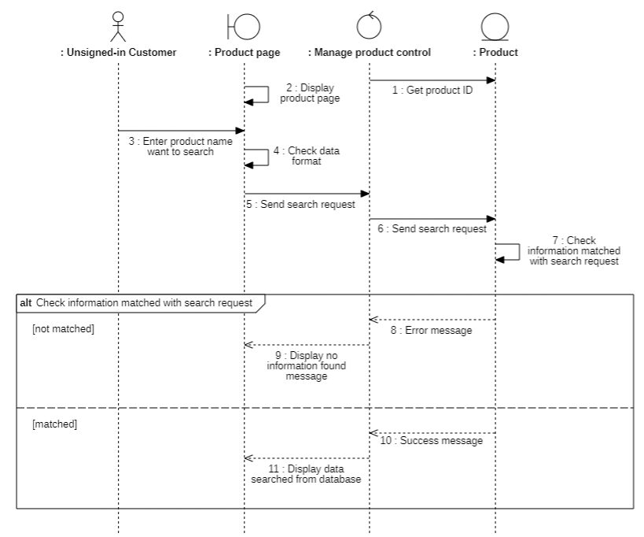

Diagram 34: Sequence Diagram of Search product (Signed-in Customer)

### 3.3.6.2. Class diagram

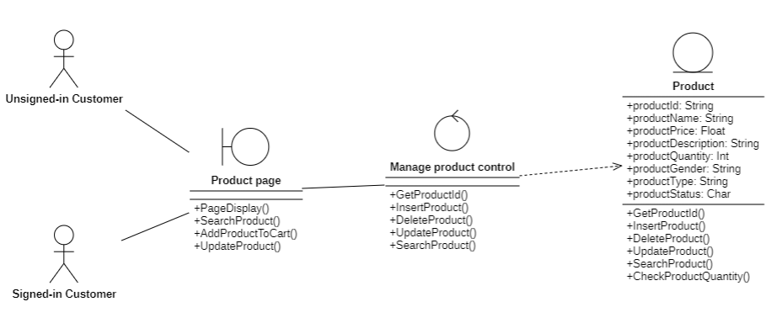

Diagram 35: Class Diagram of Search product (Customer)

### 3.3.7. Search order (Customer)

### 3.3.7.1. Sequence Diagram

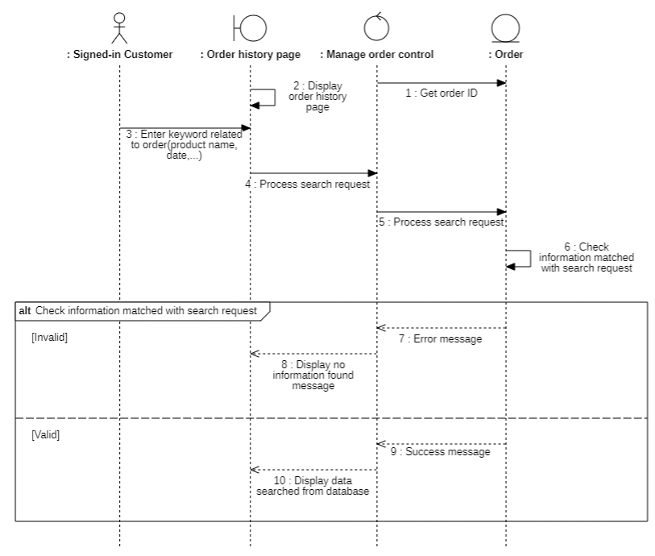

Diagram 36: Sequence Diagram of Search order(Customer)

### 3.3.7.2. Class Diagram

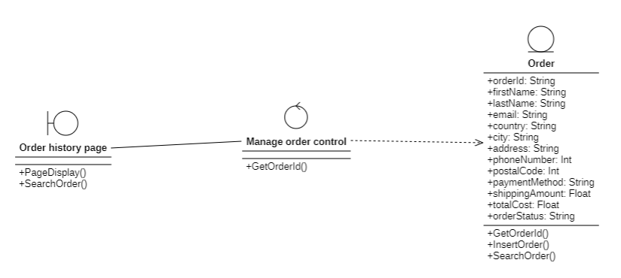

Diagram 37: Class Diagram of Search order (Customer)

### 3.3.8. Generate sales report

### 3.3.8.1. Sequence Diagram

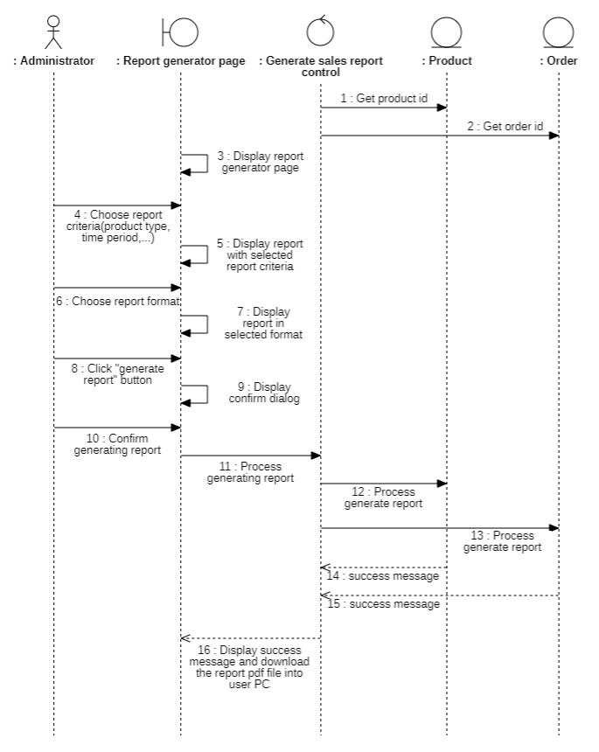

Diagram 38: Sequence Diagram of Generate sales report

### 3.3.8.2. Class Diagram

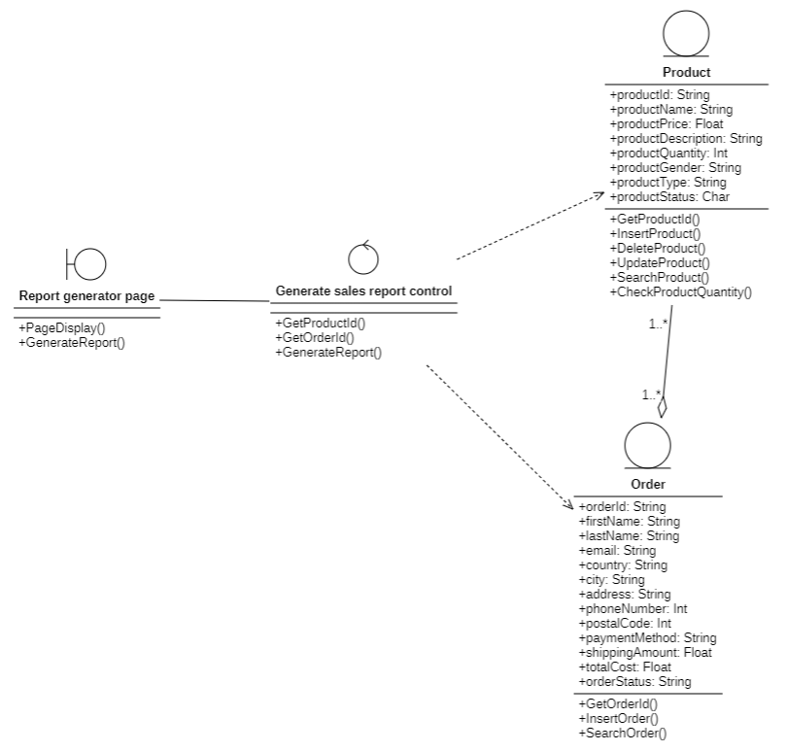

Diagram 39: Class Diagram of Generate sales report

# 

### 3.3.9. Manage products

### 3.3.9.1. Sequence Diagram

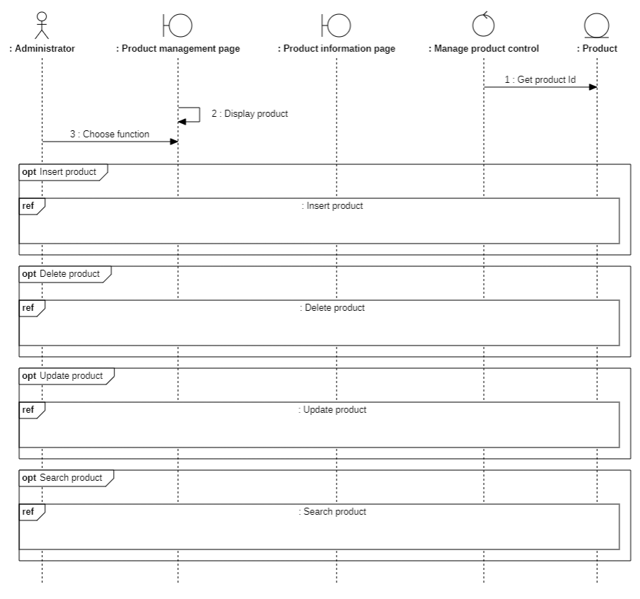

Diagram 40: Sequence Diagram of Manage product

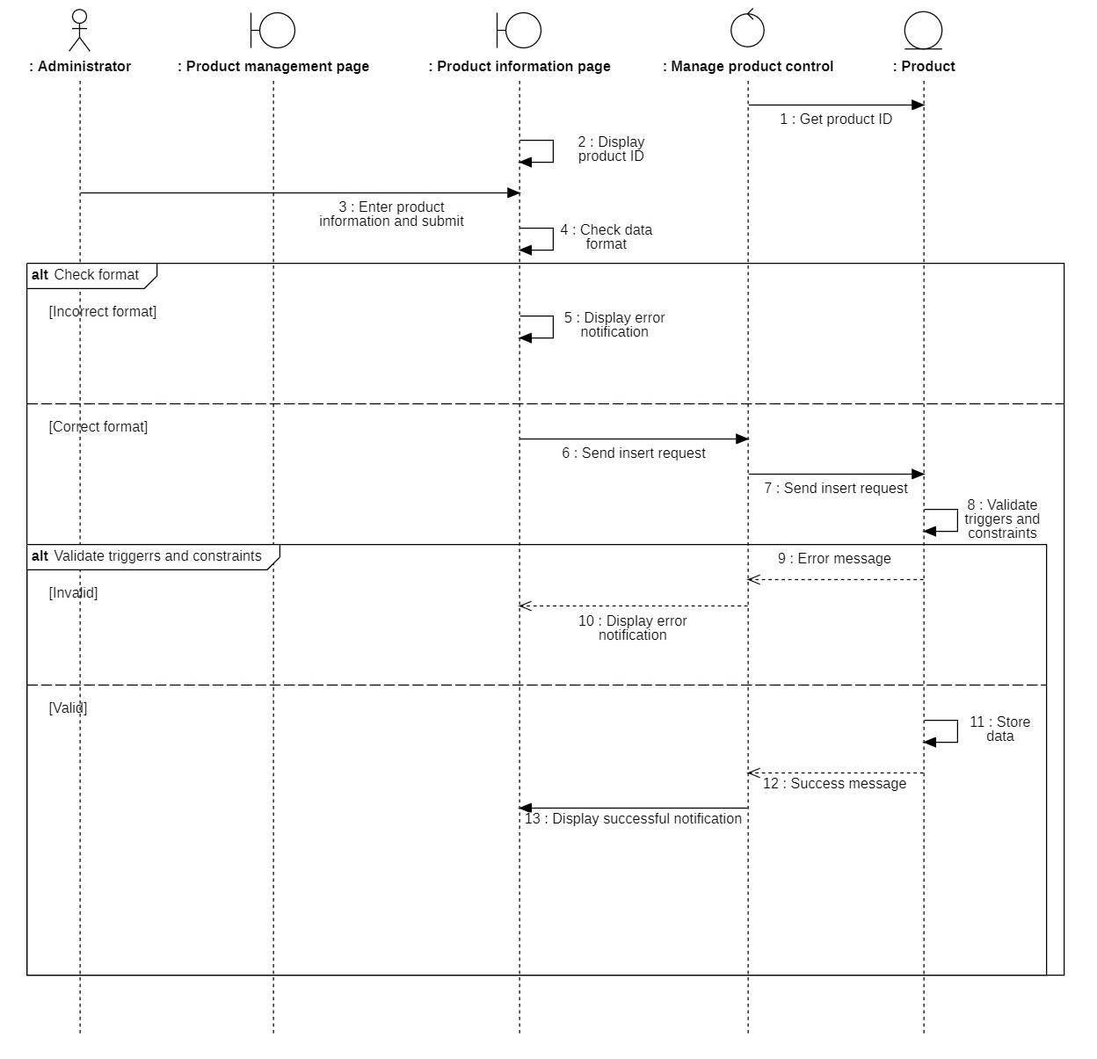

Diagram 41: Sequence Diagram of Insert product

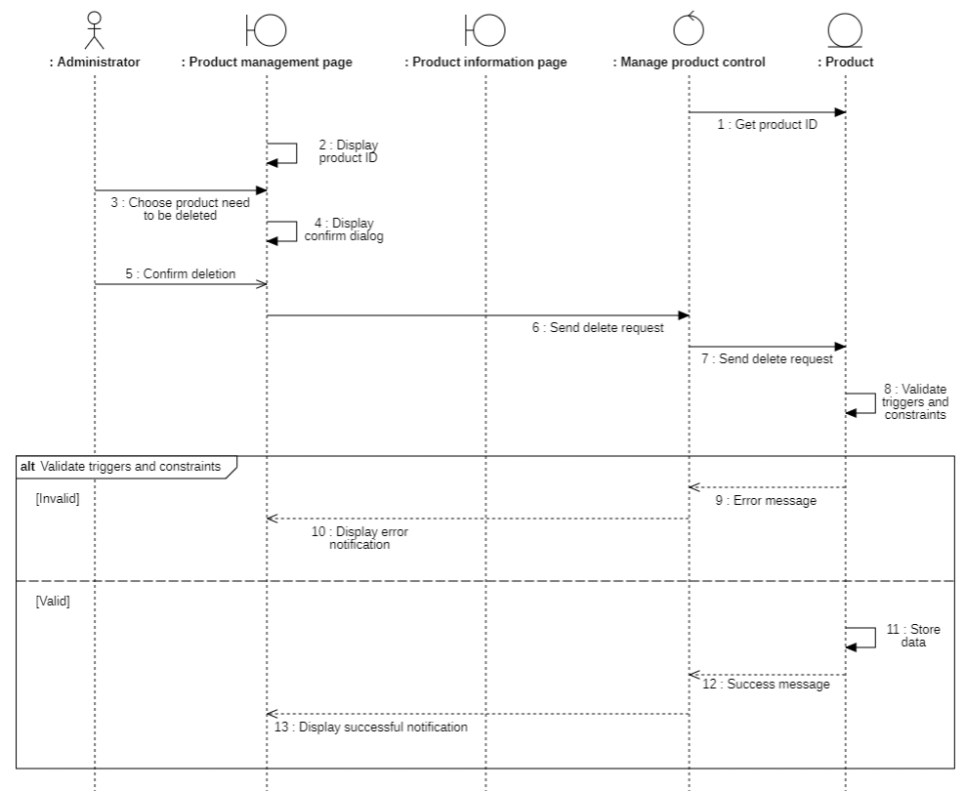

Diagram 42: Sequence Diagram of Delete product

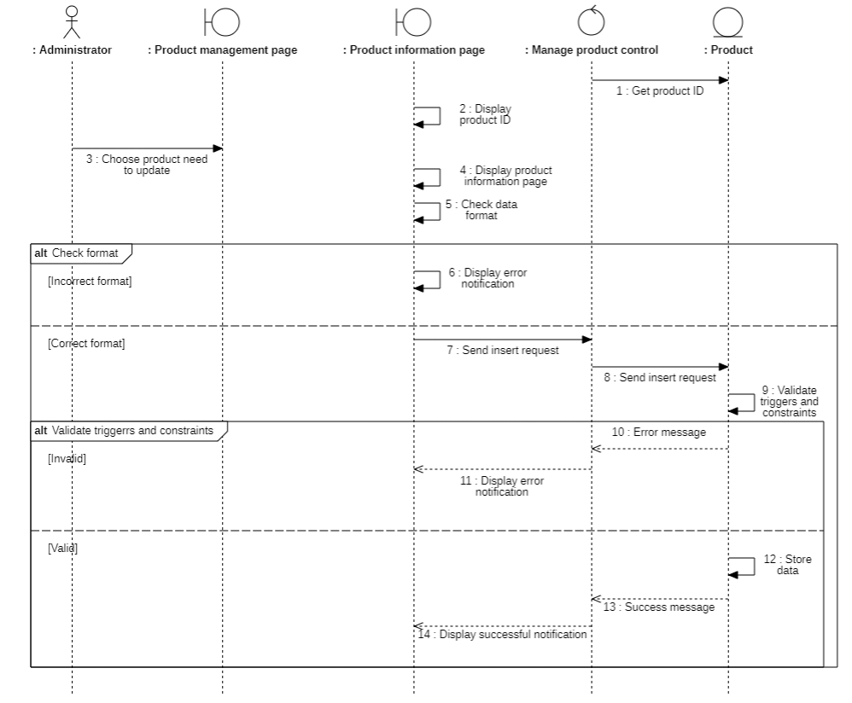

Diagram 43: Sequence Diagram of Update product

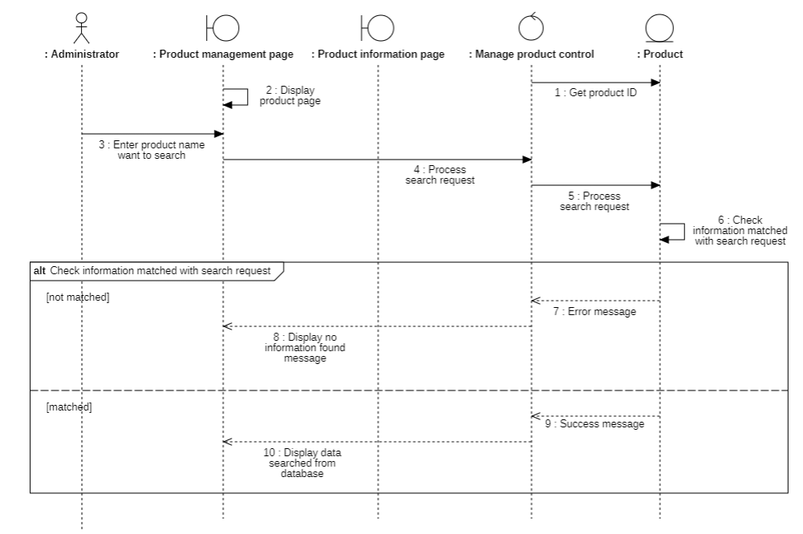

Diagram 44: Sequence Diagram of Search product

### 3.3.9.2. Class Diagram

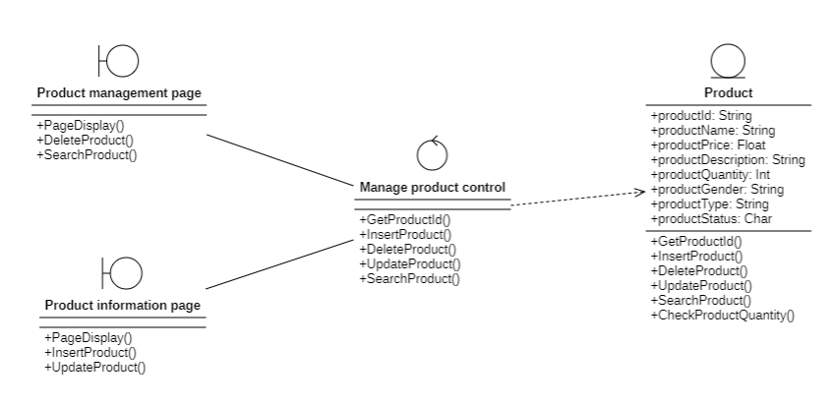

Diagram 44: Class Diagram of Manage product

### 3.3.10. Manage account

### 3.3.10.1. Sequence Diagram

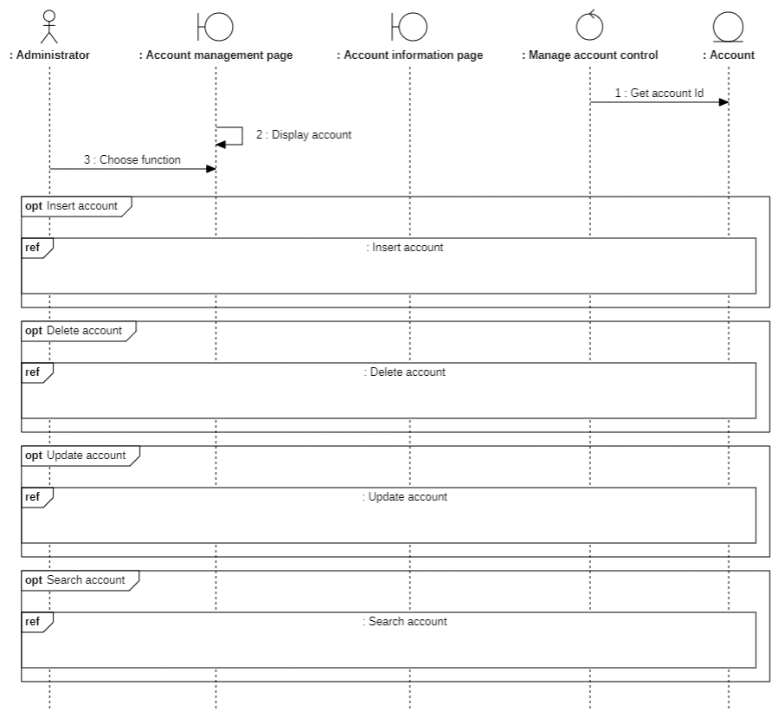

Diagram 45: Sequence Diagram of Manage account

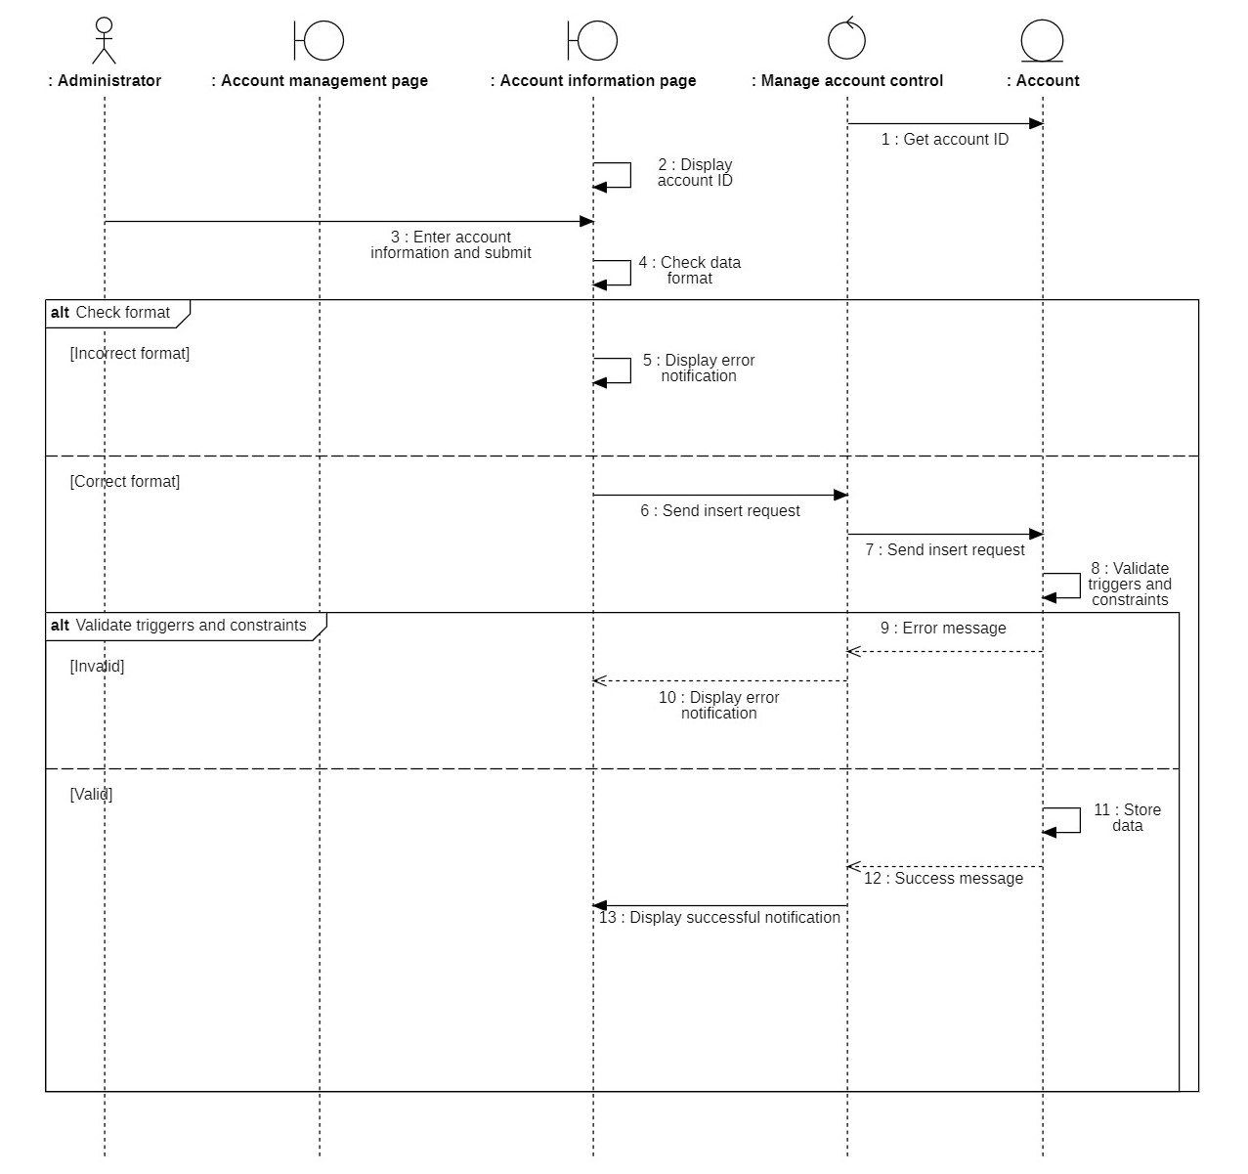

Diagram 46: Sequence Diagram of Insert account

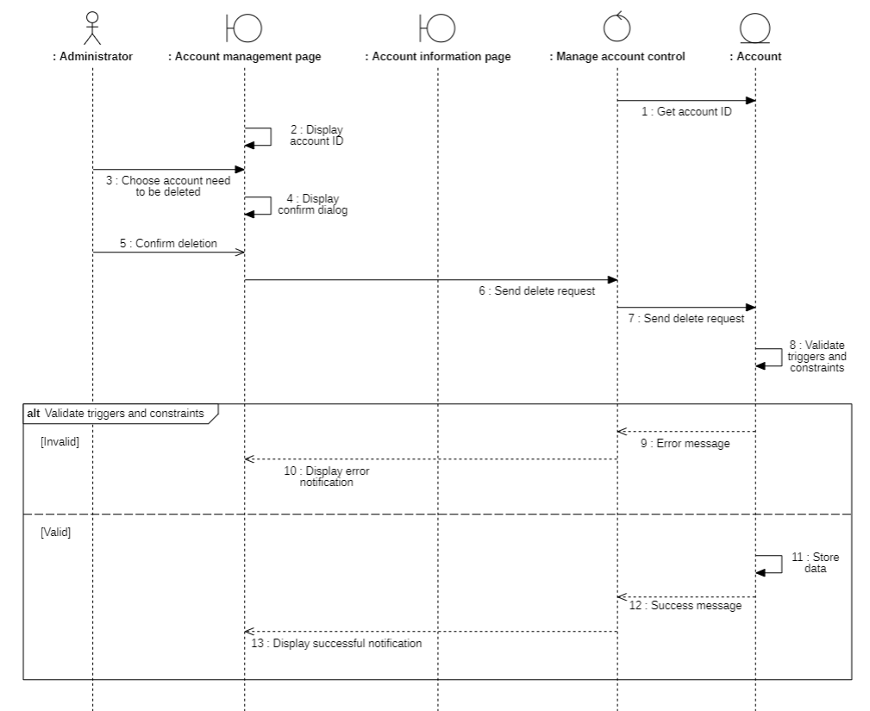

Diagram 47: Sequence Diagram of Delete account

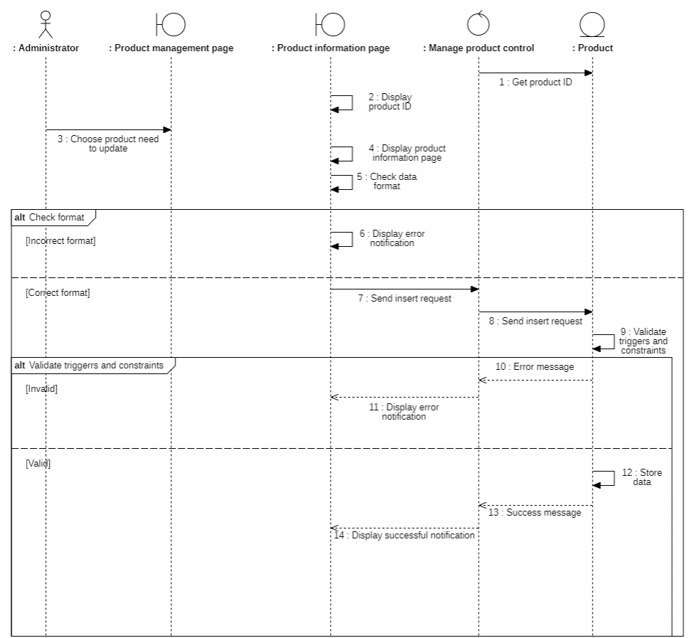

Diagram 48: Sequence Diagram of Delete account

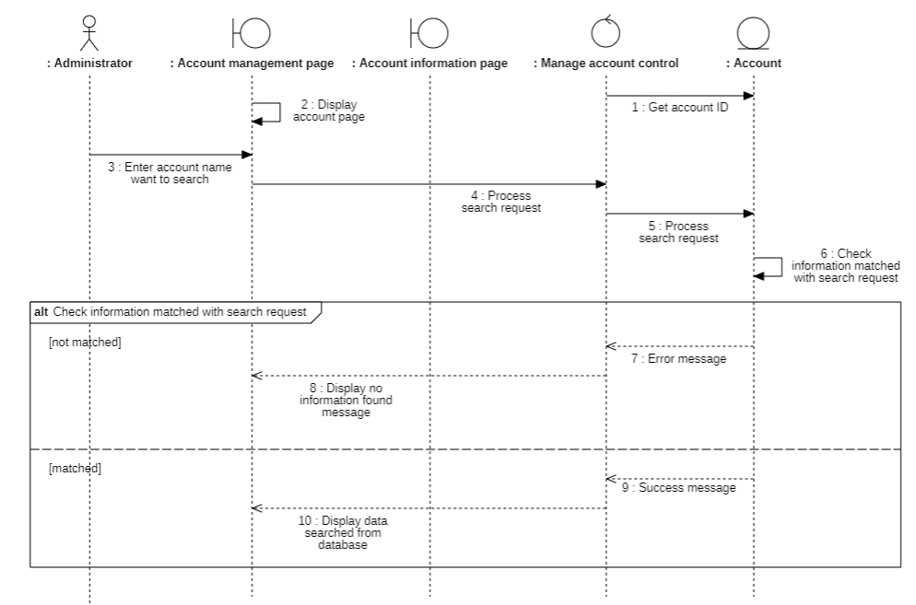

Diagram 48: Sequence Diagram of Search account

### 3.3.10.2. Class Diagram

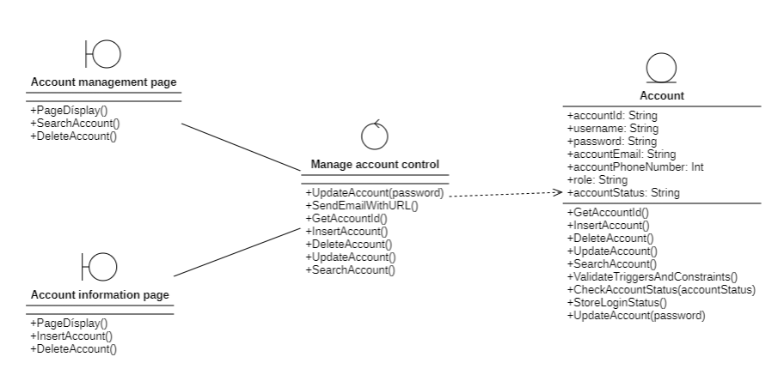

Diagram 49: Class Diagram of Manage account

### 3.3.11. Manage Order

### 3.3.11.1. Sequence Diagram

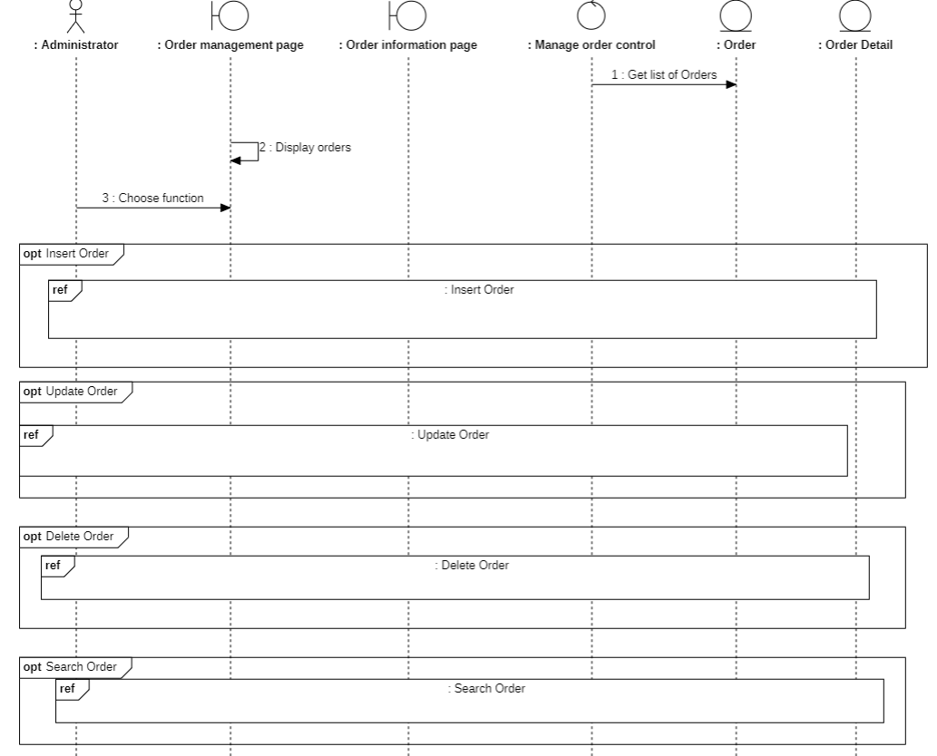

Diagram 50: Sequence Diagram of Manage order

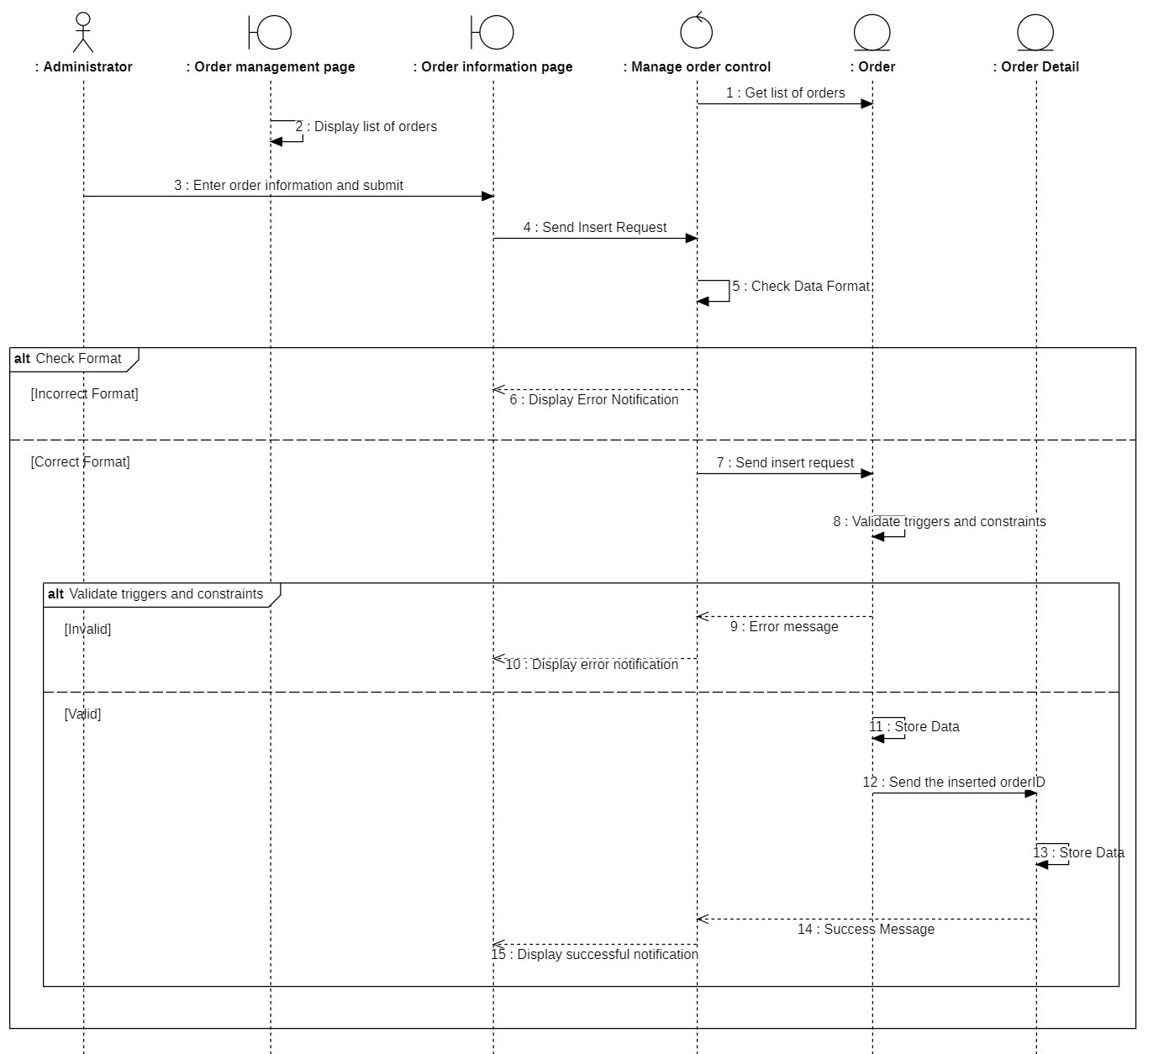

Diagram 51: Sequence Diagram of Insert order

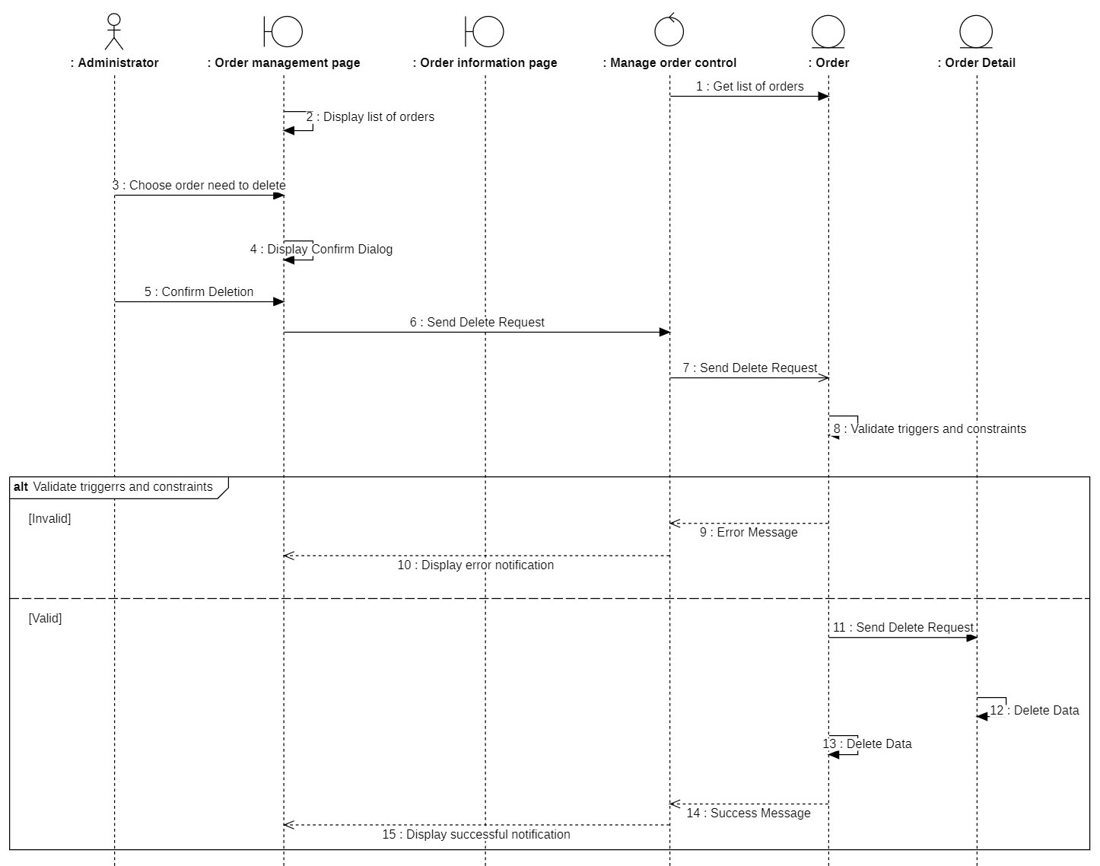

Diagram 52: Sequence Diagram of Delete order

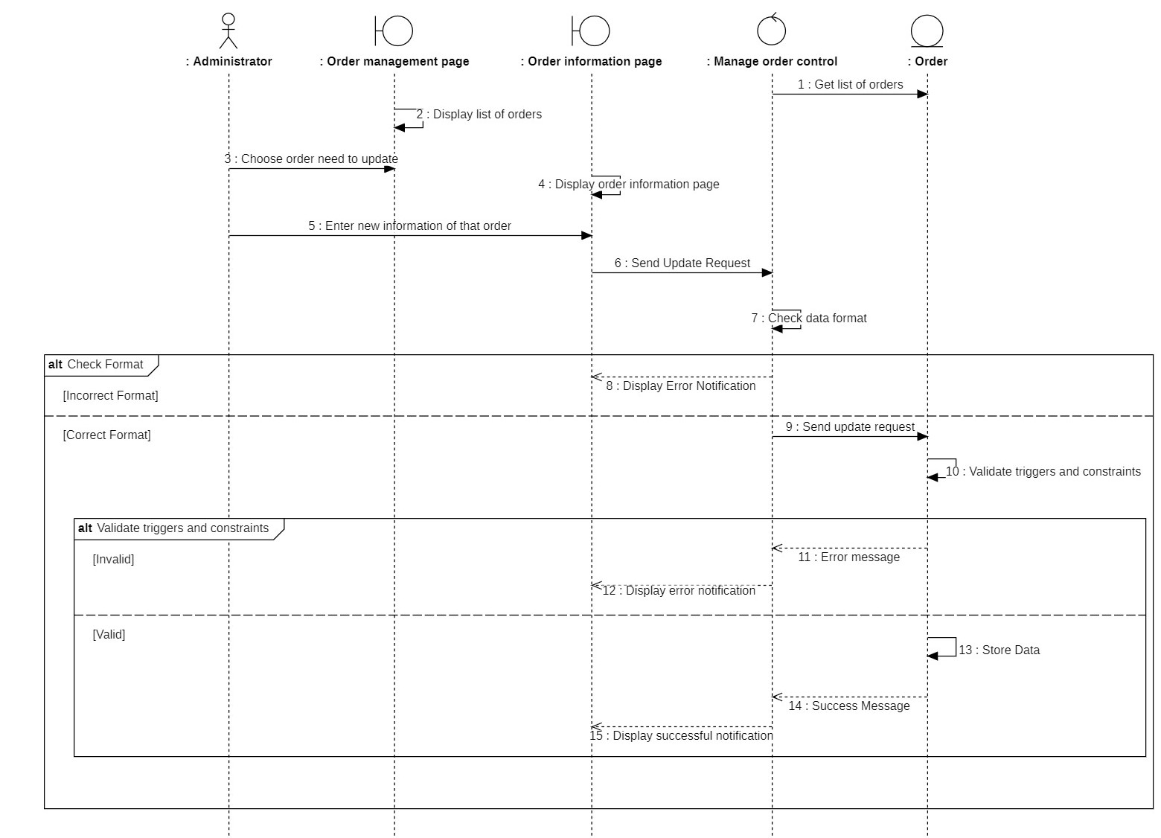

Diagram 53: Sequence Diagram of Insert order

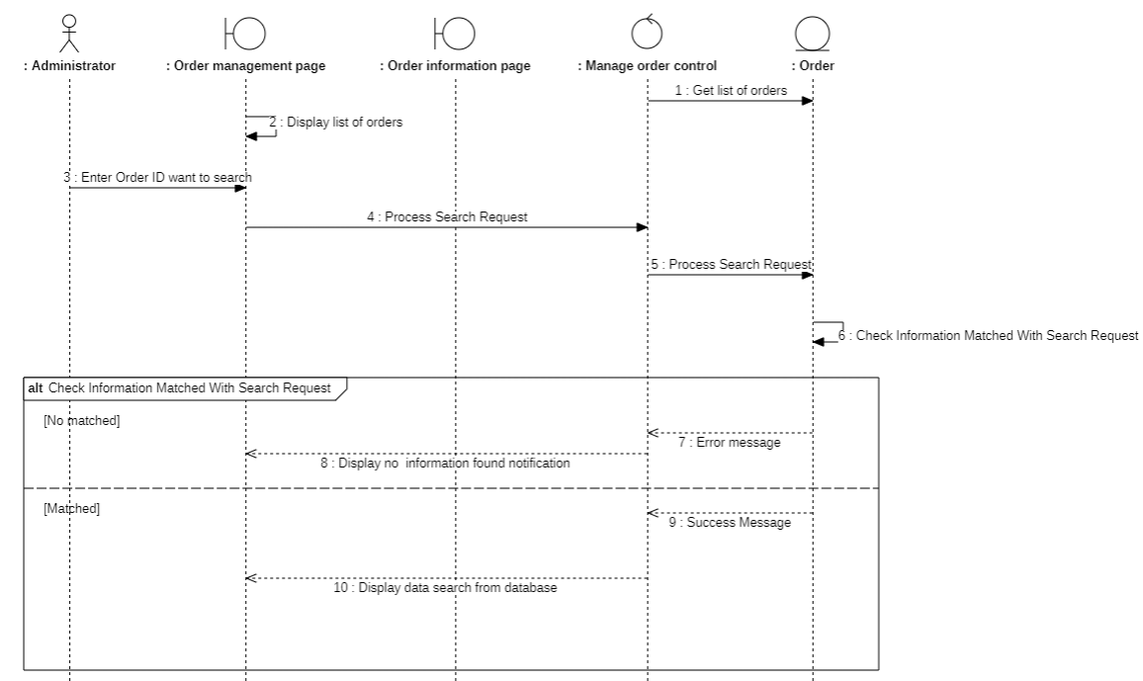

Diagram 54: Sequence Diagram of Search order

### 3.3.11.2. Class Diagram

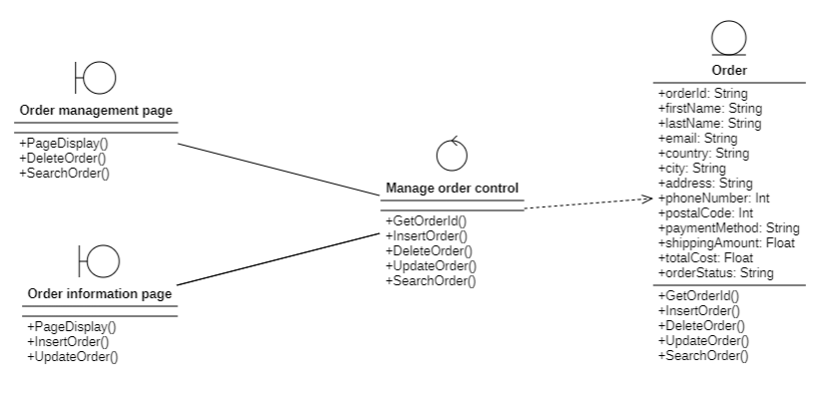

Diagram 55: Class Diagram of Manage order

## 3.4. Class Diagram and Entity class diagram

### 3.4.1. Customer class diagram overview

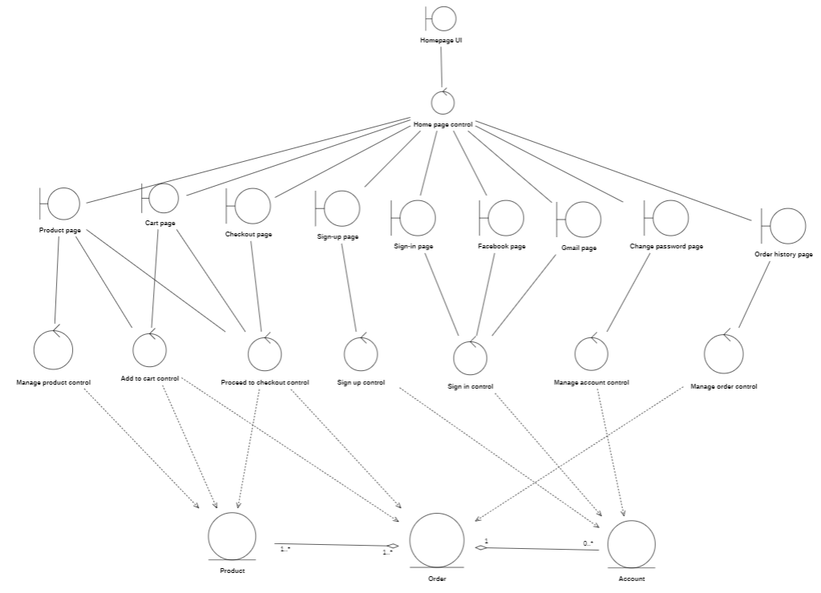

### 3.4.2. Administrator class diagram overview

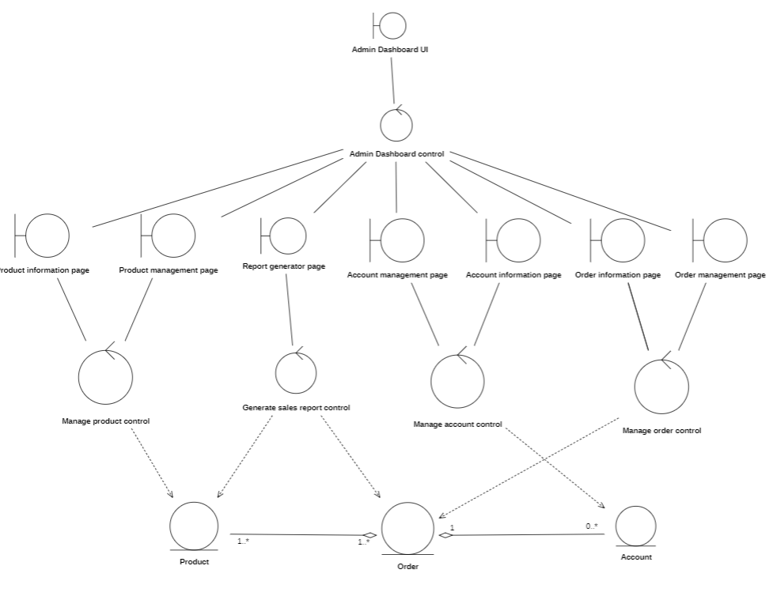

### 3.4.3. Entity class diagram

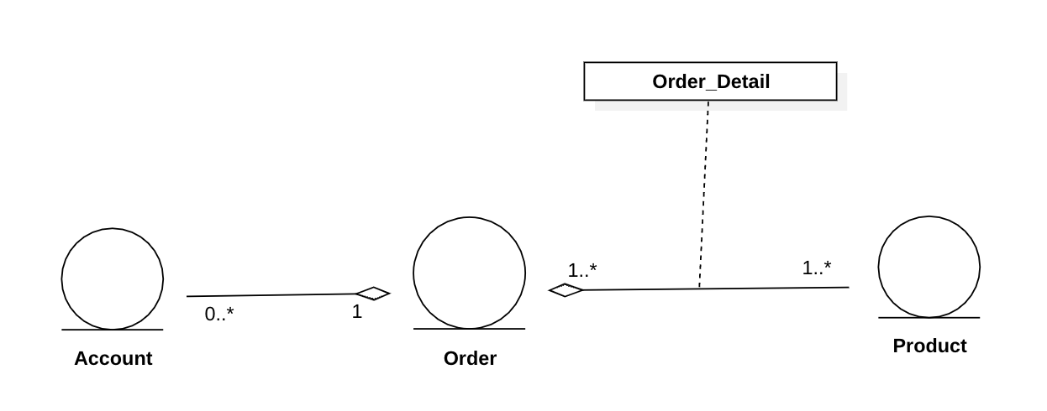

Diagram 56: Entity class diagram

### 3.4.4. Class Diagram Specification

### 3.4.4..1 Account

|  |  |  |
| --- | --- | --- |
| Account | | |
| Attribute | Variable | Meaning |
| accountID: String | Account ID generated by system automatically |
| username: String | Name of customer |
| password: String | Password of customer |
| accountPhoneNumber: int | Phone number of customer |
| role: String | Constraints on the information users enter when signing in |
| accountStatus: String | Including user account status: Newly created, Active, Nactive, Banned |
| Operation | Function | Meaning |
| GetAccountId(): Void | Get account ID of customer |
| InsertAccount(): Void | Insert account |
| DeleteAccount(): Bool | Delete account |
| UpdateAcccount(): Void | Update account |
| SearchAccount(): Void | Search account |
| ValidateTriggersAndConstraint(): Bool | Validate if the sign in data is  correct with the database |
| CheckAccountStatus(): Void | Check status of account |
| StoreLoginStatus(): Void | Save login status of customer |
| UpdateAccount(): Void | Update account |

### 3.4.4.2 Product

|  |  |  |
| --- | --- | --- |
| Product | | |
| Attribute | Variable | Meaning |
| productID: String | Product ID generated by system automatically. |
| productName: String | Name of product |
| productPrice: Float | Price of product |
| productDescription: String | Description of product |
| productQuantity: int | Quantity of product |
| productGender: String | Gender of product |
| productType: String | Type of product |
| productStatus: Char | Status of product |
| Operation | Function | Meaning |
| GetProduct(): Void | Get product ID |
| InsertProduct(): Void | Insert product |
| DeleteProduct(): Void | Delete product |
| SearchProduct(): Void | Search product |
| CheckProductQuantiry(): Void | Check quantity of product |

### 3.4.4.3 Order

|  |  |  |
| --- | --- | --- |
| Order | | |
| Attribute | Variable | Meaning |
| orderId: String | Product ID generated by system automatically. |
| firstName: String | First name of customer. |
| lastName: String | Last name of customer. |
| email: String | Email of customer. |
| country: String | Country of customers. |
| city: String | City of customers. |
| address: String | Address of customers. |
| phoneNumber: int | Status of product |
| postalCode: int | PostalCode of city |
| paymentMethod: String | Payment method |
| shippingAmount(): Float | Total |
| orderStatus: String | Status of order including: Confirm, Processing, Draft |
| Operation | Function | Meaning |
| GetOrderId(): Void | Get id order. |
| InsertOrder(): Void | Insert order. |
| DeleteOrder(): Void | Delete order. |
| UpdateOrder(): Void | Update order. |
| SeachOrder(): Void | Search order. |

## 3.5. State Diagram

### 3.5.1. Account

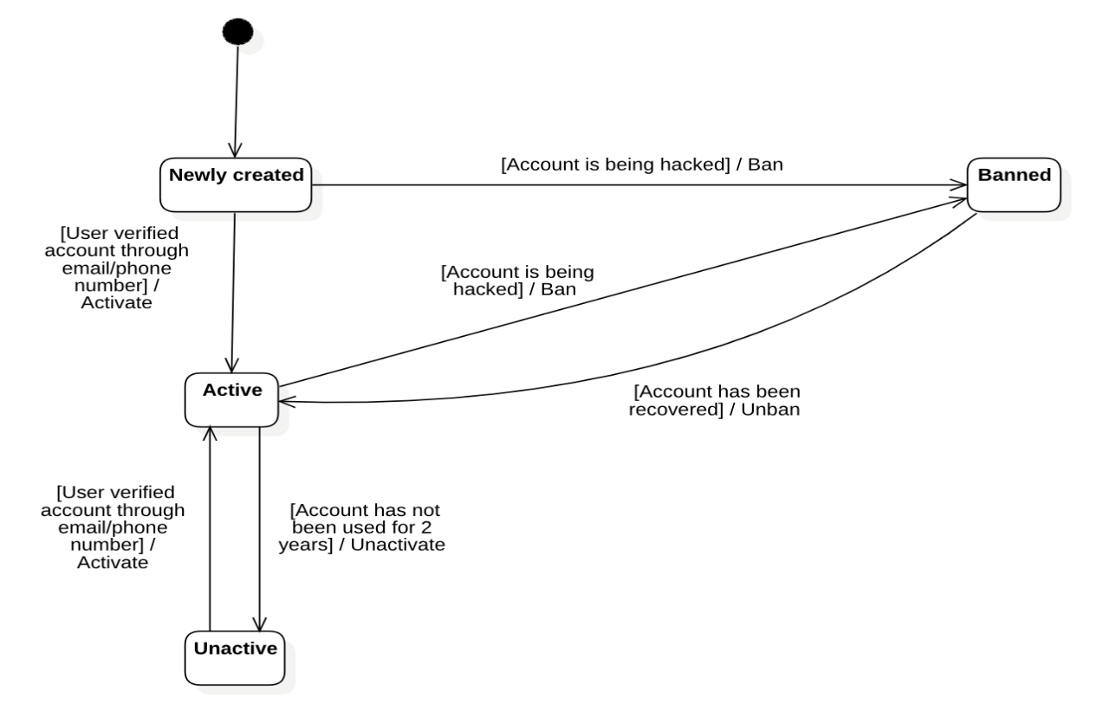

Diagram 57: State diagram of Account

### 3.5.2. Product

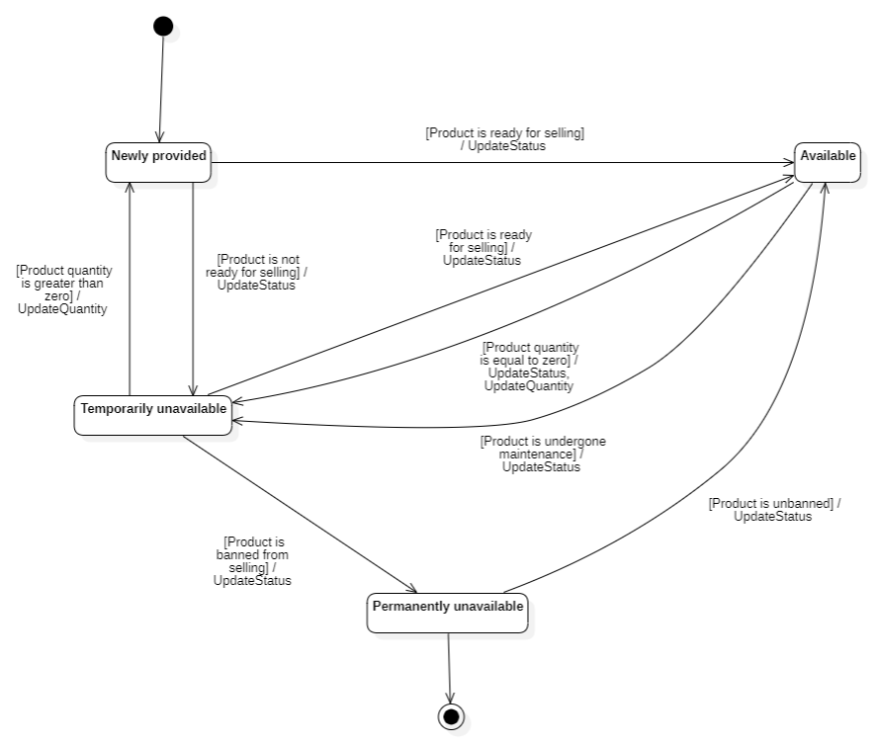

Diagram 58: State diagram of Product

### 3.5.3. Order

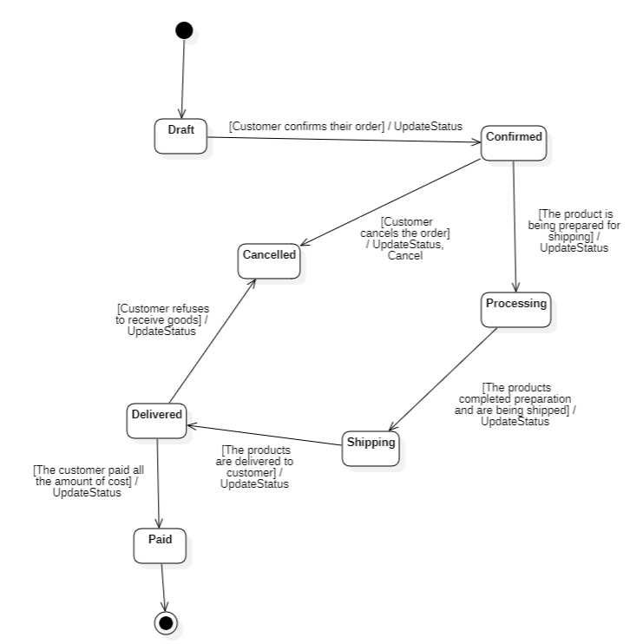

Diagram 59: State diagram of Order

## 3.6. Mapping to Relational Model from Entity class diagram

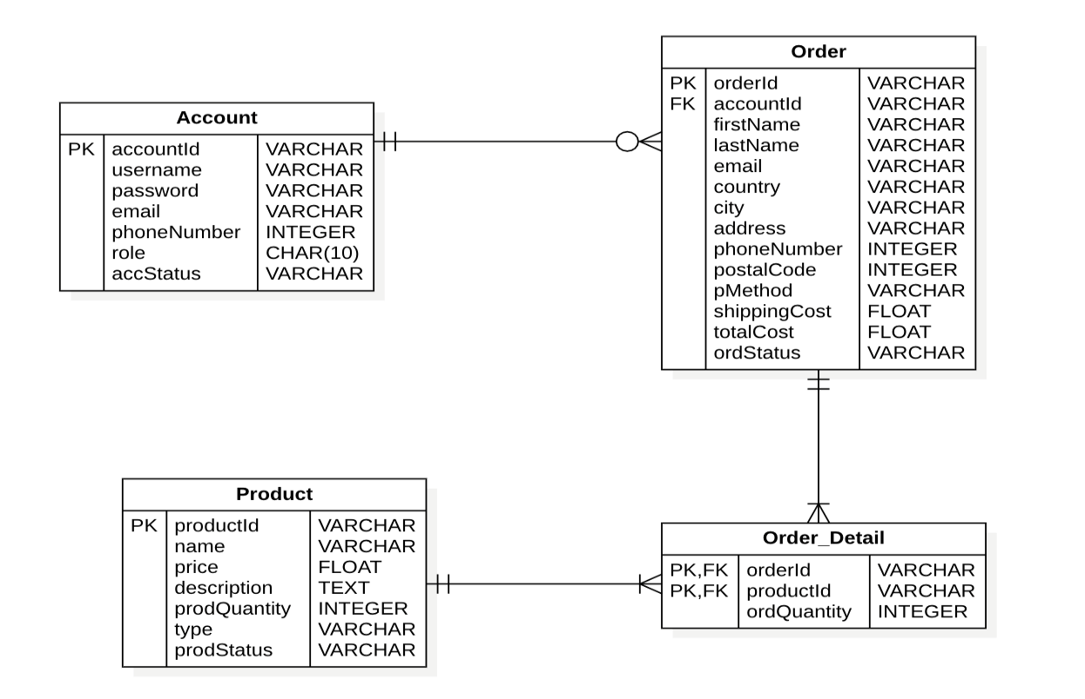

Diagram 60: Mapping to Relational Model from Entity class diagram

# Chapter 4: IMPLEMENTATION AND TESTING

## Introduction to the implementation environment

### 4.1.1 Development environment

* Operating system: Window 11
* Database: MySQL (db4free.com)
* Text Editor: Visual Studio Code
* Front-end: React
* Back-end: Nodejs.

## User Interface

### Product page

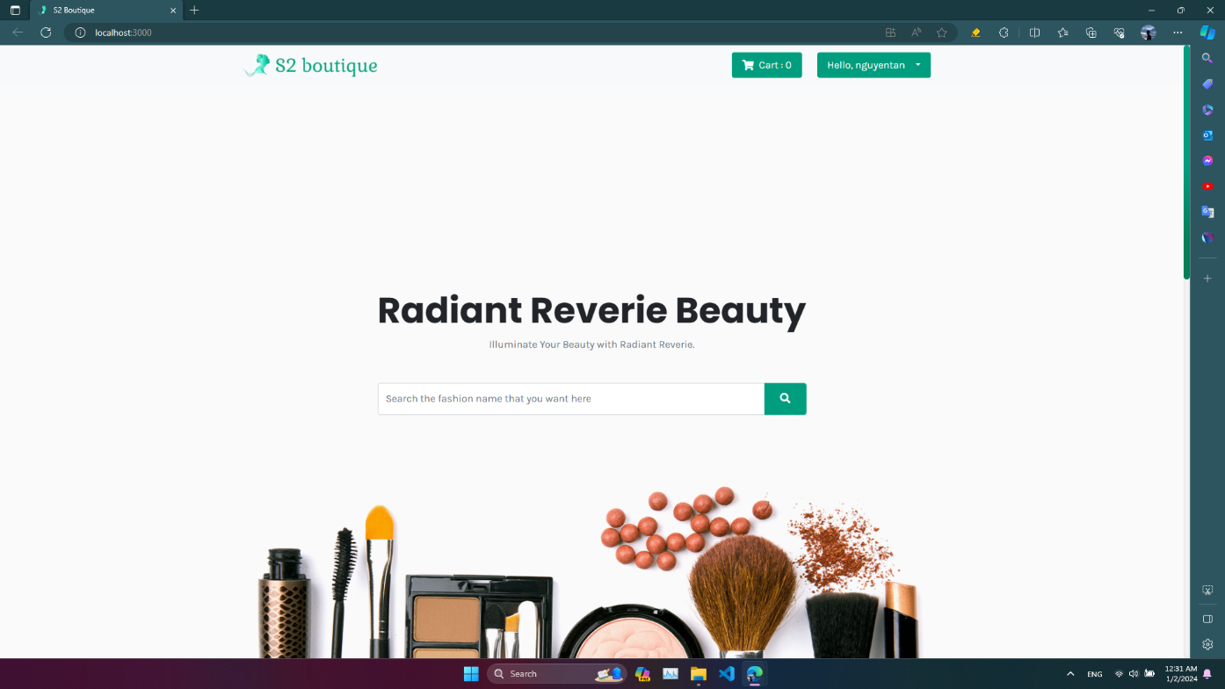

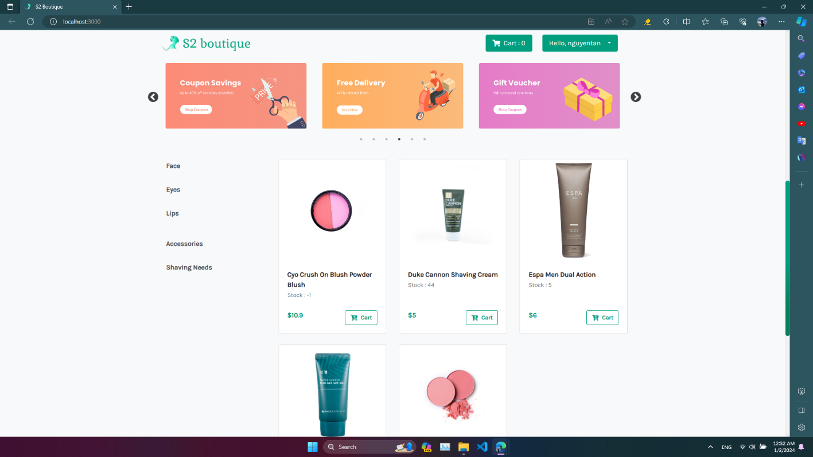

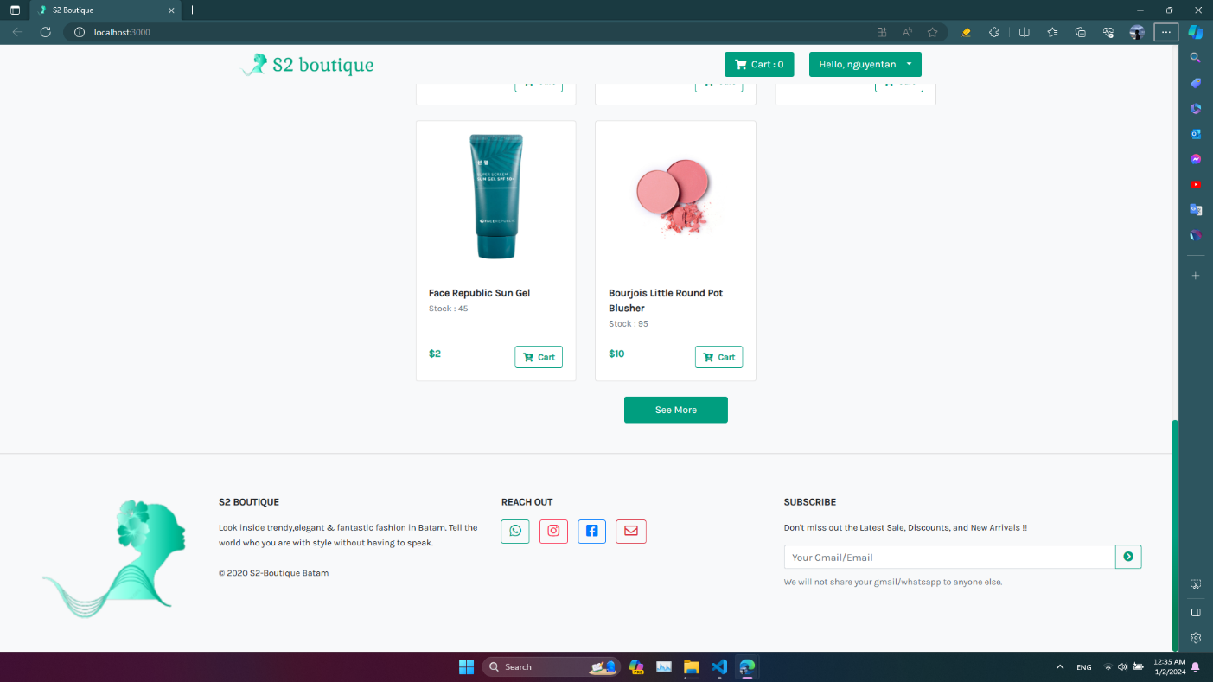

|  |  |  |
| --- | --- | --- |
| **Framework** | | **Description** |
| Function | Type to searching | Frame word-type to help user searching for their product they want to shopping. |
| Shopping cart | The place to store the products that the customer has selected. |
| Product Detail | The model will show more information about the product. |
|  | | |
| Button | See more | Users click on “See more” button to display more products. |
| Logo | User click on logo to back to home page. |
| Cart | User click on “Cart” button to add product to Cart. |
| Purchase select  + Face  + Eyes  + Lips  + Accessories  + Shaving needs | User click on available choice to quick find product.  There are 5 categories. |

### Cart page

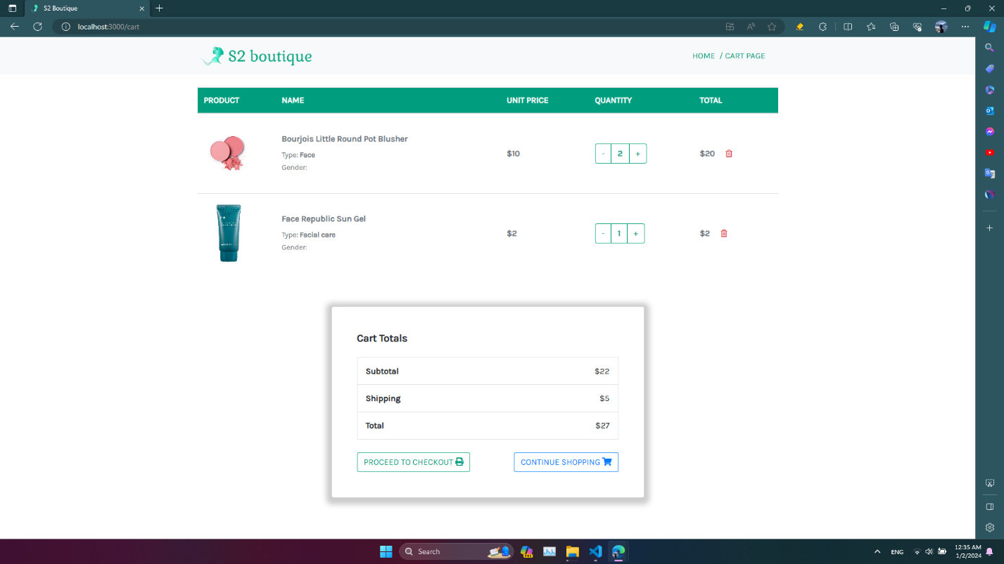

|  |  |  |
| --- | --- | --- |
| Framework | | Description |
| Function | List of Products | Show the product, name, unit price, quantity, total. |
| Cart Totals | Show the Subtotal, shipping and Total price of all products. |
|  | | |
| Button | Quantity | User click on “-“ or “+” to decrease or increase quantity product which want to buy. |
| Proceed to Checkout | User click on “Proceed to checkout” button to start order process. |
| Continue to shopping | User click on “Continue to shopping” button to return home page and continue shopping. |

### Checkout page

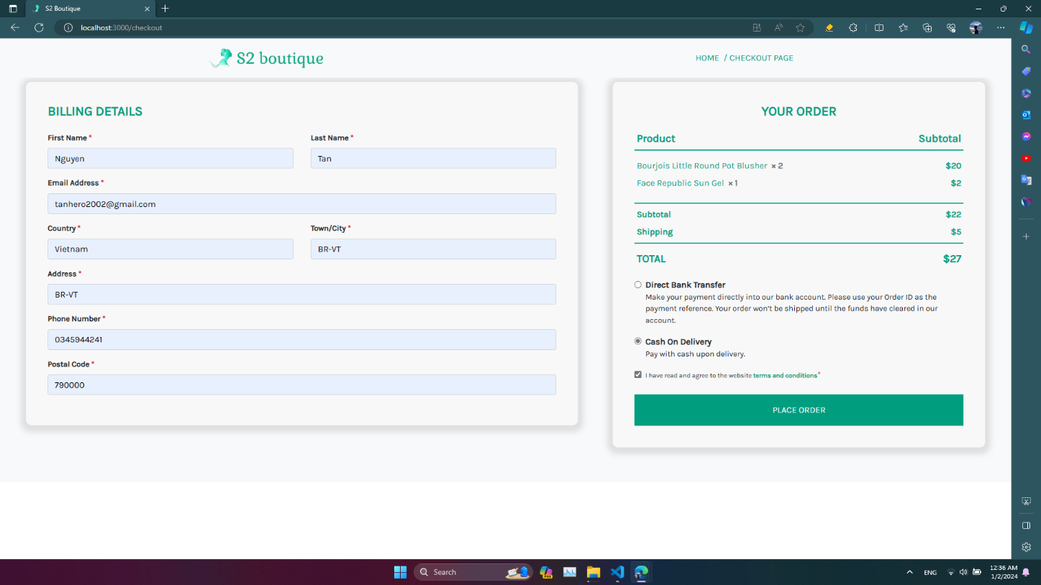

|  |  |  |
| --- | --- | --- |
| Framework | | Description |
| Function | Billing Details | Enter the order informations including First Name, Last Name, Email Address, Country, City, Address, Phone Number, Postal Code. All forms are required to be filled out |
| Your Order | Show the Subtotal, shipping and Total price of all products that selected and choose the payment and tick on policies |
|  | | |
| Button | Place Order | User click on “Place Order” button to complete the order process. |

### Order

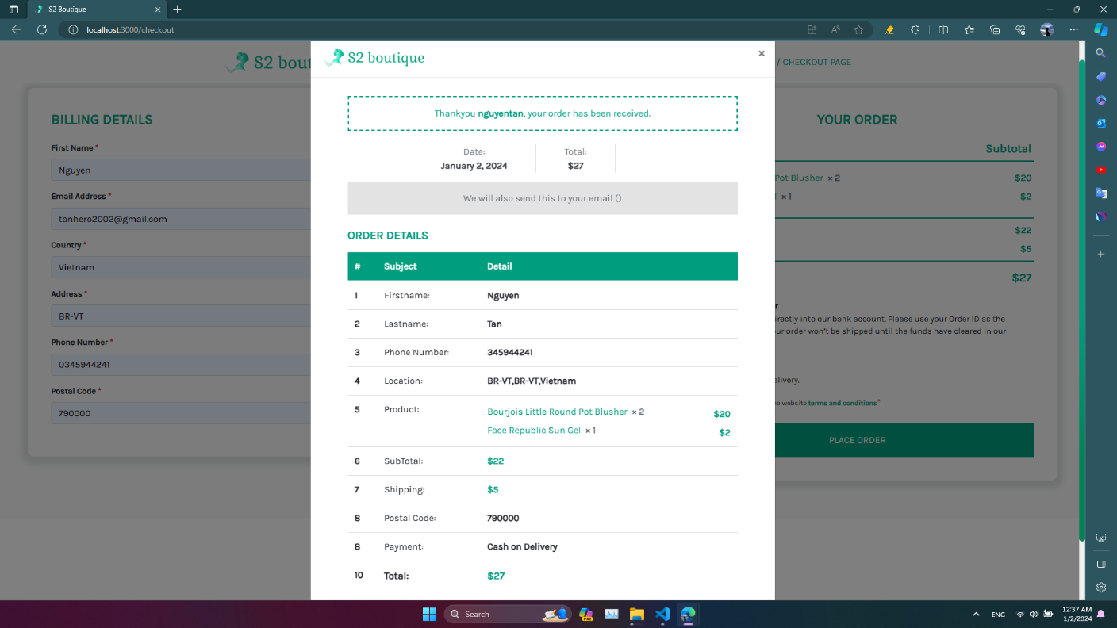

|  |  |  |
| --- | --- | --- |
| Framework | | Description |
| Function | Order details | Show all the information of order and date of order are be created |

### Login Modal

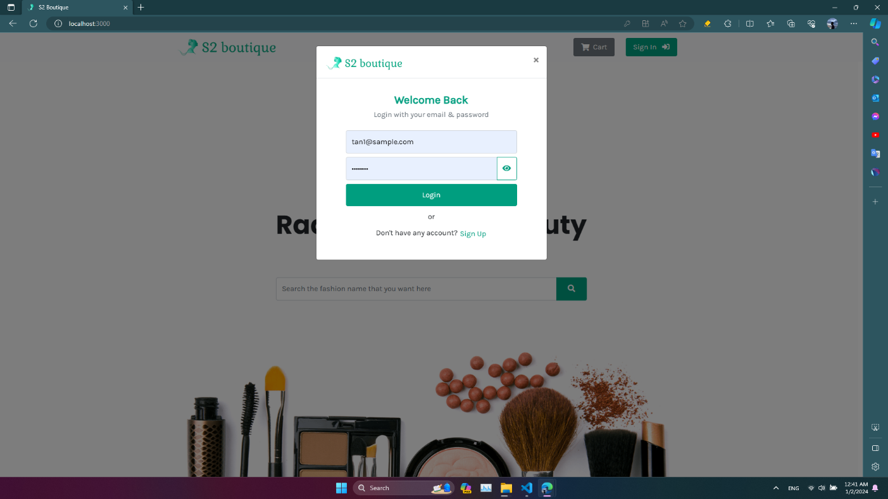

|  |  |  |
| --- | --- | --- |
| Framework | | Description |
| Function | Login form | Fill email address and password of users to login |
|  | | |
| Button | Login | Users click on “Login” button the |

### Sign Up Modal

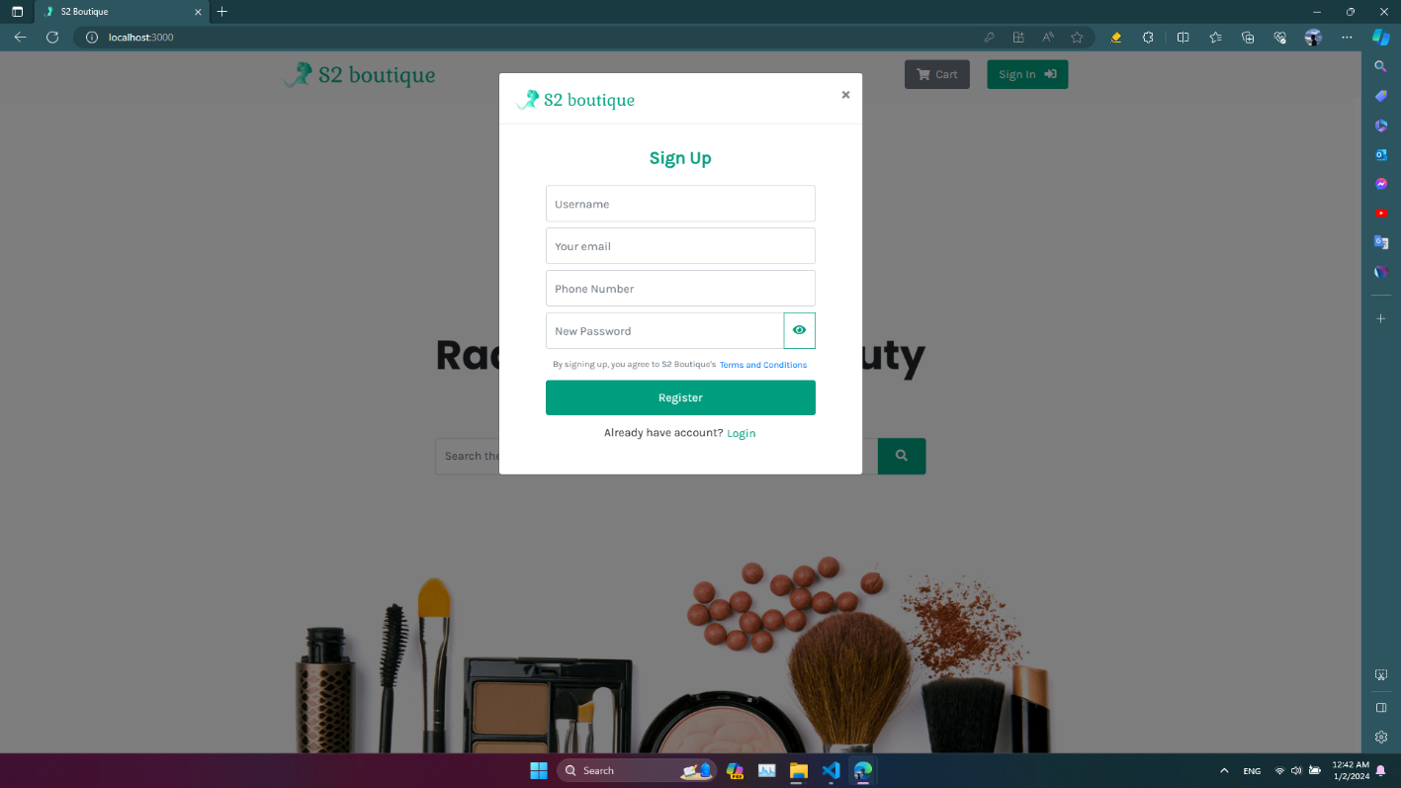

|  |  |  |
| --- | --- | --- |
| Framework | | Description |
| Function | Sign up form | Fill user name, email address, phone number and password of users to create a new account |
|  | | |
| Button | Register | Users click on “Register” button the submit the form sign up. |

### Dashboard admin

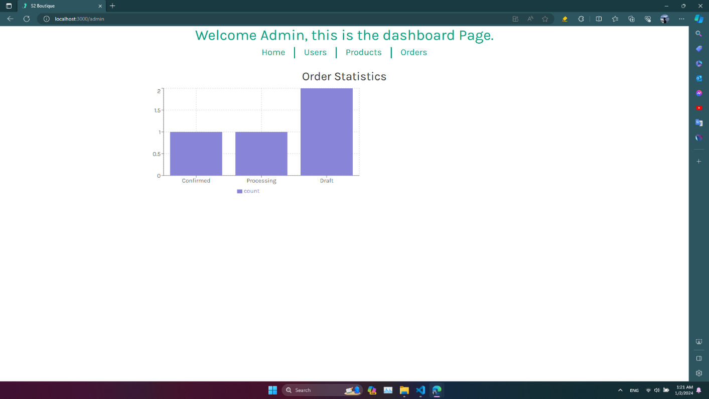

|  |  |  |
| --- | --- | --- |
| Framework | | Description |
| Function | Order Statistics | Show the number of orders and status |

### Users management

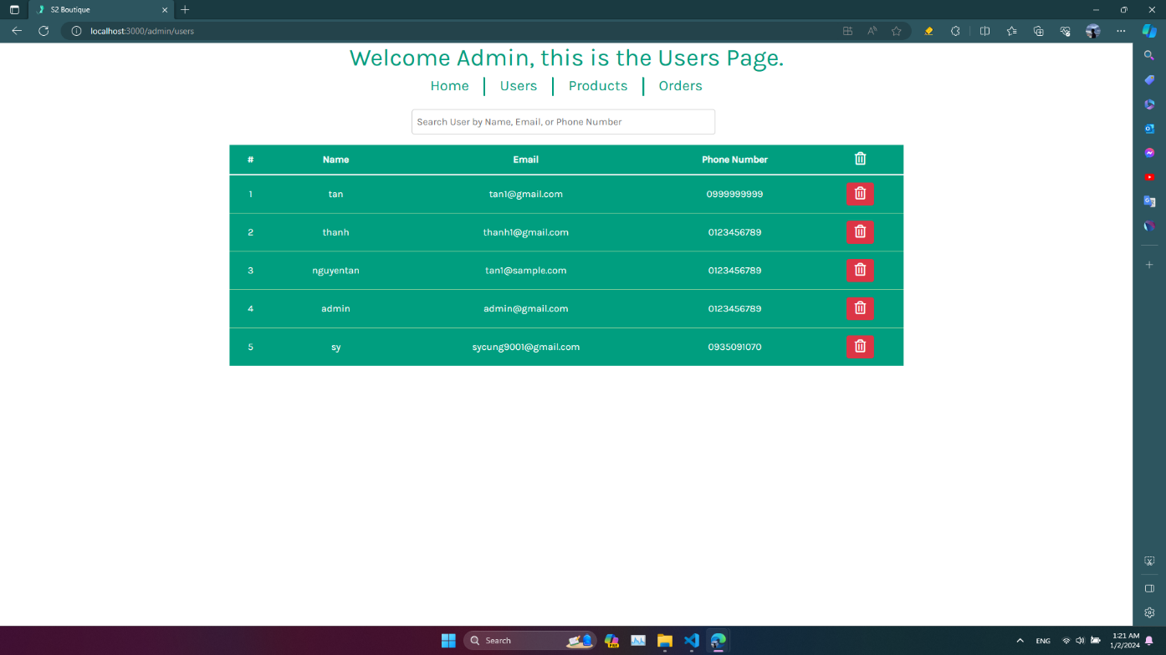

|  |  |  |
| --- | --- | --- |
| **Framework** | | **Description** |
| Function | Search form | Admin can find the information of customers more quickly |
| Table users | Show the username, email and phone number of customers |
|  | | |
| Button | Delete | Admin click on “delete” button to show the delete modal |

### Delete Users Modal

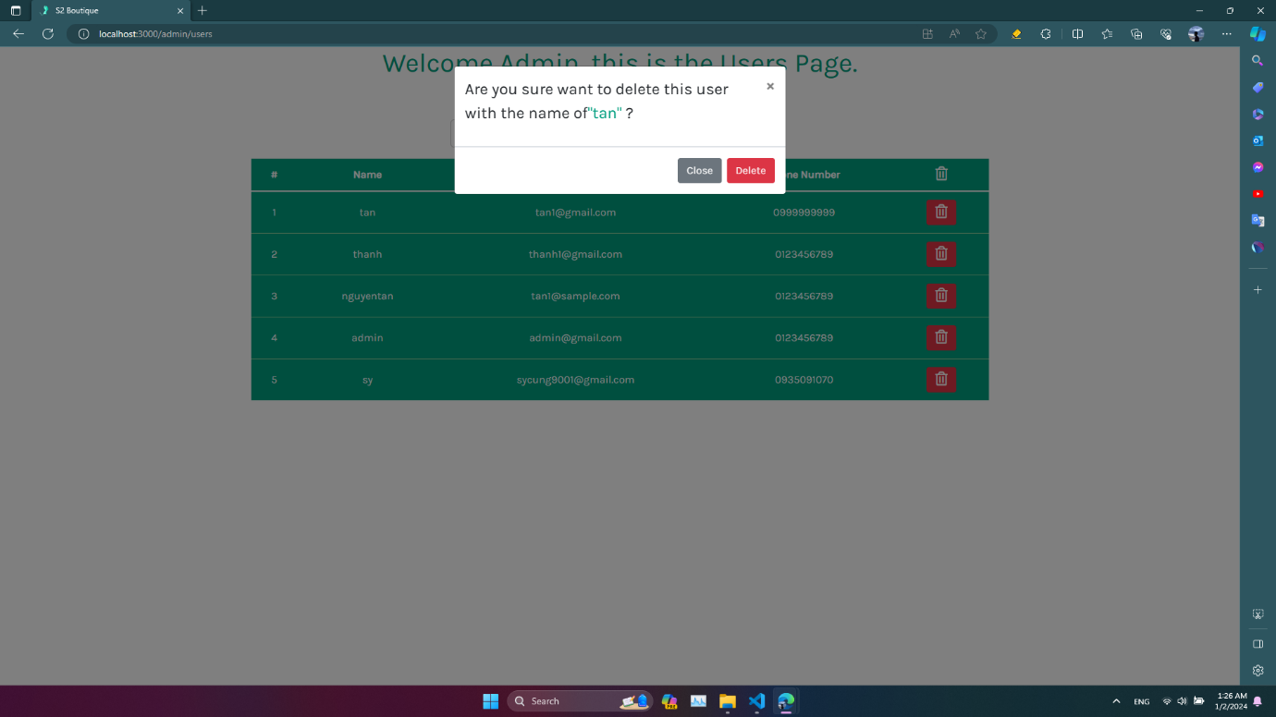

|  |  |  |
| --- | --- | --- |
| Framework | | Description |
| Button | Delete | Admin click on “Delete” button to confirm delete customer |
| Close | Admin click on “Close” button to cancel the action. |

### Products management

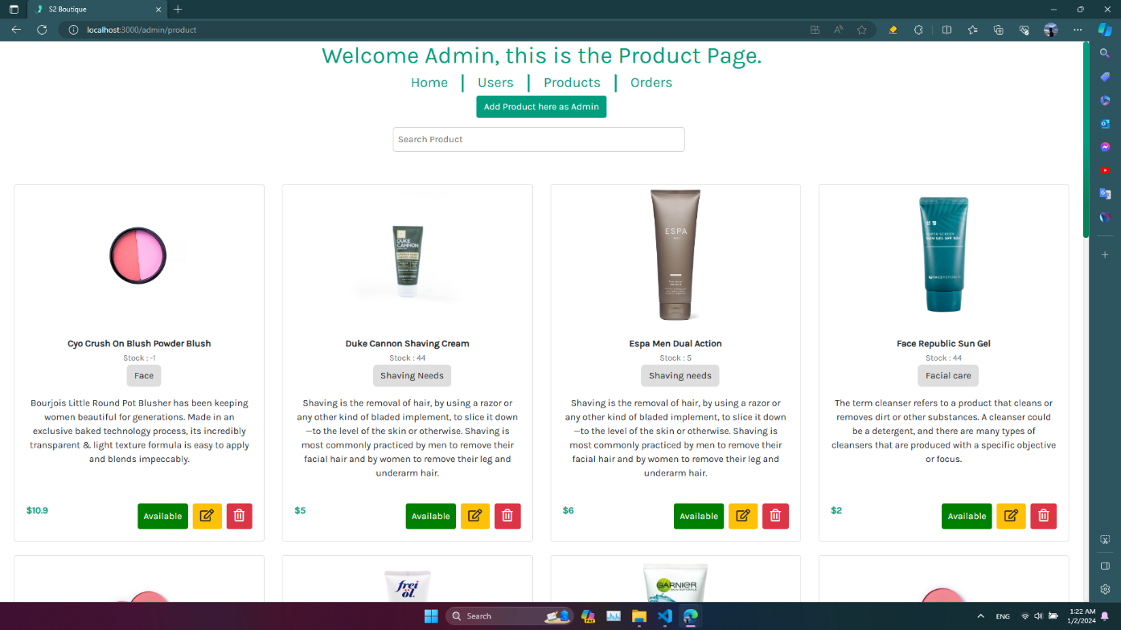

|  |  |  |
| --- | --- | --- |
| Framework | | Description |
| Function | Search form | Admin can find the information of products more quickly |
| Product cards | Show the image, name, quantity, product type, description, price and status of products |
|  | | |
| Button | Delete product | Admin click on “delete” button to show the delete product modal |
| Add product | Admin click on “add” button to show the add product modal |
| Edit product | Admin click on “edit” button to show the edit product modal |

### Add Products Modal

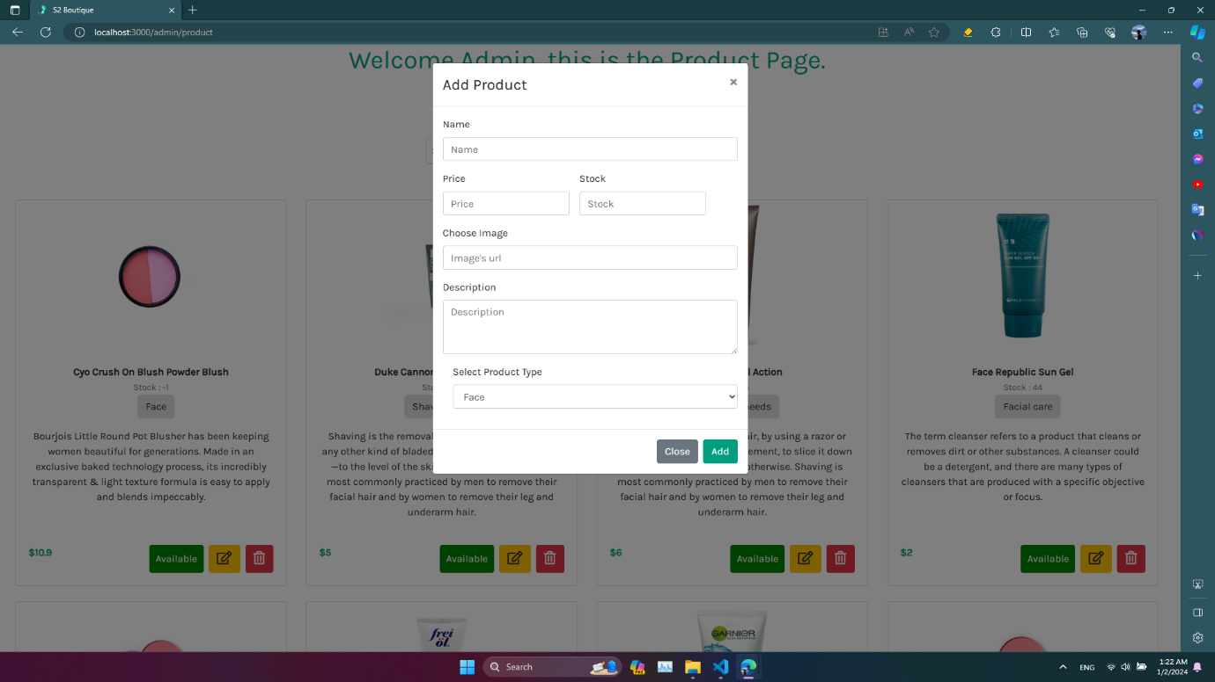

|  |  |  |
| --- | --- | --- |
| Framework | | Description |
| Function | Add product | Admin enter all the informations of product including name, image, price, stock, description, product type in the forms. |
|  | | |
| Button | Add | Admin click on “add” button to add a new product. |
| Close | Admin click on “Close” button to cancel the action. |

### Edit Products Modal

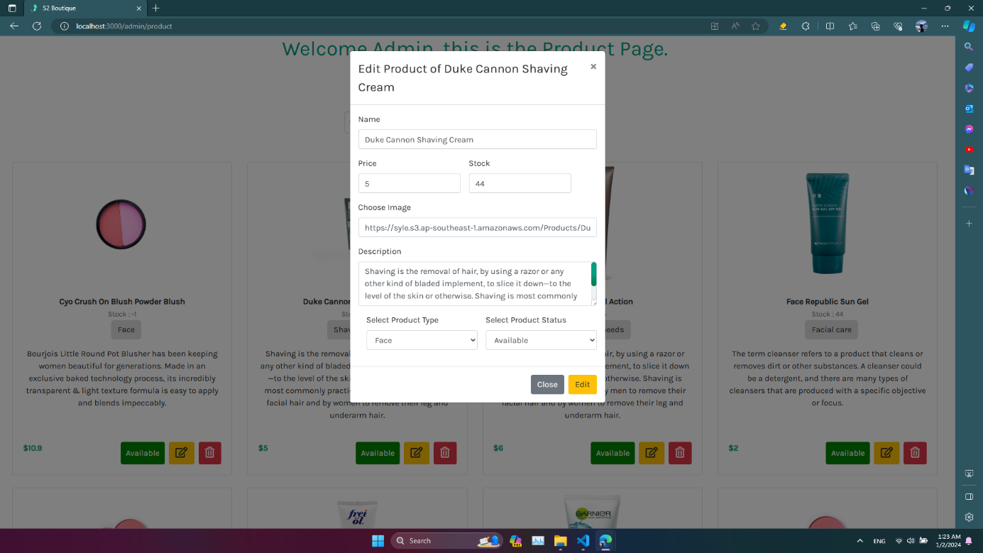

|  |  |  |
| --- | --- | --- |
| Framework | | Description |
| Function | Edit product | The modal will show the information of product and admin can update the information of product. |
|  | | |
| Button | Edit | Admin click on “edit” button to confirm update product. |
| Close | Admin click on “Close” button to cancel the action. |

### Delete Products Modal

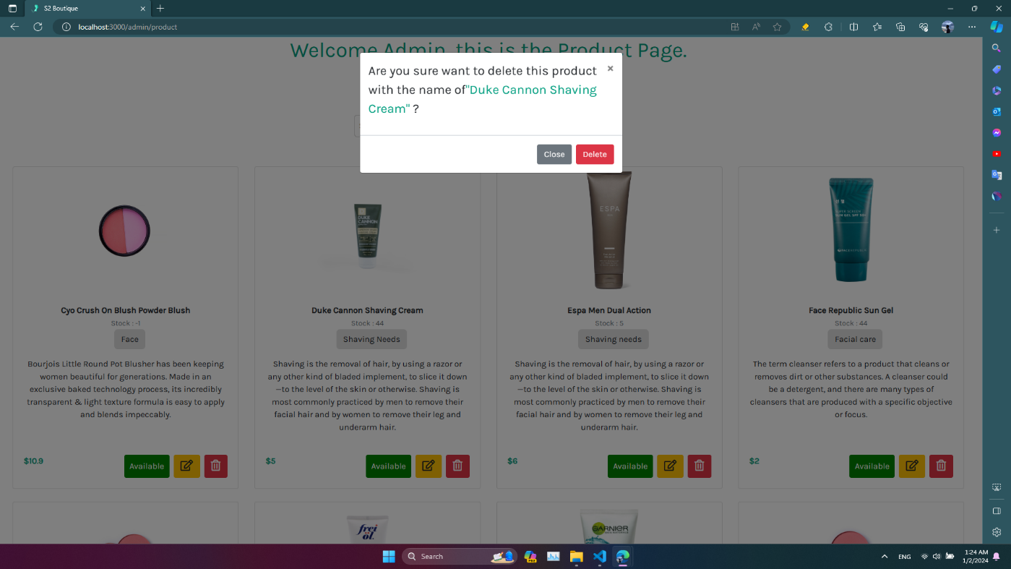

|  |  |  |
| --- | --- | --- |
| Framework | | Description |
| Button | Delete | Admin click on “Delete” button to confirm delete product |
| Close | Admin click on “Close” button to cancel the action. |

### Orders management

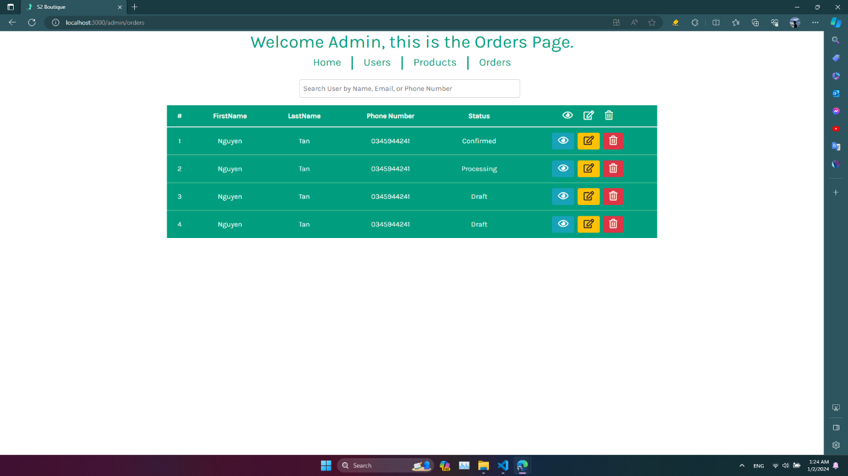

|  |  |  |
| --- | --- | --- |
| Framework | | Description |
| Function | Search form | Admin can find the information of orders more quickly |
| Table users | Show the First name, last name, phone number and status of orders |
|  | | |
| Button | Delete | Admin click on “delete” button to show the delete modal |
| More details | Admin click on “more details” button to show the order details modal |
| Edit orders | Admin click on “edit” button to show the edit order modal. |

### View Orders Details Modal

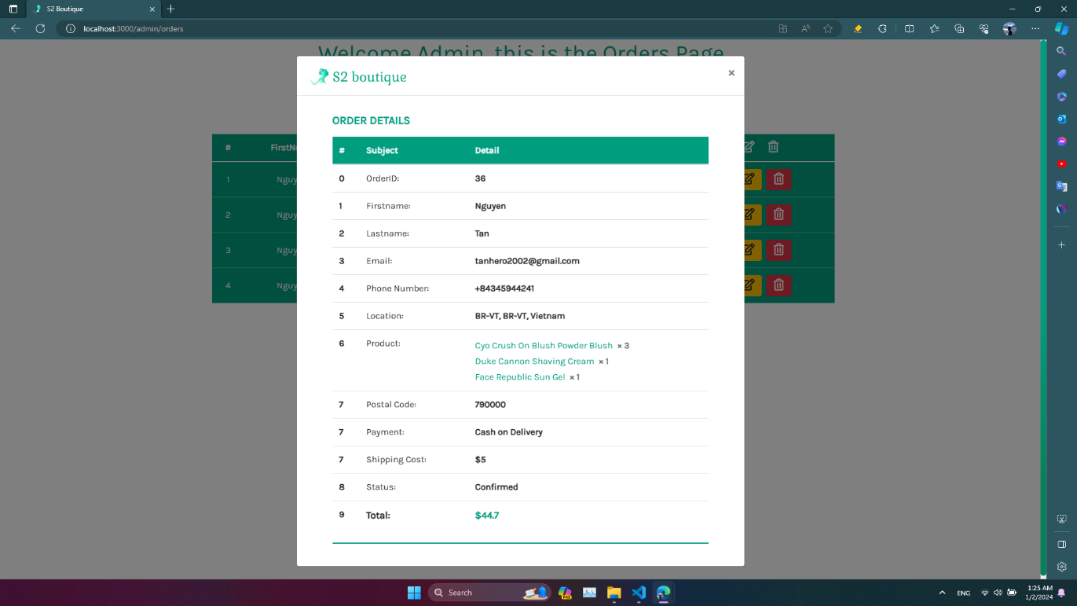

|  |  |  |
| --- | --- | --- |
| Framework | | Description |
| Function | Order details | Show more details about order including OrderID, First name, last name, email, phone number, location, Poruducts, postal code, payment, shipping cost, status and total |

### Edit Orders Modal

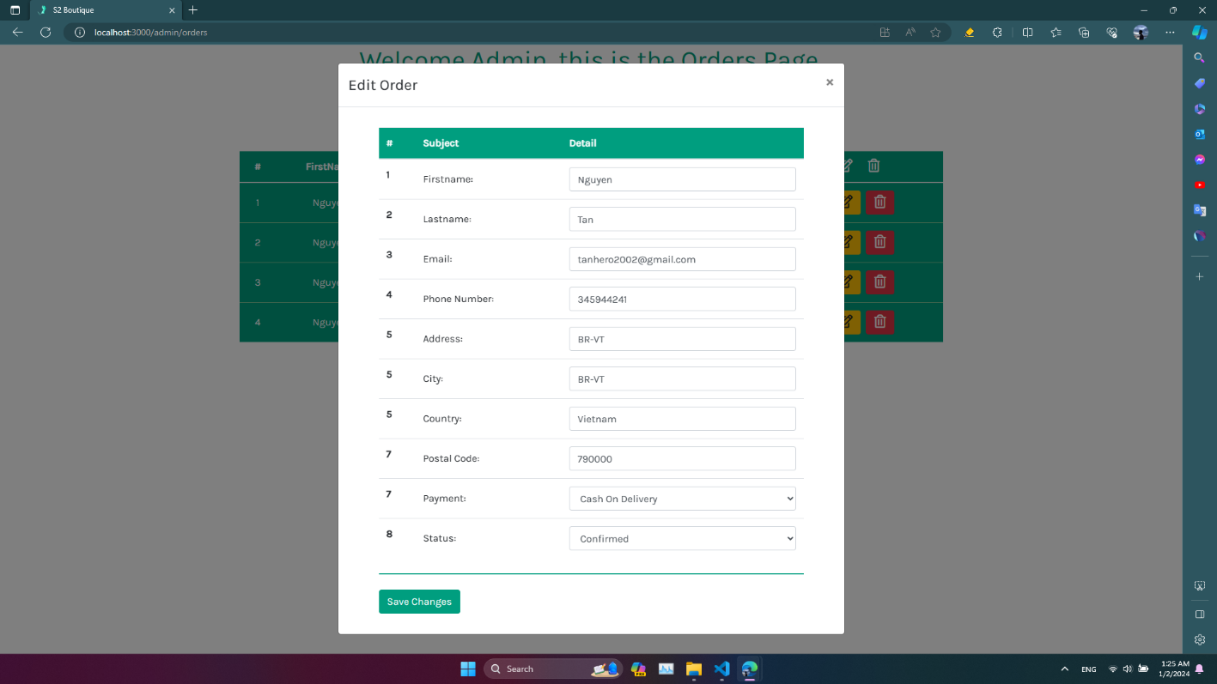

|  |  |  |
| --- | --- | --- |
| Framework | | Description |
| Function | Edit order | The modal will show the information of order and admin can update the information of order. |
|  | | |
| Button | Edit | Admin click on “edit” button to confirm update order. |
| Close | Admin click on “Close” button to cancel the action. |

### Delete Orders Modal

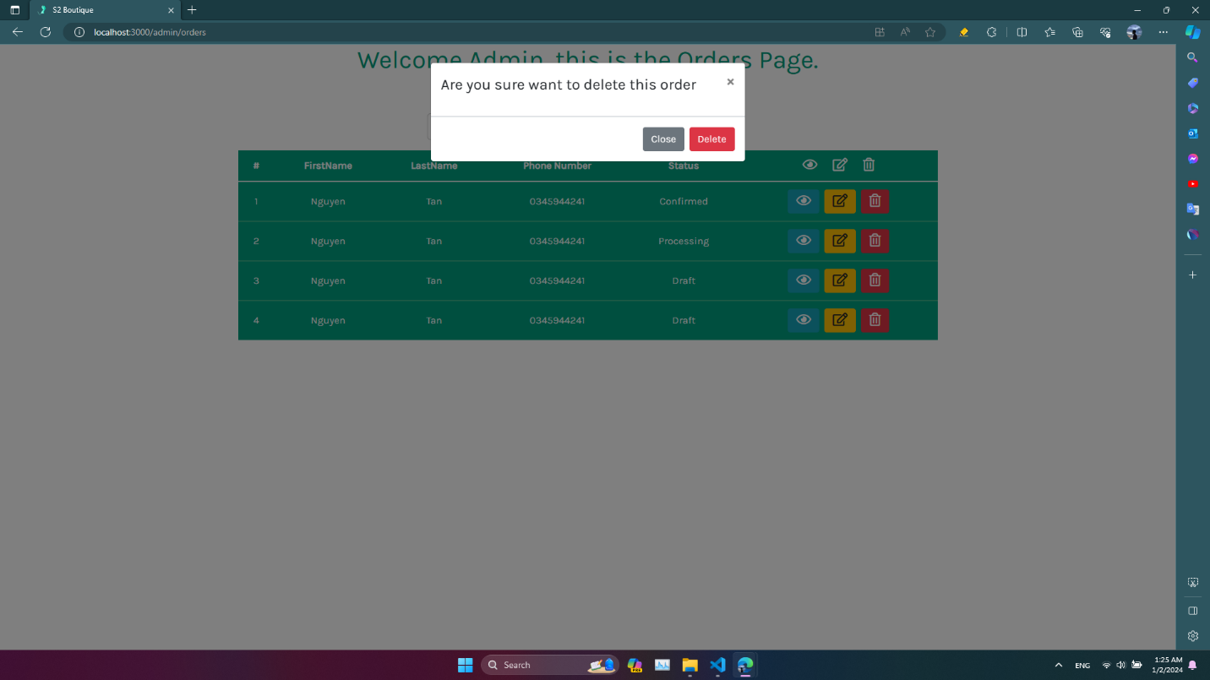

|  |  |  |
| --- | --- | --- |
| Framework | | Description |
| Button | Delete | Admin click on “Delete” button to confirm delete order |
| Close | Admin click on “Close” button to cancel the action. |

# Chapter 5: CONCLUSION

## 5.1 Project achievement

We have built 2 sites. One for customers who want to buy a product. And the other one is for administrators, who control and operate the system. Those tasks took us a lot of time, but it was worth for us. Below this is our system primary functions:

• Proceed to checkout

• Sign in/Sign up for customers

• Manage products

• Manage orders

• Manage accounts

• Visualize statistic of orders

We used ReactJs, NodeJs and MySQL technologies to build the systems. Thanks to the MVC design pattern, our project is separated into many modules easily, which helps us solve a lot of problems about project management.

## 5.2 Limitations

Due to the limited time of the study, the study has the following limitations:

• The interface is not compatible with devices such as mobile and tablet.

• The systems often crash due to limitations of db4free .

## 5.3 Development direction

In the future, the team will develop and complete the project, specifically as follows:

• Increase performance of the website by using some other service to host servers.

• The interface is compatible with devices (Laptop, PC, tablet, mobile).

# Chapter 6: SELF ASSESSMENT

|  |  |  |  |  |
| --- | --- | --- | --- | --- |
| No | Name | Role | Contribution | Grade |
| 1 | Nguyễn Minh Thành | Leader | -Report   * Chapter 3: * List Of Actors / Use Case * Manage Order (Use case, Sequence, Activity Diagram) * Chapter 5   -Demo Project   * Participating in writing a full backend | 10 |
| 2 | Quách Vinh Quang | Member | -Report   * Chapter 1: * Chapter 2:   Interview.  Software Requirement   * Chapter 3: * Sign Up (Use case, Sequence, Activity Diagram) * Sign In (Use case, Sequence, Activity Diagram) * Search Product(Use case, Sequence, Activity Diagram) * Proceed to checkout (Use case, Sequence, Activity Diagram) * Add to cart (Use case, Sequence, * Activity Diagram) * View order history (Use case, Sequence, Activity Diagram) * Class Diagram And Entity Class Diagram * State Diagram (Account, Product, Order) | 10 |
| 3 | Nguyễn Văn Tân | Member | -Report  -Demo Project   * Participating in writing a full frontend | 10 |
| 4 | Lê Văn Sỹ | Member | -Report  -Demo Project   * Participating in writing a full frontend | 10 |